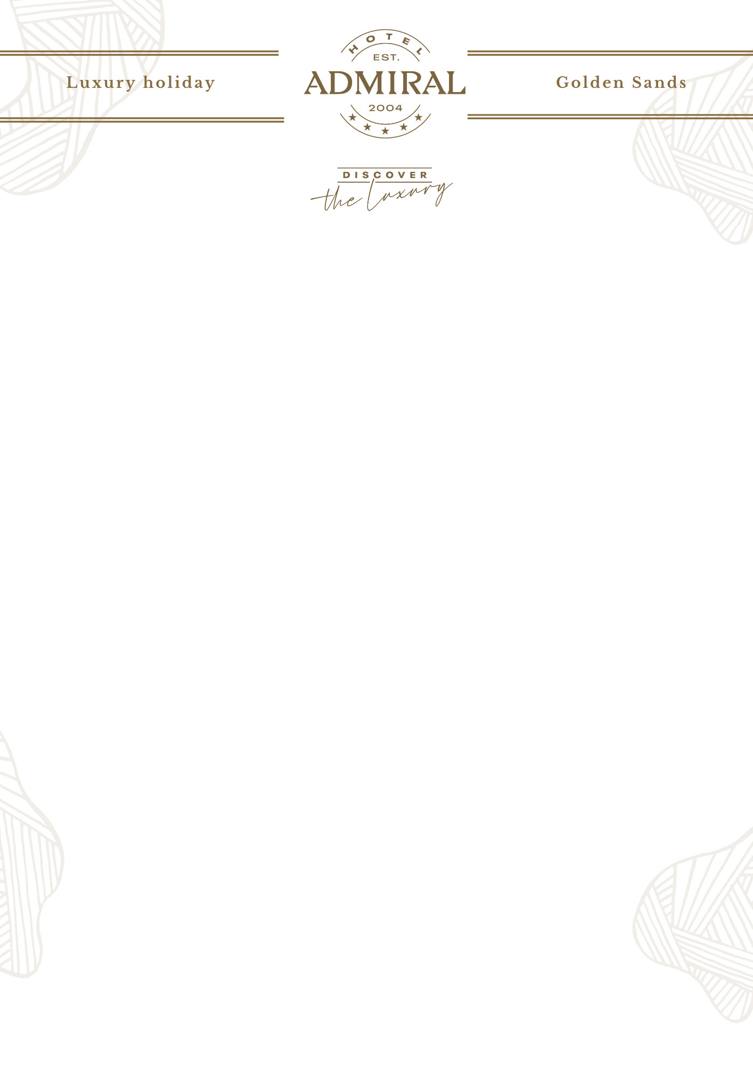

POOL BAR

- Working Hours – 09:00 – 18:00

POOL

- Lifeguard: 08:00 – 18:00; everyday
- 1 umbrella and 2 sunbeds by the pool / subject to availability
- Towels for the pool - 1 towel per person per day

TOWEL SERVICE

- 1 towel per person for the beach or for the pool is provided free of charge after providing a Towel card at the designated places
- Return of towel cards upon check-out is mandatory, otherwise a fine will be charged.
- Towels are collected from 08:00 to 18:00 by the pool lifeguards.

SPA & WELLNESS CENTER

- Working hour: 08:30 – 20:00, everyday
- Free use of fitness, indoor mineral pool, lounge area, relax zone, ice bucket, hydromassage, shower, changing rooms (W; M)
- Please contact the spa reception about the additional services.

MINIBAR :

- Minibar is available upon prior request for a fee
- Complimentary 4 coffee and 4 tea in the rooms upon arrival. Refill is subject to an additional charge with prior request.

MAIN RESTAURANT “ADMIRAL”

- Breakfast: 07:30 - 10:00 - Main restaurant
- Late breakfast – 10:30 – 12:00 – Main restaurant
- Lunch: 12:30 – 14:30 - Mediterranean buffet restaurant “Azzurro”
- Afternoon snacks: 15:00 – 17:00 – Mediterranean buffet restaurant “Azzurro”
- Dinner: 18:00 – 21:00

VIENNA CONFECTIONERY “ADMIRAL”

- Working Hours – 09:00 – 01:00
- The drinks in Viennese Confectionery between 10:00 and 22:00 are part of the Ultra All Inclusive

BEVERAGES – RESTAURANT AND BARS

- Tea and coffee
- Soft drinks (juices, water, soda, etc. /post mix/)
- Selection of local and imported alcoholic drinks from chosen producers
- Draft wines (white, red, rose)
- Selection of imported & locally bottled sparkling wines (white)
- Selection of imported & locally bottled spirits
- Selection of imported & locally bottled whiskies
- Choice of local beers /draft/
*Imported Alcohol High quality – for extra charge

LOBBY BAR

- Working Hours – 24/7

ULTRA ALL INCLUSIVE PACKAGE
HOTEL ADMIRAL 5* Discover the Luxury 2025

WE WISH YOU A PLEASANT STAY AT HOTEL ADMIRAL!

