

Amenities – Standard Double Room:
- Two beds
- Desk
- Telephone
- TV with a wide selection of channels
- Air conditioning
- Entrance door width – 90 cm
- Bathroom door width – 90 cm
- Balcony door width – 60 cm
- Folding support rails on both sides of the toilet
- Bathroom size in a standard room: 2.65 x 1.80 m Free space: 1.30 x 1.50 m
- Toilet seat height: 50 cm
- Accessible shower in the bathroom
- Hairdryer
- Average height of light switchesand sockets
- Maneuvering space on each side of the bed – 90 cm

Ensana Aquahouse Hotel offers 3 cozy and fully suitable rooms for people with disabilities, each equipped and furnished to provide a sense of comfort and spaciousness.
Like all other rooms in the hotel, the rooms for people with disabilities share the same décor and include everything needed for a perfect weekend or holiday.
- Handheld showerhead
- Raised toilet seat

Common Areas:
- Reserved parking space for people with disabilities
- Step-free access (ramp) and access to the elevator at the main entrance
- Automatic doors
- Accessible restroom on the ground floor and by the pool
- Portable lift for entering the pool
- Elevator to all accommodation floors
- Access to all common areas
- Medical services available at the hotel

If necessary, we provide a wheelchair and assistance for moving around the hotel during procedures.
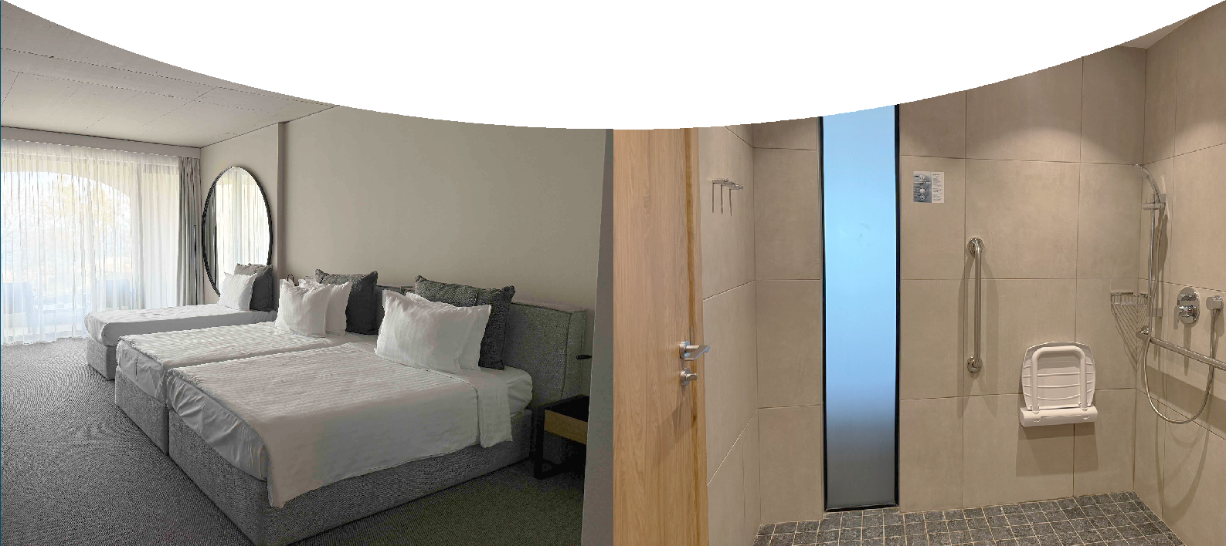
Hotel Reception: 9
Reservations Department: 3007

