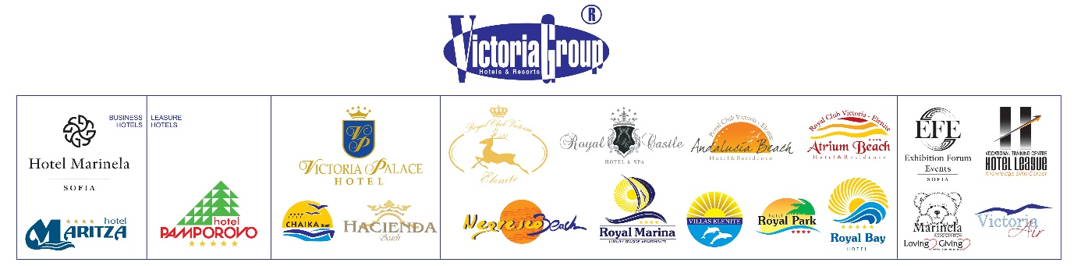

For us the guests are the focus of everything we do! Our striving to provide the best possible service goes through clear and transparent communication with our partners. In order to limit the basic prerequisite for customer dissatisfaction, we would like to remind you again of the conditions of catering for All Inclusive guests in the context of early arrival and / or late check-in.

- Main company policy for check in/out:
  - Check in time 14:30
  - Check out time 12:00

- All inclusive tourists are entitled to 3 meals per day at the main restaurant and all other snacks and beverages at the hotel.

- Main company policy is for all tourists to start their stay with dinner and finish with lunch. According to our policy, additional meals and drinks are not provided to tourists arriving before the agreed check-in time (14:30) and after the agreed check-out time (12:00)
27% of tourists' complaints over the past season are due to their expectations and demands for lunch (and sometimes breakfast) on the day of arrival. Victoria Group calls for assistance from our partnering tour operators by offering you the following options to improve guests service with a preventive communication measure:
Опция 1: Providing information of the transport schedule of each tourist's booking;.
Submitting specific information to our reservations department containing details of the transport schedule of the tourists, will allow us to adapt the first and last meal of the guests. Thus, early arrivals and early departures will have the right to lunch in the complex and to receive a bracelet before 14.30h. These tourists must be confirmed by the tour operators in advance to reflect the information in our system. Due to the introduction of a new control system, hotels will not be able to feed or accommodate early arrivals without being reflected in the system. All other guests, who leave after lunch on departure day, will not receive bracelets before 14.30h. There will be additional options for them:
2. Option 2: Payment for additional meals;
Submission of this information and activation of the option must occur within 48 hours prior to the arrival of the guests.
- Guests can enjoy breakfast in their hotel's main restaurant on the day of arrival only against a small fee: Adult - 5lv, Child- 3lv
- Guests can enjoy lunch in their hotel's main restaurant on the day of arrival only against a small fee: Adult - 5lv, Child- 3lv
.

3. Option 3: Restrict access to the hotel/complex before the standard check-in time;

Late check-out from the hotel is subject to the following fees:
- until 16.00h - 40,00 levs
- until 19.00h- 70,00 levs
- after 19.00h – the price for a night in the hotel

We would also like you to pay attention to the following:
IT IS PROHIBITED TO USE THE HOTEL TOWELS ON THE BEACH !!!
Hotel towels left on sunbeds on the beach, pools and the aqua park will be collected by staff without warning. Please note that change of towels in the rooms will be done on the basis of clean for used replacement. In the absence of towels in the room, the cleaning staff will not put new ones.
We are kindly asking tour operators to assist us in this important process. Please inform your tourists in advance, and especially the representatives, who will inform the guests before their arrival at the hotel/complex. We hope that this will ease our joint efforts to create clarity and comfort for tourists and reduce unnecessary complaints from guests.

