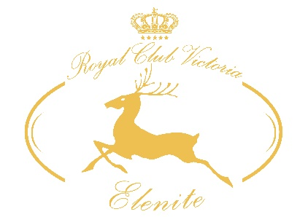
ALL INCLUSIVE
Summer 2017
ROYAL CLUB VICTORIA ELENITE ****

OUR PROMISE
To make your vacation a wonderful memory is our main goal. For us, it is important to know whether you need our special attention. We will listen to you and find a solution. We offer many ways for you to share your opinion during your stay and after.
GUEST RELATIONS SERVICES guestrelations@victoriagroup.bg
ONLINE FEEDBACK SYSTEM, which you can access via tablets located in the hotels and key points round the complex, via the internet network in the resort, through the official site of Victoria Group® Hotels and Resorts www.victoriagroup.bg , or if you leave your e-mail.
how to book
A LA CARTE restaurants
A la carte restaurants become a part of your All-inclusive programme with minimum 4 nights stay. To use this service a preliminary booking is required. Reservations are made with the Guest Relations Officer in the hotel you are staying and according the occupancy of the restaurants. The number of visits included in you package depends of the length of your stay.
From 4 to 7 nights - 1 А-la Carte restaurant
From 8 to 15 nights - 2 A-la Carte restaurants
Above 15 nights - 3 A-la Carte restaurants
IMPORTANT!
Seats in the A-la Carte restaurants are limited and are reserved UPON AVAILABILITY!
A-la Carte reservations are only available with your meal card. If you forget or lose your card, you will not be able to visit the A-la Carte restaurants.
IDENTIFICATION
All guests on All-inclusive board must be identified by their plastic bracelets. Bracelets must be returned when leaving the hotel. Lost bracelet is charged 30lv for a new one.

beach, pools, aquapark
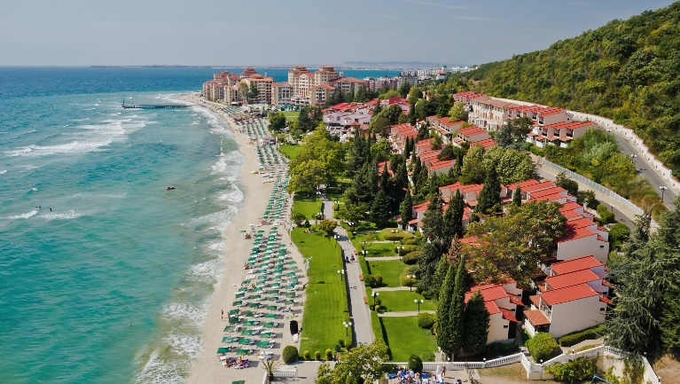
on the territory of the complex

SUNBED AND PARASOL
WORKING HOURS 09.00 – 18.00
They are a part of the All inclusive board and can be used on the beach, each swimming pool in the complex, and the Aqua park Atlantida, subject to availability. Please do not reserve sunbeds in advance by leaving towels or other personal belongings, as you obstruct the work of our employees, looking after the comfort of all guests in the resort. Towels placed on sunbeds in advance are considered to be left over and are removed.

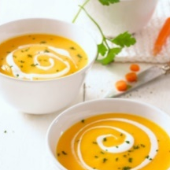
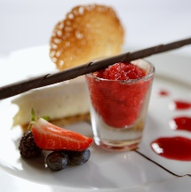
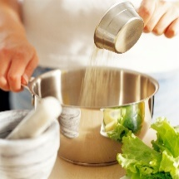
RESTAURANTS
MAIN RESTAURANT IN THE HOTEL YOU ARE STAYING
BREAKFAST – 7.30 – 10.00 | LUNCH – 12.30 – 14.30 | DINNER – 18.00 – 21.00
Buffet, salads, soups, starters, main dishes, desserts, fruit, non-alcoholic beverages, beer, wine, coffee/tea at breakfast.
A LA CARTE RESTAURANTS
RESTAURANT SOZOPOL
WORKING HOURS 18.00 – 22.30 | 15.05 - 15.09 |
Bulgarian traditional cuisine, Bulgarian alcoholic and non-alcoholic beverages, beer and wine. Branded alcohol and wines are paid.

MEDITERRANEAN RESTAURANT
WORKING HOURS 18.00 – 22.30 | 01.06 - 01.09 |
European and Mediterranean cuisine, Bulgarian alcoholic and non-alcoholic beverages, beer and wine. Branded alcohol and wines are paid.

ITALIAN RESTAURANT PIZZA AND PASTA
LA PIZZERIA IL CERVO
WORKING HOURS 18.00 – 22.30 | 01.06 - 25.09 |
Pizza and pasta, Bulgarian alcoholic and non-alcoholic beverages, beer and wine. Branded alcohol and wines are paid.

snacks and drinks
on the territory of the complex

SWEET SHOP PHILIPOPOLIS
WORKING HOURS 10.00 – 18.00 | 20.05 - 20.09 |
Cookies, sweets, bakery, Bulgarian alcoholic and non-alcoholic beverages, beer and wine

GELATERIA
WORKING HOURS 10.00 – 18.00 | 01.06 - 20.09 |
Ice cream

HOT DOG ON THE PROMENADE
WORKING HOURS 10.30 – 17.00 | 01.06 - 20.09 |
Hot dog and non-alcoholic beverages

THE MUSHROOM
WORKING HOURS 10.30 – 17.00 | 01.06 - 15.09 |
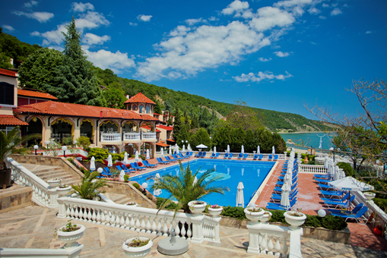
Doughnuts, beer, non-alcoholic beverages, juices and coffee

WAFFLES SWIMMING POOL ANDALUSIA
WORKING HOURS 10.30 – 17.00 | 01.06 - 15.09 |
Waffles
BURGERS AND CHIPS POOL BAR ROYAL PARK
WORKING HOURS 10.30 – 17.00 | 01.06 - 15.09 |
Burgers and chips, beer, non-alcoholic beverages, juices, coffee, cappuccino and hot chocolate. .
MINI PANCAKES POOL BAR ROYAL BAY
WORKING HOURS 10.30 – 17.00 | 01.06 - 15.09 |
Mini pancakes, beer, non-alcoholic beverages, juices, coffee, cappuccino and hot chocolate.
STUFFED/JACKET POTATOES SUMMER TERRACE CETNRAL POOL VILLAS
WORKING HOURS 11.00 – 16.00 | 01.06 - 15.09 |
Stuffe/jacket potatoes, beer, non-alcoholic beverages, juices, coffee, cappuccino and hot chocolate.
FORNETTI AND HOT DOG AQUA PARK ATLANDTIDA WORKING HOURS 11.00 – 16.00 | 01.06 - 15.09 |
Fornetti and hot dog.
POPCORN PROMENADE
WOKING HOURS 10.00 – 17.00 | 01.06 - 15.09 |
Popcorn
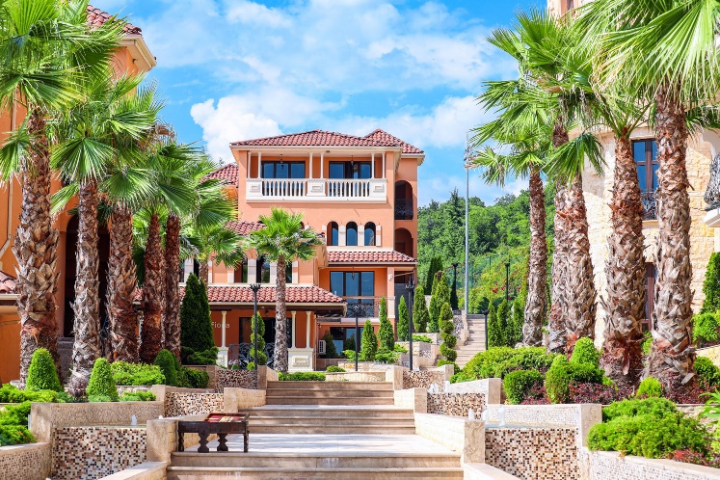
BARS
ON THE TERRITORY OF THE COMPLEX

LOBBY BAR IN THE HOTEL YOU ARE STAYING
WORKING HOURS 10.00 – 24.00
Bulgarian alcoholic and non-alcoholic beverages, beer, wine, coffee, cappuccino, hot chocolate and tea.

ANIMATION HALL BROADWAY
WORKING HOURS 18.00 – 23.00 | 01.06 - 15.09 |
Bulgarian alcoholic and non-alcoholic beverages, beer and wine.
Last order - 22.45

NIGHT CLUB GALAXY
WORKING HOURS 22.00 – 02.00 | 01.06 - 20.09 |
Bulgarian alcoholic and non-alcoholic beverages, beer and wine.

POOL BAR ATLANTIDA
WORKING HOURS 10.00 – 17.00 | 01.06 - 15.09 |
Beer, non-alcoholic beverages, coffee and tea.
animation, sport activiteis
ON THE TERRITORY OF THE COMPLEX

Elenite Holiday Village offers a team of professional animators. Daily programme includes different sports and entertaining activities – darts, beach volleyball, aerobics, water exercises, water polo, etc.

AQUAPARK ATLANTIDA
WORKING HOURS 09.00 – 18.00 | 01.06 - 15.09 |
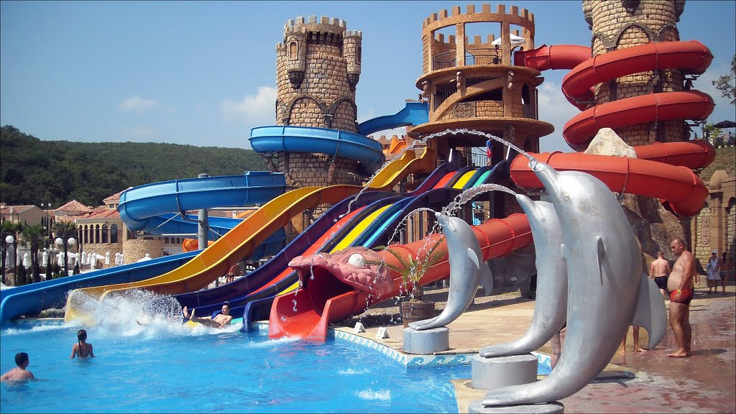
KINDERGARTEN CLUB ALADIN
WORKING HOURS 10.00 – 12.00 и 15.00 – 17.00 | 15.05 - 15.09 |
Club Aladdin welcomes children between 4 and 12 years old.

FITNESS CENTRE
WORKING HOURS 09.00 – 19.00 | 15.05 - 15.09 |

AMPHITHEATHER ARENA
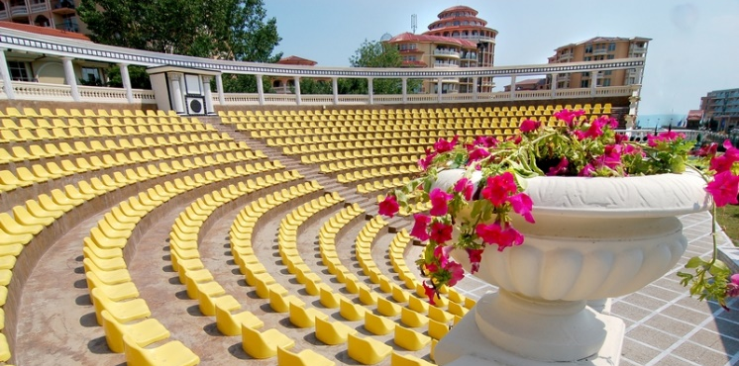
LOOK FOR THE PROGRAMME IN YOUR HOTEL

TENNIS COURT
WORKING HOURS 09.00 – 21.00 | 01.06 - 15.09 |
Free of charge using of the court. If you do not have your own racket and balls, you may rent them for BGN 12.00 per hour.

MINI GOLF CLUB
WORKING HOURS 10.00 – 22.00 | 01.06 - 15.09 |
Free use of the mini-golf. To rent a stick and a ball, you should pay a refundable deposit of BGN 30.00.

MINI FUN FAIR
WORKING HOURS 18.00 - 21.00| day-off Monday | | 01.06 - 15.09 |
Free of charge mini train for children and adults, swings and carousel on the territory of the complex.
additional services outside of the all inclusive board
ON THE TERRITORY OF THE COMPLEX

A vacation on the sea without a party on the beach or a drink in the sunset at our exotic Beach bar is not a real vacation. We offer some additional ideas to make your stay even more pleasant.

BEACH BAR
WORKING HOURS 09.00 – 24.00 | 01.06 - 15.09 |
A variety of cocktails at the beach.
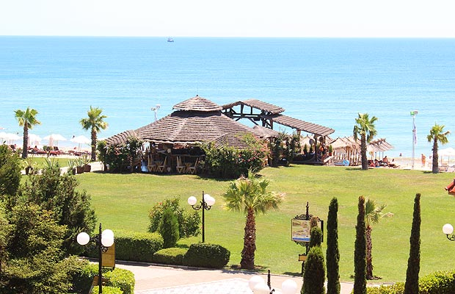

BOWLING
WORKING HOURS 17.00 – 24.00 | 01.06 - 15.09 |
One game - 10.00lv per person

VICTORIA SPA CENTRE
WORKING HOURS 09.00 – 21.00
Beauty treatments, massages and many other SPA therapies.

WINDSURF
WORKING HOURS 09.00 – 18.00
Only for licensed users. A paid course of training and international certificate is offered.
SAFE
Paid at reception – BGN 7.00 per day. The service is available only for the entire duration of the stay.
BILLIARDS
WORKING HOURS 09.00 – 21.00
PARKING
To make our complex paradise, we have organized parking spaces at the entrance of the resort. In the complex conventional cars are not used. Parking price – 12lv per day for each car.

CHARGING STATION FOR ELECTROMOBILES
We are the first hotel chain in Bulgaria which offers this service at all its destinations.

