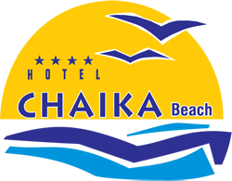
ALL INCLUSIVE
Summer 2017

Нашето обещание
To make your vacation a wonderful memory is our main goal. For us, it is important to know whether you need our special attention. We will listen to you and find a solution. We offer many ways for you to share your opinion during your stay and after.
GUEST RELATIONS SERVICES guestrelations@victoriagroup.bg
ONLINE FEEDBACK SYSTEM, which you can access via tablets located in the hotels and key points round the complex, via the internet network in the resort, through the official site of Victoria Group® Hotels and Resorts www.victoriagroup.bg , or if you leave your e-mail.
IDENTIFICATION
All guests on All-inclusive board must be identified by their plastic bracelets. Bracelets must be returned when leaving the hotel. Lost bracelet is charged 30lv for a new one.

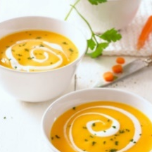
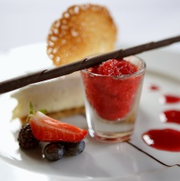
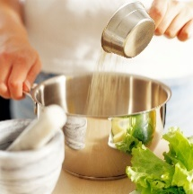
RESTAURANT
MAIN RESTAURANT CHAIKA
BREAKFAST – 7.30 – 10.00 | LUNCH – 12.30 – 14.30 | DINNER – 18.00 – 21.00
Buffet Breakfast -Standard buffet; hot and cold dishes, fruit, desserts, non-alcoholic and hot beverages.
Buffet Lunch and Dinner - Standard buffet; hot and cold dishes, fruit, desserts, ice cream, non alcoholic and low alcoholic beverages.

CHAIKA BEACH
Sunny Beach ****

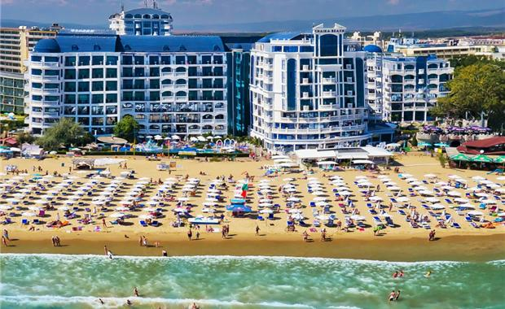

beachand pools

SUNBED AND PARASOL
They are a part of the All-inclusive board and can be used at the two swimming pools of the hotel, subject to availability. Sunbeds and parasols on the beach are additionally paid, as the service is provided by an external operator. Please do not reserve sunbeds in advance by leaving towels or other personal belongings, as you obstruct the work of our employees, looking after the comfort of all guests in the resort. Towels placed on sunbeds in advance are considered to be left over and are removed.
snacks and drinks

LOBBY BAR METROPOL
WORKING HOURS | 10.00 – 24.00 |
Bulgarian alcoholic and non-alcoholic beverages, draft beer and hot beverages. Last orders – before 23.45

IRISH BAR
WORKING HOURS | 10.00 – 24.00 |
Bulgarian alcoholic and non-alcoholic beverages, draft beer and hot beverages. Last orders – before 23.45

POOL BAR ARCADIA
WORKING HOURS | 10.00 – 18.00 |
Bulgarian alcoholic and non-alcoholic beverages, draft beer and hot beverages. Last orders – before 23.45

RESTAURANT METROPOL
WORKING HOURS | 11.00 – 17.00 |
Variety of snacks. Bulgarian alcoholic and non-alcoholic beverages, draft beer and hot beverages.
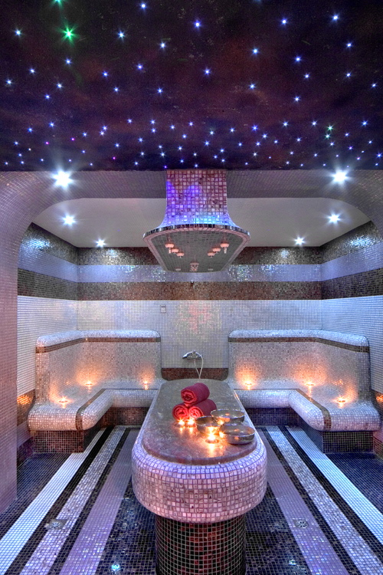
animation, sport activities

Chaika Resort offers a team of professional animators. Daily programme includes different sports and entertaining activities – darts, beach volleyball, aerobics, water exercises, water polo, etc. The evening programme offers children disco and games.

additional services outside of the all inclusive board
ON THE TERRITORY OF THE COMPLEX

A vacation on the sea without a party on the beach or a drink in the sunset at our exotic Beach bar is not a real vacation. We offer some additional ideas to make your stay even more pleasant.

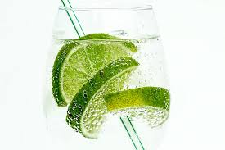

BEACH BAR
A variety of cocktails at the beach.

CLUB MYSTIQUE
Contermporary bar, located in the hotel, with an acces to the Sunny Beach promenade.

БИЛЯРД
A service paid per game.

WATER ATTRACTIONS ON THE BEACH
A variety of exciting adventures - 10m away from the hotel.

SPA CENTRE
SPA treatments sauna, Jacuzzi, massage, Turkish hammam, aromatherapy, hairdresser, manicure.

SAFE
Paid at reception – BGN 7.00 per day. The service is available only for the entire duration of the stay.

PARKING
Price – 12lv per day for each car. Subject to availability.

CHARGING STATION FOR ELECTROMOBILES
We are the first hotel chain in Bulgaria which offers this service at all its destinations.

