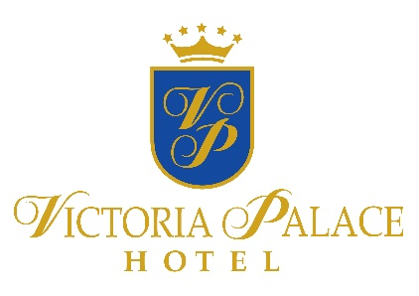
ALL INCLUSIVE
Summer 2017
VICTORIA PALACE SUNNY BEACH *****

OUR PROMISE
To make your vacation a wonderful memory is our main goal. For us, it is important to know whether you need our special attention. We will listen to you and find a solution. We offer many ways for you to share your opinion during your stay and after.
GUEST RELATIONS SERVICES guestrelations@victoriagroup.bg
ONLINE FEEDBACK SYSTEM, which you can access via tablets located in the hotels and key points round the complex, via the internet network in the resort, through the official site of Victoria Group® Hotels and Resorts www.victoriagroup.bg , or if you leave your e-mail.
hOW TO BOOK
A LA CARTE RESTAURANT
The A la carte restaurant becomes a part of your All-inclusive programme with minimum 4 nights stay. To use this service a preliminary booking is required. Reservations are made with the Guest Relations Officer in the hotel, minimum 24h in advance. Each guest has 1 visit included per stay, which can be reserved according to the occupancy of the restaurant.
IMPORTANT!
A-la Carte reservations are only available with your meal card. If you forget or lose your card, you will not be able to visit the A-la Carte restaurants.
IDENTIFICATION
All guests on All-inclusive board must be identified by their plastic bracelets. Bracelets must be returned when leaving the hotel. Lost bracelet is charged 30lv for a new one.

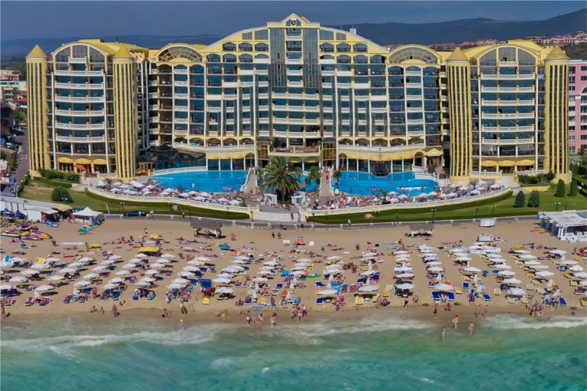

Beach and pool

SUNBED AND PARASOL
They are a part of the All-inclusive board and can be used at the swimming pool of the hotel, subject to availability. Sunbeds and parasols on the beach are additionally paid, as the service is provided by an external operator. Please do not reserve sunbeds in advance by leaving towels or other personal belongings, as you obstruct the work of our employees, looking after the comfort of all guests in the resort. Towels placed on sunbeds in advance are considered to be left over and are removed.

Free SPA services, part of the All-inclusive – Sauna and Hammam

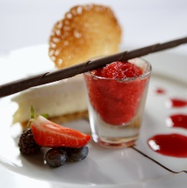

restaurants
MAIN RESTAURANT HOLLYWOOD
BREAKFAST – 7.00 – 10.00 | LUNCH – 12.30 – 14.30 | DINNER – 18.00 – 21.00
Breakfast -Standard buffet; hot and cold dishes, non-alcoholic and hot beverages.
Late Breakfast – Served at the buffet – cold dishes and mezze.
Lunch - Standard buffet; hot and cold dishes, fruit, desserts, ice cream, non alcoholic, low alcoholic and hot beverages.
Dinner - Standard buffet; hot and cold dishes, fruit, desserts, ice cream, non alcoholic and low alcoholic beverages. One thematic dinner per week /Bulgarian national cuisine/
A LA CARTE RESTAURANT
LА GОNDOLA
WORKING HOURS 18.00 – 22.00 two sittings
I–st sitting – 18.00 – 19.30
II–nd sitting – 20.00–21.30
Fixed 4 component A la carte menu - preliminary reservation with the Guest Relations minimum 24 hours in advance, and 1 visit included per stay, according to the occupancy of the restaurant.
Draft non-alcoholic and low alcoholic beverages.
snacks and drinks
on the territory of the hotel

LOBBY BAR SAFARI
WORKING HOURS 10.00 – 24.00 | Last orders - 23:30 |
Bulgarian draft alcoholic, low alcoholic, non-alcoholic and hot beverages

POOL BAR PALMA
WORKING HOURS 10.00 – 18.00
Bulgarian draft alcoholic, low alcoholic, non-alcoholic and hot beverages

SNACK BAR A LA CARTE RESTAURANT
WORKING HOURS 12.00 – 16.00
A variety of snacks, ice cream, Bulgarian draft alcoholic, low alcoholic, non-alcoholic and hot beverages.

IRISH BAR
WORKING HOURS 16.00 – 24.00
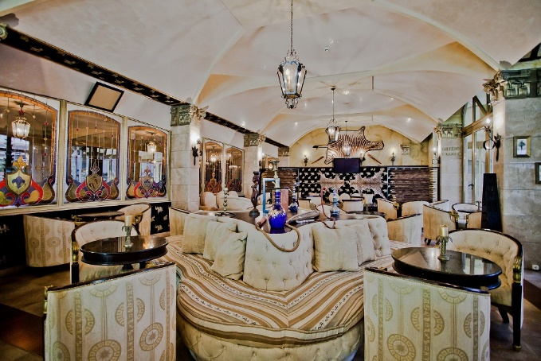
Light breakfast 16.00 – 17.00h. Bulgarian draft alcoholic, low alcoholic, non-alcoholic and hot beverages.

additional services outside of the all inclusive board
on the territory of the hotel

MEZANINE BAR
WORKING HOURS 18.00 – 02.00
Branded alcoholic, low alcoholic, non-alcoholic and hot beverages. Cocktails.


SPA CENTRE
WORKING HOURS 09.00 – 21.00
Free services for All-inclusive guests – Sauna and hammam;
Paid services - massage, aromatherapy, hairdresser, manicure.

MINI MARKET
WORKING HOURS 08.00 – 24.00
A variety of packed snacks and beverages, cigarettes, alcohol, newspapers, magazines, postcards and souvenirs.

SAFE
Paid at reception – BGN 7.00 per day. The service is available only for the entire duration of the stay.

PARKING
Price – 12lv per day for each car. Subject to availability.

CHARGING STATION FOR ELECTROMOBILES
We are the first hotel chain in Bulgaria which offers this service at all its destinations.

OTHERS
Telephone, taxi, rent-a-car, doctor.

