СЕМЕЙНЫЙ ОТЕЛЬ АДЕНА расположен недалеко от центрального пляжа и центральной части города Черноморец, с прекрасным панорамным видом на море. Элегантный 4-х этажный семейный отель предлагает отличные условия для летнего отдыха с удобствами для отдыха и развлечений.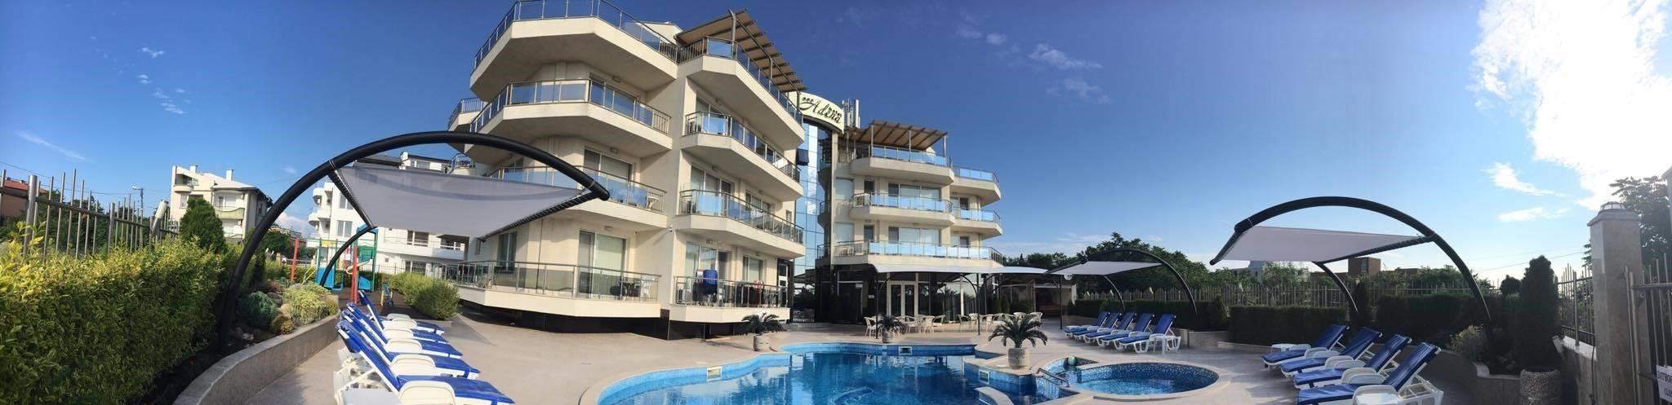
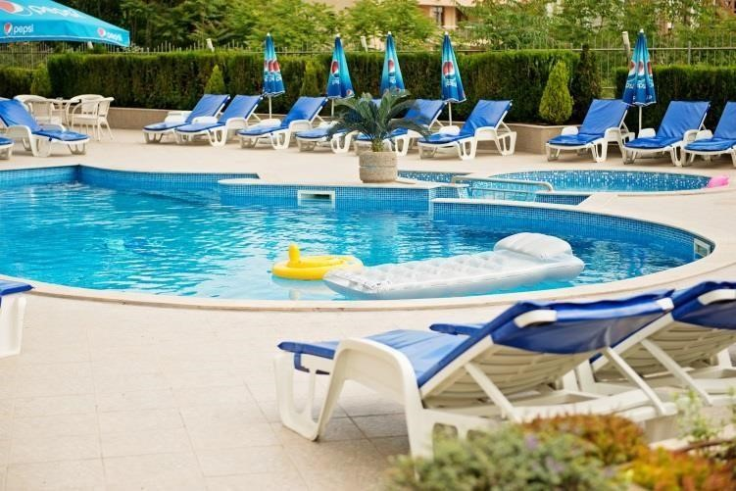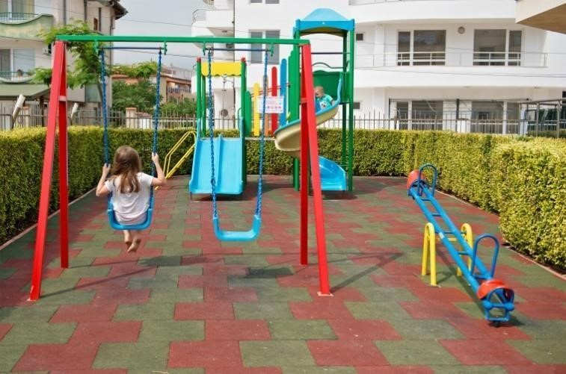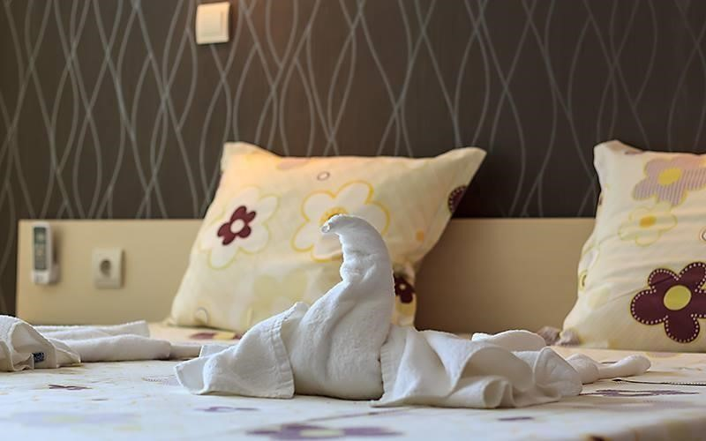
Размещение: 60 мест для ночлегов, располжены в 4 двухместных номерах, 16 апартаментах для трех человек и 1 апартаменте с кухней для 4 человек.
В номерах: Kондиционер, мини-бар, LCD-телевизор с кабельными каналами, туалет, душевая комната с феном и большая терраса со столом и стульями. Во всех номерах есть возможность добавить дополнительную кровать.

ЗАВТРАК
Завтрак с 8.00ч. до 10.00ч. на шведском столе: Кофе, чай, свежее молоко, какао, мед, брынза, желтый сыр, ветчина, бекон, несколько видов колбас , сосиски, масло, помидоры,огурцы, яйца.Завтрак в неограниченом количестве только на территории ресторана с 8:00 до 10:00. Запрещено выносить еду с ресторана.

ОБЕД
По меню (супы,гриль, салаты,закуски,аламинуты, десерты), разнообразное меню болгарской кухни.

УЖИН
Предоплаченый ужин с 18.00 до 20.00часа по трехстепенным меню.
Меню изготавливается заранее. Напитки за доп. плату.
При гостинице парковка- места ограничены. Бассейн для детей и взрослых, с бесплатными лежаками и зонтиками. Детская площадька для детей. Наличие беспроводного интернета wi-fi на всей территории отеля!

- ДВУХМЕСТНЫЙ НОМЕР (DOUBLE ROOM - STANDARD - min 2; max 2 adt)

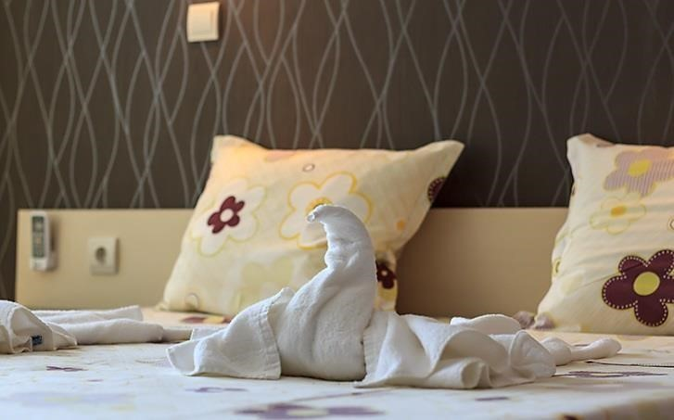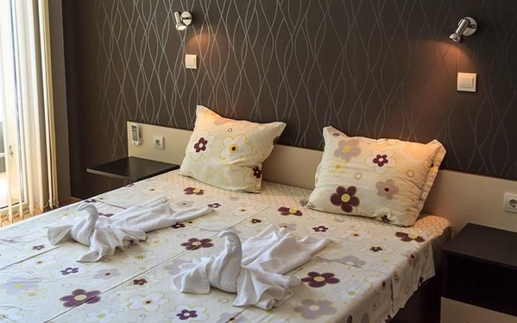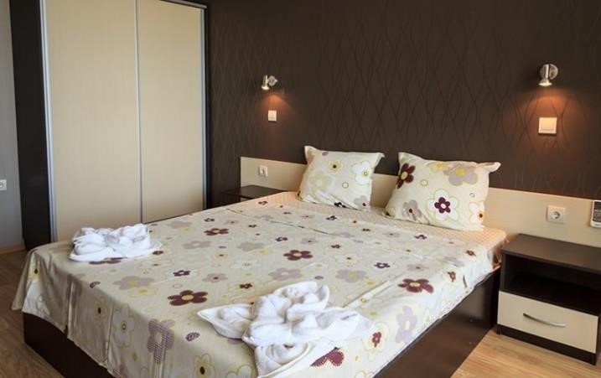

- ТРЕХМЕСТНЫЙ НОМЕР (TRIPLE ROOM - STANDARD - min 3; max 3+1 or 4 adt)
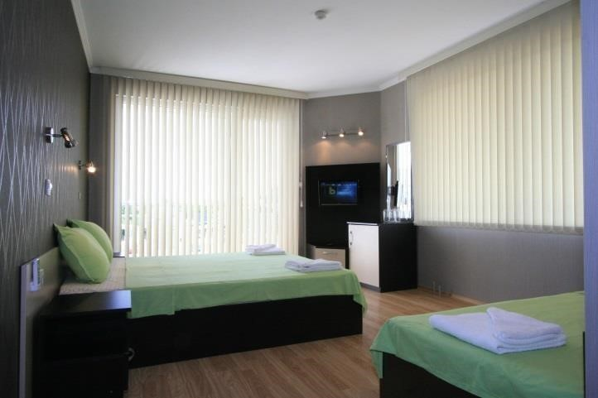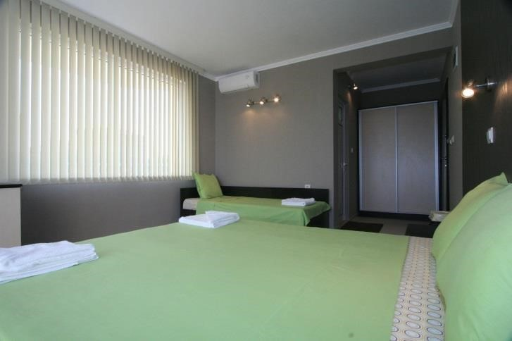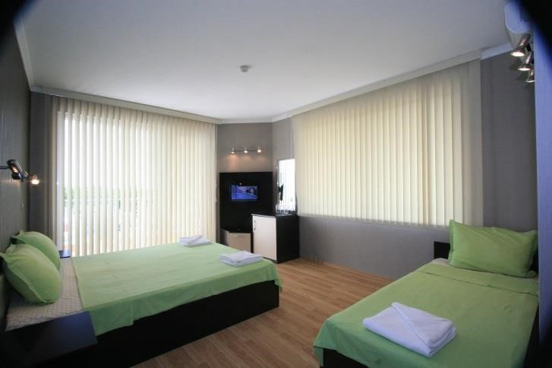
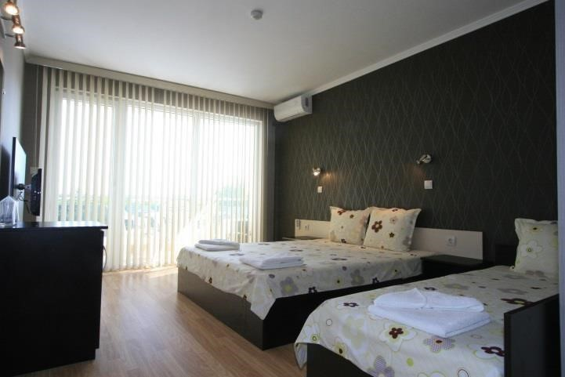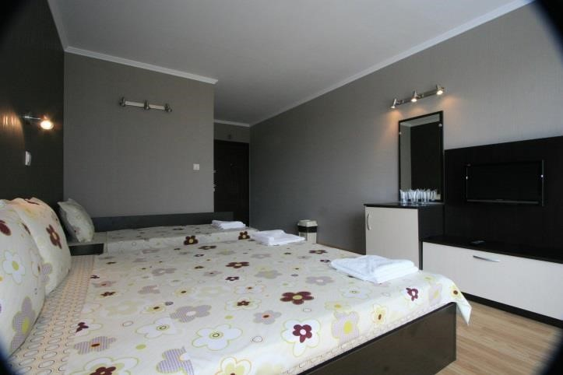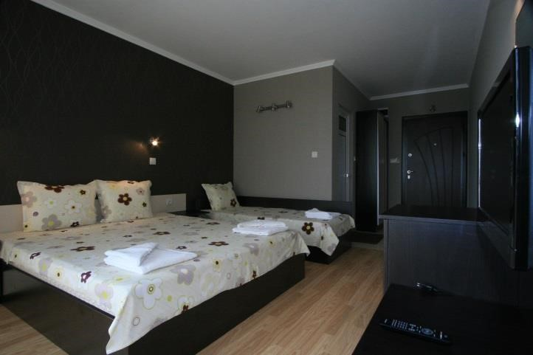
- АПАРТАМЕНТ (1 BR APARTMENT - STANDARD - min 2; max 2+2 or 4 adt)
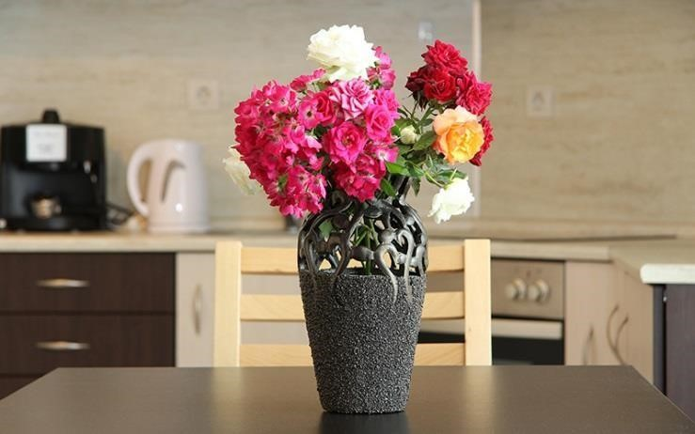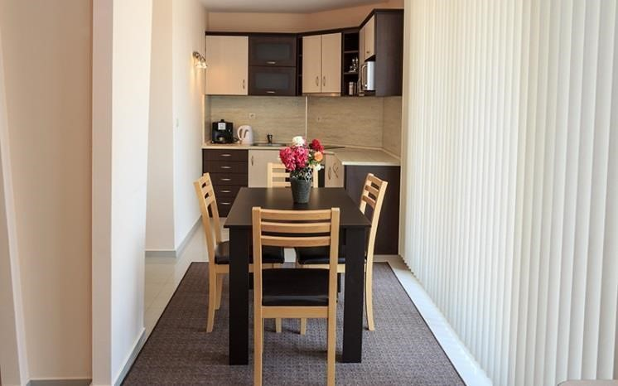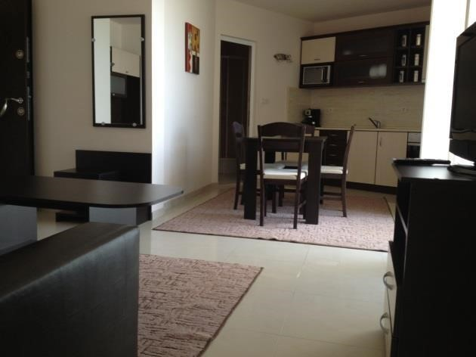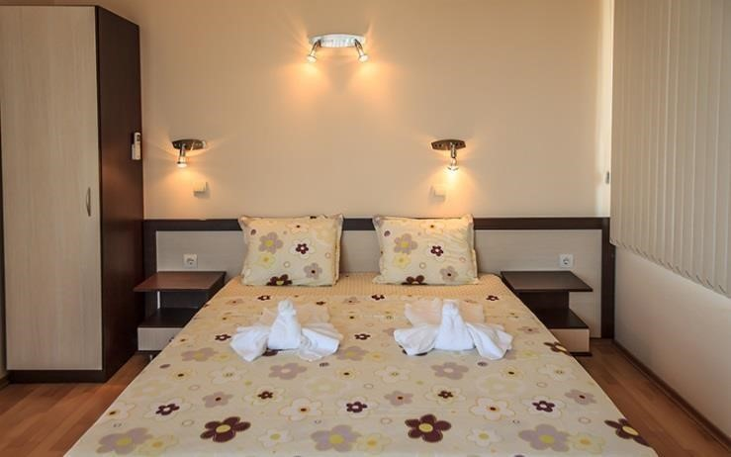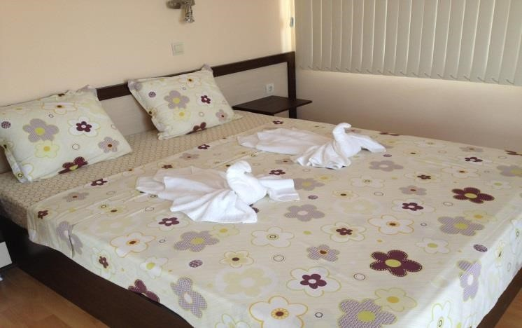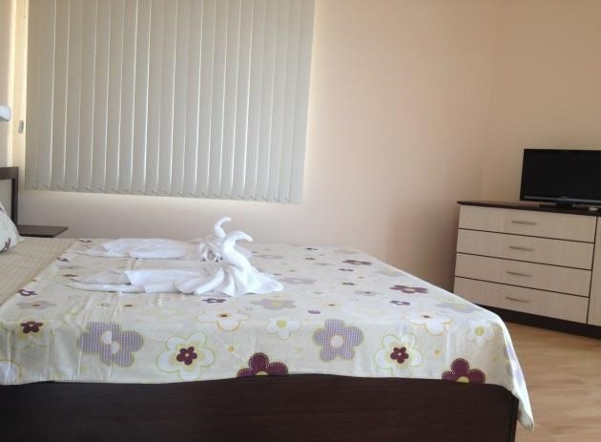

www.hoteladena.com

If you are looking for a beautiful and a calm place to stay, you have already found it!
ADENA FAMILY HOTEL is located close to the central beach and the center of the city of Chernomorec with a lovely panoramic view of the whole city and the seaside. The four-stored hotel offers the perfect setting for a summer vacation having the needed equipment forensuring yourrelaxation and entertainment.
The rooms are equipped with comfortable furniture and offer contemporary facilities such as air conditioner, minibar, LCD cable TV, toilet and bathroom with a hair dryer installed. From the big balcony you can enjoy the view to the swimming pool, the central beach and the beach of “Vromos” orthe near city of Burgas which lights are shining in the sky.
Hotel Adena has its own swimming pool with a special section for children. In addition, around the swimmingpool there are lounges, sunshade tents and a playground forthe children with different kinds of entertainments.
Stylish bistro with the best beverages with indoor and outdoor seating next to the pool and "a-la cart" service will complete the pleasure of your stay in the family hotel «Adena».
- BREAKFAST
Breakfast is served from 8.00 am to 10.00am on a buffet and includes:coffee, tea, fresh milk,cocoa, several type sof packed sweet, honey, cheese, yellow cheese, melted cheese, ham, bacon,a few types of salami and flat sausage , frankfurter , butter, tomatoes,cucumbers, boiled eggs, scrambled eggs, white and black bread and more.Breakfast can be consumed in the restaurant area in unlimited quantities from 8.00 am to 10.00am.
NOTALLOWED to take out food to the room sand for the beach, other wise you will have to pay the taken at restaurant prices.
- FORLUNCH
Apart from the menu (soups, grill, salads, starters, pasta, desserts), every day different and a great variety of meals from the Bulgarian national cuisine, such as moussaka, chicken with rice or potatoes, peppers stuffed with rice and minced meat, chirpanski sauce orwhite sauce, kebab, beans with sausage, mish-mashand many othersat .
- DINNER
The prepaid dinner is served after 18.00 to 20.00 on a menu prepared in advance and includes salad, main dish (meat or fish with garnish)and dessert(fruit).Food information can be obtained inthe morning during breakfast and if you wishto eat something different than the one provided, you can choose something from the lunch menu. Inthe prepaid dinner isincluded only the food, alcohol and non-alcoholic drinksare paid extra.
The menu of the restaurant contain a great variety of meals forevery taste. In the summer garden of the hotel around the pool you can enjoy a relaxed atmosphere with a cup of fragrance coffee oryour favorite drinkina pleasantcompany. Thefood isvery tasty, and once you tryit,you willremain exceptional satisfied and will repeat.In the lobby bar you can relax with a cup of fragrant coffee, as well as enjoy cocktails and alcoholic beverages. All this is complemented by the availability of wireless internet throughout the whole hotel!
Тhere is a parking with a limited number of places in the hotel.
Not far from the hotel there are plenty of opportunities fortourism,kitesurfing,wakeboard, windsurf,rafting and kayak in the nearby “Ropotamo” river.Unfortunately, pets are notallowed inthe hotel.
Dear guests, the Adena hotel`smanagement isworking only inorder to ensureyourpleasant and comfortable vacation which you will enjoy forsure!
- DOUBLEROOM
- TRIPLEROOM
- APARTMENT WITH KITCHEN FOR 4PERSONS

