FACT SHEETS 2019
Grifid Hotel Bolero ****
Address: Golden Sands resort
Varna 9007, Bulgaria
tel: +359 52 333 666, fax: +359 52 394 900
e-mail: bolero@grifidhotels.com
web site: www.grifidhotels.com

Grifid Hotel Bolero is the second property of the Bulgarian hotel chain GRIFID HOTELS. Guided by the GRIFID's high standards of quality and unsurpassed service, a team of experienced professionals fulfills the company’s ongoing commitment to guest satisfaction.

Highlights and new services!
- NEW: Theme parties with BBQ evenings and beach parties in July-August
- Fully renovated Double Deluxe rooms in 2018 (fresh colors in textile and new laminated floor)
- Relax bar offers lovely relaxing ambience for all of you who want to have a drink with friends or family and to have enjoyable conversation ... Extend your vacation!
- The unique for Golden Sands Grifid Aqua Park∗ with total area of 8000 sq. m. is available free of charge for all Grifid Bolero guests. With its two sections: for adults and for children, each one accommodating 3 slides the Grifid Aqua Park offers the fun of over 400 m. of thrilling riding experience. Changing rooms and safe deposit box available free of charge. Operating June till September, weather permitting. There are height requirements for the access of adults aqua park section – from 1.40 m. The slides:
    - The PIPEline™ - a classic thriller designed with over 168 m. of alternating tunnels and high speed open flume sections
    - The TOPSY-TURVY™ (Tornado Slide) - 3 open funnels oscillate the rider several times before dropping them back into the ride and onto the next funnel. A combination of over 158 m. of dark tunnels and high-speed open flume sections. A slide with no match in Europe
    - The BulletBOWL™ – with a steep (over 12 m. drop), tunneled in-run (88 m. of tunnels) and compact tubing bowl, provides a truly unparalleled centrifugal experience
- Human Soccer play field
- The Grifid Mini Club shaped like a Pirate Ship is a pure 200 sq. m. fun zone for the little guests comprising of 2 separate in-door sections, outdoor veranda and playground area with many children attractions. All that is surrounded by the lush greeneries of the natural park. The Grifid Children Aqua Park has 3 slides specially designed and built for children and are the central joy point of the area. The slides end up in to 2 children pools - beautifully decorated with beloved animation characters.
- 24 hours All inclusive (24 hours beverages and midnight snack)
- Free use of in-room safe and WI FI; free use of sauna and steam bath in the Relax Center of Bolero
- Grifid Mascot – Griffi – the joyful friend of all children
- Romantic Dinner at the beach in front of Grifid Metropol – reservation required and with surcharge
- Grifid Dine Around - complimentary dinner choice of Grifid a la carte restaurants in hotel Bolero, Vistamar and Metropol including Fusion (9 course degustation menu, molecular cuisine), Italian, Bulgarian, Asian, Tex-Mex. Rodizio and Mediterranean cuisine in Grill restaurant Bolero on buffet.
- Tex-Mex open air a la carte restaurant – opened in 2016

Location
Grifid Bolero is a hotel with club characteristics located in the modern Bulgarian resort Golden Sands - the true pearl on the Bulgarian Black Sea coast in a unique blend of lovely nature park, warm sea and fine golden sands. The hotel boasts a beautiful garden of 15 000 sq. m., lavish greenery and flower beds.

- 3 separate buildings  - 8 floors in the main building  - 500 m from the centre of the resort  - 50 m from the beach  - 15 km from Varna city | - 30 km from the airport  - 400 m from a bus stop  - GPS coordination:  - LAT: 43°17'34.44"N  - LON: 28° 2'44.16"E

General Information
Grifid Hotel Bolero is ideal choice for a successful holiday in terms of both location and facilities, offering a whole world of possibilities for our clients’ leisure and relaxation – excellent Ultra all inclusive formula, delightful gastronomy, spacious and comfortable rooms, amusing and engaging entertainment team and attentive staff.
- Fully equipped 3 meeting rooms for conference and banquette events  - Specially created external stage for animation  - Snack terrace with pool and park view  - Pastry shop for sweet addicts  - Well-fit Zone  - Natural Green Park with Aqua Park, Mini Club and Human Soccer play field | - Credit cards accepted: Visa, Mastercard/Eurocard;  - Languages spoken at reception: Bulgarian, English, German, French, Russian  - Environment -friendly  - Dress code for dinner required: for gentlemen – long trousers  - Check-in time – 14h  - Check-out time – 12h
Early check-in and late check-out are subject to availability and are due to additional charge.

PHOTOS available at:
http://grifidhotels.com/marketing/Grifid%20Bolero/
http://grifidhotels.com/marketing/Grifid%20AquaPark/

Accommodation
- 297 hotel rooms, of those:  - 264 double deluxe rooms with view to the pools and garden in the inside court;  - 27 renovated in 2016 family rooms, with pool view, carpet floor, one bedroom and а room with two single beds, one bathroom with shower and two sinks, tea and coffee making facilities  - 6 suites with pool and garden view, with one living room, one bedroom and two bathrooms, one of them with a shower  - bathroom with а bathtub and shower in it in all deluxe rooms | - international direct dialing telephone  - laminated floor in all double deluxe rooms  - central air conditioning  - complimentary mini bar  - satellite TV and Flat TV sets  - Wi-Fi (free of charge)  - in-room safe (free of charge)  - balcony  - pillow menu  - cosmetic mirror in bathroom  - hairdryer in bathroom
Services
- 24 – hour Front desk with multi-lingual staff;  - Grifid Guest Relations - taking care of all little details that matter for your stay  - rent a car  - laundry service  - currency exchange  - 24 hour security  - internet corner at a charge  - cooking classes  - Grifid Dine Around Program | - free Wi-Fi internet access in the hotel lobby and in all rooms  - shop  - taxi  - Indoor garage - extra charge; parking lot – limited and against charge  - Doctor  - Grifid Logo Shop  - Grifid Loyalty Guest Program – providing benefits for all Grifid returning guests!
Children friendly
- Free services
- Grifid Mini club with 200 sq. m. of fun zone for the little guests comprising of 2 separate in-door sections, outdoor playground  - Mini Aqua Park with Two children`s pools and three different slides (June-September)  - Professional children animator and theme days  - Mini disco every day  - Grifid Children Menu in all a la carte restaurants | - Children show once in two weeks  - X-box games  - Baby cots  - Children lunch and dinner with our animators  - Highchairs in restaurants  - Baby food warming/preparation in the restaurant – upon request

- Paid services
- Tennis lessons for children – charged, reservations required  - Baby sitter – children from 4 years old, charged, upon request; | - Baby phone – available at a fee  - Baby buggies for rent

Restaurants and Bars
- Bolero Restaurant  Classical restaurant for breakfast, lunch and dinner, buffet style. Offers elegant ambience and cozy atmosphere  - capacity: 240 seats  - main restaurant  - smoking is not allowed  - varied buffets with on spot cooking, carving, pizza and pasta station, diet and other culinary sections  - beverage buffet with mineral water, soft drinks, beer and country wine  - thematic culinary buffets – 2 times per week  - Gala dinner – once in 10 days  - dress code for dinner required –long trousers for gentlemen | Opening hours:  Breakfast 07:30 – 10:00 buffet  Lunch 12:30 – 14:00 buffet  Dinner 18:00 – 21:30 buffet
- Grill Restaurant – theme evenings  - capacity: 100 seats inside and 135 on both terraces  - included in our Snack offer – Sandwiches, Hot Dog, Pizza, Dönner, Burgers, Pancakes, Salads, Fruits  - smoking is not allowed  - dress code for dinner required – long trousers for gentlemen  Theme Grill restaurant with variety of specialties, show cooking station, savory salads and delicious pastry buffet offers different theme evenings part of the Dine Around program. Unique with its two spacious terraces and with excellent view to the swimming pools and the garden of the hotel. | Opening hours:  Breakfast 09:00 – 10:30 buffet /in high season only/  Continental breakfast 10:30 – 12:00 table service  Lunch 12:00 – 15:00 buffet  Snack 15:00 – 17:00 counter service  Dinner 18:30 – 21:30 buffet, reservation required
- Bulgarian A la carte Restaurant “Old House”  Thematic a la carte restaurant with traditional Bulgarian menu. Welcomes its guests in the atmosphere and spirit of typical Bulgarian house. Operates only for dinner and reservation in advance is required  - Capacity: 60 seats  - A la carte service and traditional Bulgarian menu for dinner  - Advance reservation required  - Smoking is not allowed  - Dress code for dinner required – long trousers for gentlemen | Opening hours:  Dinner 18:30 – 21.30 table service
- A la carte Restaurant „Asia”  Culinary trip to the Far East in an elegant ambience and discreet service  - capacity: 54 seats  - selection of exotic culinary specialties, delivered by attentive service  - advance reservation required  - smoking is not allowed  - dress code for dinner required – long trousers for gentlemen  - A la carte Restaurant “Tex Mex”  - open air restaurant with capacity: 60 seats  - traditional Mexican cuisine  - advance reservation required  - smoking is not allowed  - dress code for dinner required- long trousers for gentlemen | Opening hours:  Dinner: 18.30 – 21.30 table service  Opening hours:  Dinner: 18.30 – 21.30 table service
- Grifid Dine Around Program – a diverse and complimentary choice of a-la-carte restaurants with variety of cuisine types for our guests, including Fusion (9 course degustation menu, molecular cuisine), Italian, Bulgarian, Asian, Tex-Mex. Rodizio and Mediterranean cuisine at Grill restaurant Bolero on buffet. True culinary journey around the Globe provided by Grifid with no match on the Bulgarian Black sea coast!

- Pool bar  Situated next to a water cascade, connecting the lagoon and classic pools  - capacity: 40 seats  - Ultra All inclusive Bar with refreshing cocktails, international and local alcoholic drinks, non - alcoholic beverages, local draught beer, coffee & tea  - bar service | Opening hours:  10:00 – 19:00 bar service
- Bar salon  Spacious and modern furnished amphitheater salon, situated on 3 levels, with large stage for evening performances and a dancing floor. There is a belonging sunny outdoor terrace on 2 levels  - capacity: 400 seats inside and 80 on the terrace  - Ultra all inclusive offer features international and local alcoholic drinks, non-alcoholic beverages, cocktails, local draught beer, wine, coffee & tea  - bar service | Opening hours:  19:00 – 24:00 bar service
- Relax Bar - lovely place to spend the evening, relax and enjoy the ambience.  - capacity: 60 seats  - Ultra all inclusive offer continues after midnight with international and local alcoholic drinks, non-alcoholic beverages, cocktails, draught beer, wine, coffee and tea  - bar service  - Midnight snack | Opening hours:  00:30-07:30 bar service  23:30 – 00:30 buffet
- Beach Bar  Situated on the Grifid Beach in front of Grifid Vistamar Hotel.  - ULTRA All Inclusive offer features local alcoholic and non-alcoholic beverages, refreshing cocktails, coffee and tea, draught beer  - bar service | Opening hours:  10:00 – 17:00 bar service
- Pastry Shop  Open air, next to the Bar Salon of the hotel  - Ultra All inclusive offer features cakes, cookies, crème, tartlets and ice cream, coffee and tea. Self service. | Opening hours:  10:00 – 12:00  14:30 – 17:00
- Mini bar
- Complimentary – offers mineral water, soft drinks and beer
- Restocked daily

Hotel reserves the right to change opening hours of the outlets if necessary.

24 hours Ultra All inclusive included:
- 24 hours beverages at one of our bars and midnight snack

Swimming Pools
- Outdoor pools:  - Laguna pool with integrated complimentary whirlpool;  - Classic pool with dimensions: W 12 m.; L 25 m.  - Sun terraces by the pools  - Complimentary sun lounges, parasols and towels  - Life guard service provided; | Opening hours:  08:00 – 17:00
- Indoor pool:  - Heated with dimensions W 13 m., L 30 m.  - Complimentary whirlpool  - Complimentary lounges and towels  - Life guard service provided | Opening hours:  09:00 – 18:00

Beach services included:

One parasol and two sun beds (with mattresses) per room on the beach available! Children, accommodated free of charge, don’t receive the above services! Sun beds and parasol are only offered to full paying customers!

Wellness and Relax
Bolero Wellness and Relax center offers perfect combination of relaxing and revitalizing treatments and temptations, sophisticated atmosphere and professional staff.
- Services
- Steam bath  - Two saunas  - Relax zone  - Massage rooms  - Hot stone massage  - Hydro-massage bath | - Mud applications  - Boutique features massage oils, crèmes and fragrances and other body products  - Body and face cosmetic  - Hairdresser  - Manicure and pedicure | Opening hours:  09:00 – 18:00

Free services included:
- Sauna and steam bath
All other treatments and procedures are additionally charged.

Sports and Animation
Professional animation team takes care of the pleasant stay and active holiday at Grifid Hotel Bolero.

- Well fit Zone – open air for following activities:
- Gymnastics  - Aerobics  - Nordic Walk | - Pilates  - Zumba  - Fit ball | - Hot Iron  - Back Fit  - Table tennis
- Other sports and animation part of the Ultra all inclusive offer:
- Multipurpose playground for basketball and volleyball  - Floodlit tennis court  - Football playground  - French bowl | - Human soccer  - Foot tennis  - Aqua gym Aqua Jogging  - Darts  - Tae-Bo | - Water polo  - Bicycle tours  - Air riffle shooting  - Dancing lessons  - Gym
- Animation program for teenagers (from 12 to 17 years old) with different sport activities
- Theme parties with BBQ evenings and beach parties in July-August
- Evening shows – daily
- Disco
- Grifid Mini club with daytime entertainment program for children:
- Open every day 10:00 - 12:30 & 15:00 – 17:30  - For children aged 4 to 12  - Mini disco - every day  - Grifid Mascot – Griffi – the joyful friend of all children | - Children show once in 2 weeks  - Regular theme days and activities - free of charge  - Special Kids events - against extra charge, advance reservation required  - X box games

Charged sport facilities in the hotel
- Tennis lessons for children and adults  - Billiards | - Bicycle (when not part of the animation bicycle tour )
Charged sport facilities in the vicinity of the hotel
- Banana boat  - Mini golf | - Scuba diving  - Bowling | - Waterskiing
MICE:
- Grifid Hotel Bolero provides 4 modern meeting rooms:
- Conference room “Bulgaria” - capacity 120 pax  - Conference room “Sofia” - capacity 40 pax | - Conference room “Varna” - capacity 16 pax  - Bar Salon Grifid Hotel Bolero - capacity 400 pax
Coffee breaks, audio-visual equipment, flip charts and additional equipment and services available.

MISCELLANEOUS:
- Pets not admitted
- Under Bulgarian legislation it is not allowed to smoke in the hotel lobby, restaurants, bars and rooms
- Indoor garage – extra charged; parking lots – limited and charged
- Sun bed reservation is not accepted. Any unattended towels are removed from the pool staff
- Any Food and Drinks could not be taken out of the restaurants due to Public and HACCP regulations

AWARDS & CERTIFICATES
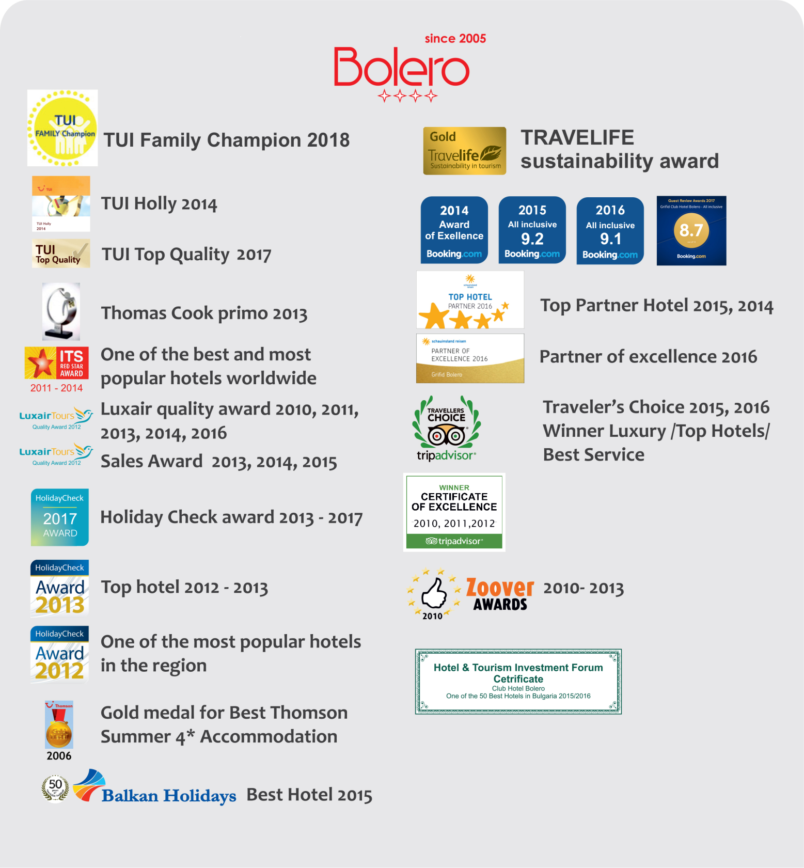

∗ Open from June till September, at selected times, weather permitting

