HVD CLUBHOTEL MIRAMAR **** DELUXE CONCEPT
Ultra All Inclusive DELUXЕ- Summer 2019
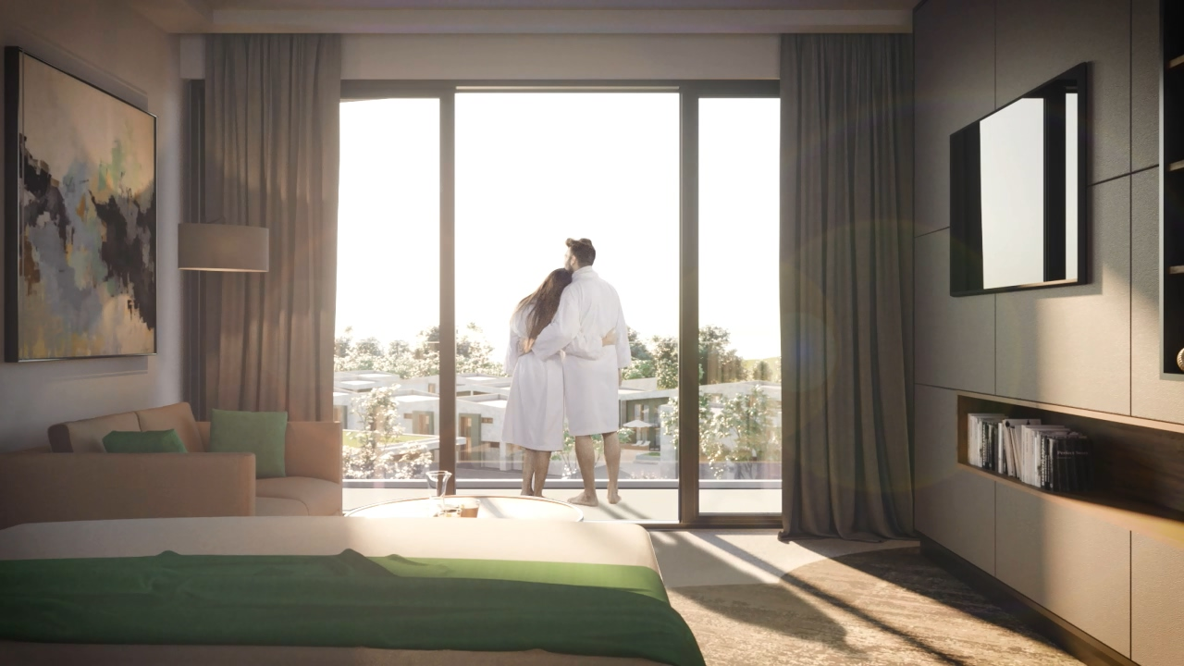

Welcome to our family Paradise!

MIRAMAR DELUXE ROOMS
ROOM TYPE | FACILITIES | VIEW | MAX. CAPACITY
Standard Double Land view room DELUXE | The rooms have an area of 40m² and are furnished with 2 single beds, double sofa bed, free mini-bar refilled every day with mineral water, soft drinks and beer, personal safe box (free of charge), telephone, coffee machine, hair-drier, cosmetic mirror, special pillow menu, special aroma menu, luxury bath accessories and cosmetics, kid’s bath set, bath ropes and slippers, 43 inches TV, cabel TV, free Wi-Fi, central air conditioning system, bathroom with shower and double sink, balcony or terrace with table and chairs. | Land view | 3 adults or 2 adults + 2 children + baby
Standard Double Sea view room DELUXE | The rooms have an area of 40m² and are furnished with 2 single beds, double sofa bed, free mini-bar refilled every day with mineral water, soft drinks and beer, personal safe box (free of charge), telephone, coffee machine, hair-drier, cosmetic mirror, special pillow menu, special aroma menu, luxury bath accessories and cosmetics, kid’s bath set, bath ropes and slippers, 43 inches TV, cabel TV, free Wi-Fi, central air conditioning system, bathroom with shower and double sink, balcony or terrace with table and chairs. | Sea view | 3 adults or 2 adults + 2 children + baby
Family room Land view DELUXE | The family room consists of two standard double rooms with separating door in between. Each room has an area of 40m² and oversees the beautiful gardens of the complex.Both rooms are furnished with 2 single beds, double sofa bed, free mini-bar refilled every day with mineral water, soft drinks and beer, personal safe box (free of charge), telephone, coffee machine, hair-drier, cosmetic mirror, special pillow menu, special aroma menu, luxury bath accessories and cosmetics, kid’s bath set, bath ropes and slippers, 43 inches TV, cabel TV, free Wi-Fi, central air conditioning system, bathroom with shower and double sink, balcony or terrace with table and chairs | Land view | 6 adults or 4 adults + 2 children + baby
Apartment | The apartments have an area of 80m² and two separate rooms.There is a double sofa bed in the living room and a king size bed in the bedroom.The apartments are furnished with free mini-bar refilled every day with mineral water, soft drinks and beer, personal safe box (free of charge), telephone, coffee machine, hair-drier, cosmetic mirror, special pillow menu, special aroma menu, luxury bath accessories and cosmetics, kid’s bath set, bath ropes and slippers, 43 inches TV, cabel TV, free Wi-Fi, central air conditioning system, 2 bathrooms with shower and double sink, balcony or terrace with table and chairs. | Sea view | 4 adults or 2 adults + 2 children + baby

FOOD | When? | Where? | What? | Type
BREAKFAST | 07:30 – 10:00 | MAIN BUFFET RESTAURANT | Drinks are served; Bottled drinks; Varied buffet with wholegrain products, vital dishes – fresh fruit and vegetables | BUFFET
 | 10:00 – 11:30 | BURGER BAR | Late riser breakfast | BUFFET
LUNCH | 12:30 – 14:00 | MAIN BUFFET RESTAURANT | Drinks are served; Bottled alcohol and non-alcohol drinks; Fresh salad and dessert assortment, warm and cold starter, vegetarian and meat dishes and fish | BUFFET
LUNCH | 12:00 – 17:00 | BURGER BAR | Salad , barbeque | BUFFET
DINNER | 18:00 – 21:00 | MAIN BUFFET RESTAURANT | Drinks are served; Bottled alcohol and non-alcohol drinks; An entire spectrum of dishes and specialities, catered to your taste, theme dinner – Bulgarian, Italian, Asian, Fish, | BUFFET
 | 18:30– 21:30 | A-LA-CARTE RESTAURANT | /Reservation required/ | A-LA-CARTE
MIDNIGHT SNACK | 22:00 – 07:00 | MAIN BUFFET RESTAURANT | Soup , snack, sandwiches , fresh vegetables and fruits | BUFFET

Gala dinner in the Main buffet restaurant once per week
You can have a-la-carte dinner in our a-la-carte Restaurant once per stay free of charge with reservations in advance upon availability.

BEVERAGE | When? | Where? | What? | Type
 | 09:00 – 24:00 | POOL BAR | Unlimited local and selected IMPORTED beverages (alcoholic and non-alcoholic bottled drinks) (June – middle September) | BEVERAGE SERVICE
 | 10:00 – 23:00 | BEACH BAR | Unlimited local and selected IMPORTED beverages (alcoholic and non-alcoholic bottled drinks) (June – middle September) | BEVERAGE SERVICE
 | 10:00 – 22:00 | CAFÉ/PATTISERIE | Café, cappuccino, late, Frappe and milk shakes  Hand made desserts, Cakes, sweets, ice-cream | BEVERAGE SERVICE

SWIMMING POOLS DELUXЕ
 | Relax pool | Outdoor/Heated | Free of charge
 | Sport pool | Outdoor | Free of charge
 | Baby pool | Outdoor/ Heated | Free of charge
 | 2 separated Kids pool | Outdoor/ Heated | Free of charge

SMILING BABIES
 | Baby cot | Free of charge
 | Baby TV Channel | Free of charge
 | HIGH CHAIR | Free of charge
 | Kids menu in Restaurant | Free of charge
 | Kids playground | Free of charge
 | Mini club | Free of charge
 | BABY TOOLKIT – baby potty, baby bath tub, baby changing mat, baby cosmetics | Extra charge

- DELUXЕ CONCEPT is valid for certain room types;
- All guests who book DELUXЕ CONCEPT are welcome to use all facilities of HVD Clubhotel Miramar;
- FREE SUN BEDS and PARASOLS – directly in front of the hotel and by the pool / upon the availability /
- FREE TOWELS BY THE POOL AND ON THE BEACH
- MIRAMAR Spa & Wellness center is available to DELUXE GUESTS;
- Daily entertainment program and LIVE SHOW in HVD Clubhotel Miramar;
- GYM – free of charge in HVD Clubhotel Miramar;
- MINI BAR – DAILY REFILLED – FREE OF CHARGE;
- All alcohol and non-alcohol drinks are bottled and served;
- WI-FI – FREE OF CHARGE;
- PARKING – FREE OF CHARGE;
- Wearing a bracelet is required in order to use all Ultra All Inclusive services
- Check-in at 14:00 o’clock, check-out at 12:00 o’clock



