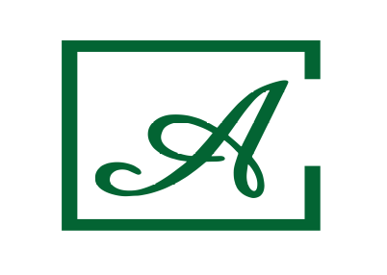

ALL INCLUSIVE DISCRIPTION

Hotel name: | AKTINIA
Destination: | BULGARIA, SUNNY BEACH

Meals:
All Inclusive on buffet:
Breakfast | 07:30-10:00
Lunch | 12:30-14:00
Dinner + show cooking | 18:00-21:00
Vegetarian meal  Ice cream | for lunch and dinner
Snacks, afternoon tea and coffee – in the main restaurant:  sandwiches, burgers, pizza, seasonal fruits, pastry, ice cream | 15:00-17:00
Drinks:
Local alcoholic drinks | 11:00-23:00
Local alcohol-free drinks | 7:30-23:00
Alcoholic cocktails (from inclusive beverages) | 11:00-23:00
Sport and entertainment:
Outdoor swimming pool, free umbrellas and sun loungers by the pool (upon availability) | 09:00-18:00
Animation for adults - activity and entertainment programme for adults – 6 times per week | According to the animation program
Kid's animation /04-08 years/ - daytime entertainment programme for children , mini disco in the evening – 6 times per week | According to the animation program
Free WiFi access - free of charge in the entire hotel | 24 hours
Baby cot | free of charge

