Since winter of 2017 „Prestige Deluxe Hotel Aquapark Club” is part of Prestige Hotels’ family! Completely renovated, the 4-starred hotel welcomes his rst tourists in the Summer of 2018!
ntroduction
Right in the heart of Golden sands among natural green park, having excellent location 350m from the beach and the main promenade, it is a hotel with both luxury and family oriented facilities.
We offer accommodation in:
- 137х Double Deluxe rooms
  - 7х Deluxe Family rooms
- 5x Two-bedroom Deluxe Suites
  - 7x Premium rooms

NEW!!! Starting from Summer 2020, we will offer PRIVATE BEACH ZONE with FREE shuttle!

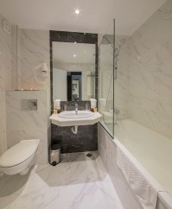
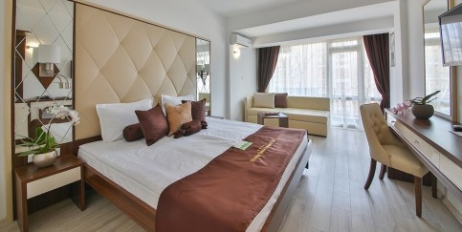
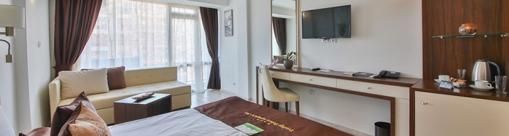Double Deluxe room / ~31 m2 – consist of: Double bed, extendible sofa, table, individual air-conditioner, 32” LCD TV with satelite television, safe, telephone, bathroom (with bathtub or shower cabin) with hair-dryer and cosmetic kit, mini fridge, electric kettle, one-time supply of coffee and tea, bathrobes & slippers, balcony. The hotel offers Double Deluxe rooms with connecting door.

Two-bedroom Deluxe Suite
Double Deluxe room

Two-bedroom Deluxe Suite / ~55 m2 – two bedrooms, which offer: Double bed & extendible armchair in rst bedroom, two separate beds in second bedroom, individual air-conditioner in each room, LCD TV's in each room with satelite television, safe, telephone, mini fridge, bathroom with hair-dryer and cosmetic kit, second toilet, electric kettle, one-time supply of coffee and tea, bathrobes & slippers, balcony.
Deluxe Family room / ~40 m2 – one room, consist of : Double bed, extendible sofa, exten- dible armchair, table, individual air-conditioner, 32” LCD TV with satelite television, safe, tele- phone, mini fridge, bathroom with hair-dryer and cosmetic kit, electric kettle, one-time supply of coffee and tea, bathrobes & slippers, balcony.

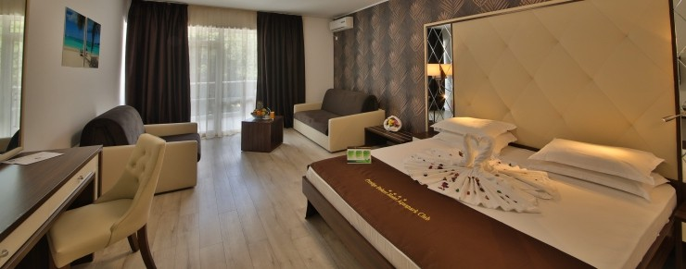

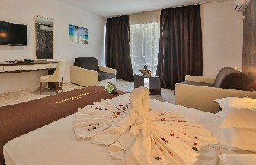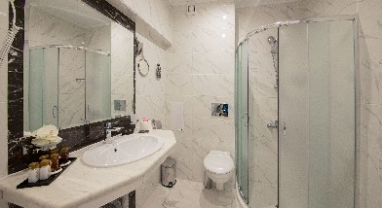

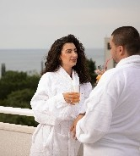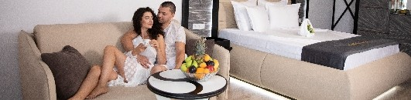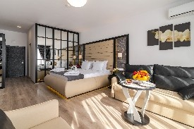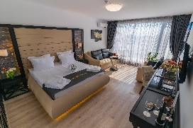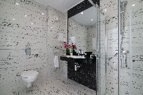Premium room / ~40 m2 – on top oor, which offers: Double bed, extendible sofa, extendible armchair, table, individual air-conditioner, 43” LCD SMART TV with satelite television, safe, telephone, mini fridge, bathroom with hair-dryer and cosmetic kit, electric kettle, one-time supply of coffee and tea, bathrobes & slippers, balcony.
Premium room
Deluxe Family room

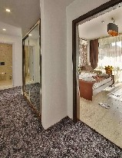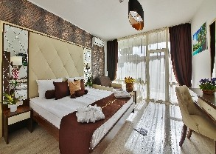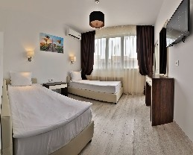

The All Inclusive concept of Prestige Deluxe Hotel Aquapark Club allows you to enjoy your summer vacation at maximum, giving you the chance to take advantage of TWO hotels facilities for FREE!
All
nclusive concept

Enjoy having a late breakfast, afternoon snack, ice-cream, popcorn, semi-frozen drinks, alcoholic & non-alcoholic drinks, coffee & tea at many pla- ces! At our guests disposal are:
Prestige Dine around
- 2x Lobby bars
- 2x Pool bars
- 1x Pastry shop
- 1x A-la-carte restaurant “Premium”*
- 2x All inclusive restaurants*
- Coffee machines and water dispensers at each
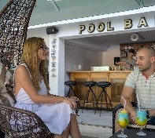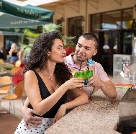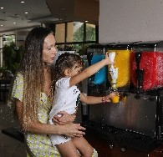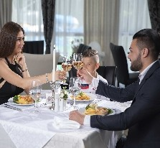oor in the hotel

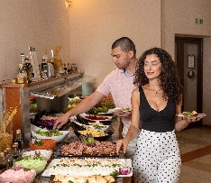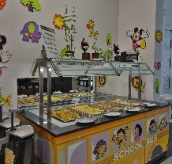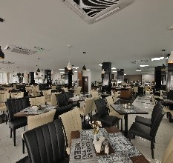*Guests of Prestige Deluxe Hotel Aquapark Club can enjoy main meals at the All inclusive restaurant (breakfast, lunch or dinner) and a-la-carte dinner at Prestige Hotel & Aquapark with prior reservation!

2>1! Relax your senses at 2xSPA centers with free use of the following facilities:
Spa facilities
- 2x Indoor pools with heated pools (28-30C)
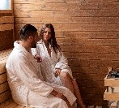
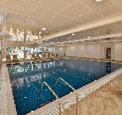
- 2x Jaccuzzi
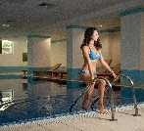
- 2x Sauna
- 2x Fitness

With additional charge are offered the following services: Turkish bath; Steam bath; Salt sauna, Massages; Beauty salon & Hairdresser
Dive into the Summer with our 2 Aquaparks! Our guests can use for free not only our Aquapark, but Prestige Hotel & Aquapark’s too! Live a complete water adventure!
- 1x pool with big water slides
Water adventures x2
- 1x pool with big and small water slides
- 1x separate children pool with small water slides (pirate ship, four fountains and four slides)
- 1x relax pool
- sun-beds and parasols around all pools
- pool towels
- sun-beds and parasols on the beach NEW!!!

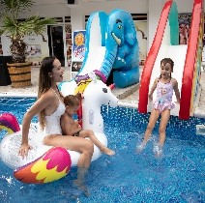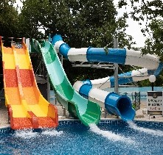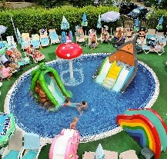

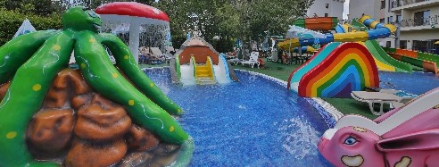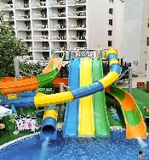
Children’s paradise

Prepare for your children to experience their true paradise! They will be able to enjoy the following activities:
- 2x Children playgrounds
- 1x Open-air children Fun center
- 4x Table tennis
- 4x Trampolines
- 4x Billiard tables
- 1x Table football
- 1x Darts
- 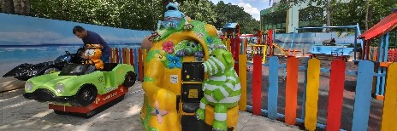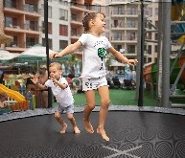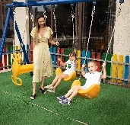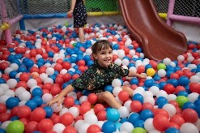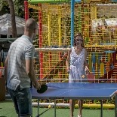5x Electronic entertainment games for small kids

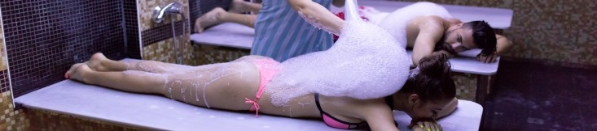



All nclusive program
Included free services by hours
Food and bavareges Activities

Main restaurants:
-07:30 – 10:00 – Breakfast on buffet – with hot drinks, juices, mineral water, coffee, tea
-12:00 – 14:00 – Lunch on buffet – with soda, juices, mineral water, beer, wine
-18:00 – 21:00 – Dinnet on buffet – with soda, juices, mineral water, beer, wine
-Themed dinners
Pastisserie:
-10:30 – 11:30 – snacks, sandwiches, popcorn, sweets, ice-cream, fruits
-15:00 – 17:00 – sandwiches, pizza, french fries, vegetables, sweets, ice-cream, fruits, popcorn
-10:00 – 17:00 – all kinds of hot drinks, soft drinks, beer, wine, bulgarian alcohol, cocktails
Lobby bars:
-10:00 – 23:00 – all kinds of hot drinks, soft drinks, beer, wine, bulgarian alcohol, cocktails
-After 23:00h all consumation is extra charged
Pool bars:
-10:00 – 23:00 – all kinds of hot bavereges, soft drinks, beer, wine, bulgarian alcohol, coctails
-10:30 – 11:30 – snacks, sandwiches, popcorn, sweets, ice-cream, fruits
-15:00 – 17:00 – sandwiches, pizza, french fries, vegetables, sweets, ice-cream, fruits, popcorn
*Coffee machines and water dispensers on every oor of the hotel

Animation
Children animation (4 – 12 y.o.)
-Kids club – children bingo, games with ball, water games, musical games, pirate games etc.
-Kids' play room
-Mini disco
Sport animation – gymnastic, zumba, streching, aerobics, boccia, darts, water gymnastic, water ball, volleyball, football, table tennis, shulbak, shufeboard etc. according to the set hours of the animation program;
Evening entertainment – 6 times per week
Beach zone: 09:00 - 18:00
Outdoor pools: 09:00 - 18:00
  - pool with water slides for big and small
  - pool with big water slides
  - children pool with small water slides and fountain
  - relax pool
  - jaccuzzi
  - lifeguard provided
  - sun-beds and parasols
  - pool towels complimentary
Indoor heated pools: 09:00 - 18:00
  - heated 28-30 degrees
  - sun-beds complimentary
  - lifeguard provided
  - pool towels complimentary
SPA centers: 09:00 - 18:00
  - sauna
  - jaccuzzi
  - tness
Children activities: unguarded, 24/7
  - children playgrounds
  - open-air children Fun center
  - trampolines
  - electronic entertainment games for small kids
Table tennis: 09:00 - 18:00
Billiard: 09:00 - 18:00
Darts: 09:00 - 18:00
Table football: 09:00 - 18:00

Wi-Fi among the whole hotel: 24/7
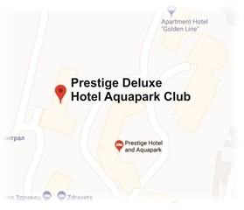
Guarded parking lot: 24/7

