Since winter of 2016 „Prestige Hotel & Aquapark” is part of Prestige Hotels’ family! Partially renovated, the 4-starred hotel welcomes his rst tourists in the Summer of 2017!
Introduction
Having splendid location only 150m from the beach and the main promenade, it is a hotel with family oriented facilities. We offer accommodation in:
- One-bedroom apartments
  - Studios
- Double rooms
- Premium rooms
NEW!!! Starting from Summer 2020, we will offer PRIVATE BEACH ZONE with FREE shuttle!
One-bedroom apartment

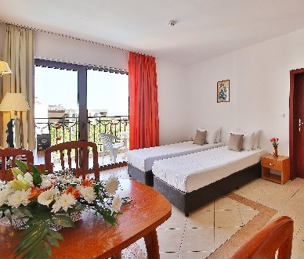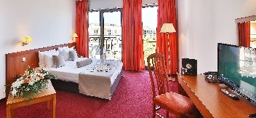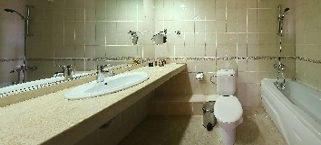Double room / 17 m2 – consist of: Two separate beds, 32” LCD TV with satelite television, safe, telephone, bathroom with hairdryer and cosmetic kit, balcony with sea view or park view.
Double room

One-bedroom apartment / 45m2 – consist of: Bedroom, kitchenette, extendible sofa, air-conditioner, mini fridge, 32” LCD TV, satelite television, safe, telephone, bathroom with hairdryer and cosmetic kit, two toilets, balcony with sea or park view.
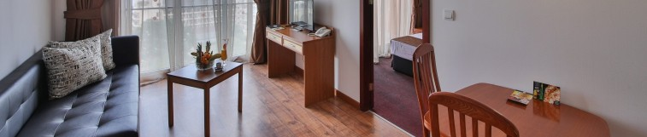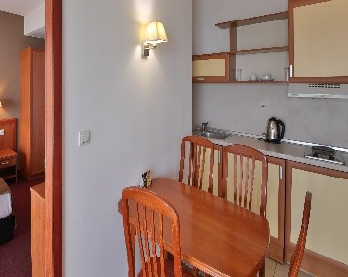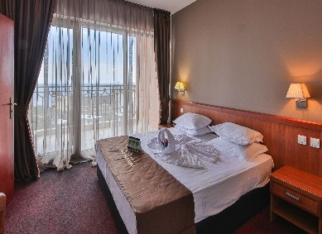
Premium room

Premium room / ~31 m2: Double bed, extendible s o f a , e x t e n d i b l e a r m c h a i r , t a b l e , i n d i v i d u a l air-conditioner, 43”LCD SMART TV with satelite television, safe,telephone, mini fridge, bathroom with hair-dryer and cosmetic kit, electric kettle, one-time supply of coffee and tea, bathrobes & slippers, balcony.

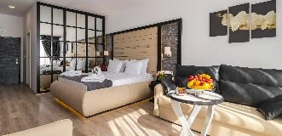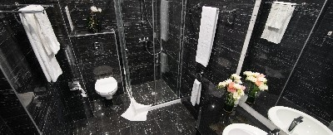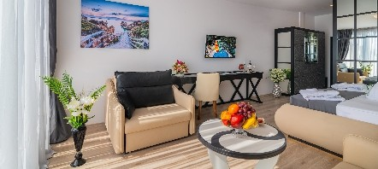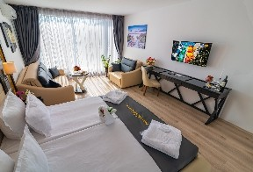

The All Inclusive concept of Prestige Hotel & Aquapark allows you to enjoy your summer vacation at maximum, giving you the chance to take advantage of TWO hotels facilities for FREE!
All
nclusive concept

Prestige Dine around Water adventures x2

Enjoy having a late breakfast, afternoon snack, ice-cream, popcorn, semi-frozen drinks, alcoholic & non-alcoholic drinks, coffee & tea at many pla- ces! At our guests disposal are:
- 2x Lobby bars
- 2x Pool bars
- 1x Pastry shop
- 1x A-la-carte restaurant “Premium”*
- 2x All inclusive restaurants*
- Coffee machines and water dispensers at each
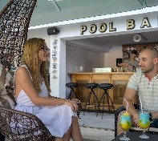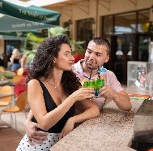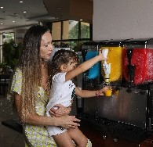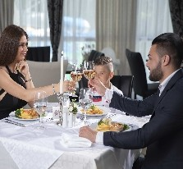oor in the hotel

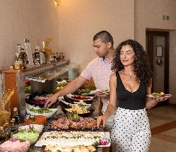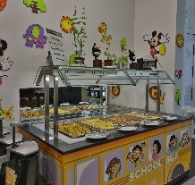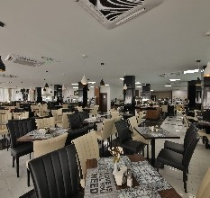*Guests of Prestige Hotel & Aquapark can enjoy main meals at the All inclusive restaurant (breakfast, lunch or dinner) and a-la-carte dinner at Prestige Deluxe Hotel Aquapark Club with prior reservation!

Spa facilities
2>1! Relax your senses at 2xSPA centers with free use of the following facilities:
- 2x Indoor pools with heated pools (28-30C)
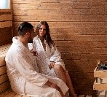
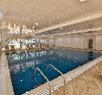
- 2x Jaccuzzi
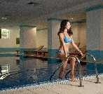
- 2x Sauna
- 2x Fitness

With additional charge are offered the following services: Turkish bath; Steam bath; Salt sauna, Massages; Beauty salon & Hairdresser
Dive into the Summer with our 2 Aquaparks! Our guests can use for free not only our Aquapark, but Prestige Deluxe Hotel Aquapark Club’s too! Live a complete water adventure!
- 1x pool with big water slides
- 1x pool with big and small water slides
- 1x separate children pool with small water slides (pirate ship, four fountains and four slides)
- 1x relax pool
- sun-beds and parasols around all pools
- pool towels
- sun-beds and parasols on the beach NEW!!!

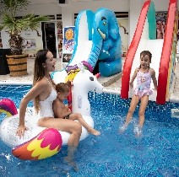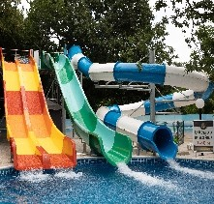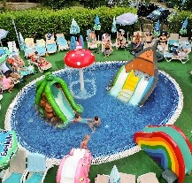

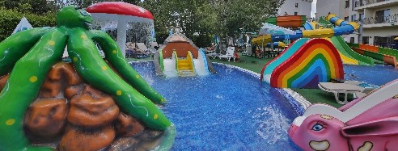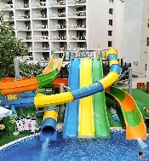
Children’s paradise

Prepare for your children to experience their true paradise! They will be able to enjoy the following activities:
- 2x Children playgrounds
- 1x Open-air children Fun center
- 4x Table tennis
- 4x Trampolines
- 4x Billiard tables
- 1x Table football
- 1x Darts
- 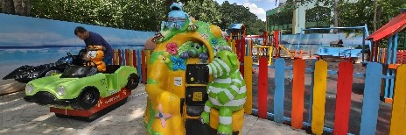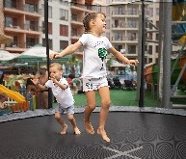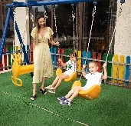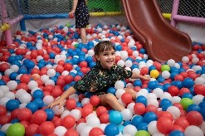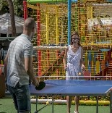5x Electronic entertainment games for small kids

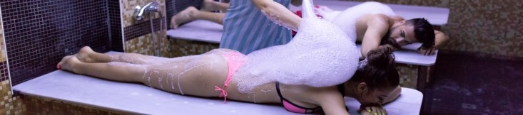


All nclusive program
Included free services by hours
Food and bavareges Activities

Main restaurants:
-07:30 – 10:00 – Breakfast on buffet – with hot drinks, juices, mineral water, coffee, tea
-12:00 – 14:00 – Lunch on buffet – with soda, juices, mineral water, beer, wine
-18:00 – 21:00 – Dinnet on buffet – with soda, juices, mineral water, beer, wine
-Themed dinners

Pastisserie:
-10:30 – 11:30 – snacks, sandwiches, popcorn, sweets, ice-cream, fruits
-15:00 – 17:00 – sandwiches, pizza, french fries, vegetables, sweets, ice-cream, fruits, popcorn
-10:00 – 17:00 – all kinds of hot drinks, soft drinks, beer, wine, bulgarian alcohol, cocktails

Lobby bars:
-10:00 – 23:00 – all kinds of hot drinks, soft drinks, beer, wine, bulgarian alcohol, cocktails
-After 23:00h all consumation is extra charged

Pool bars:
-10:00 – 23:00 – all kinds of hot bavereges, soft drinks, beer, wine, bulgarian alcohol, coctails
-10:30 – 11:30 – snacks, sandwiches, popcorn, sweets, ice-cream, fruits
-15:00 – 17:00 – sandwiches, pizza, french fries, vegetables, sweets, ice-cream, fruits, popcorn
*Coffee machines and water dispensers on every oor of the hotel

Animation
Children animation (4 – 12 y.o.)
-Kids club – children bingo, games with ball, water games, musical games, pirate games etc.
-Kids' play room
-Mini disco
Sport animation – gymnastic, zumba, streching, aerobics, boccia, darts, water gymnastic, water ball, volleyball, football, table tennis, shulbak, shufeboard etc. according to the set hours of the animation program;
Evening entertainment – 6 times per week
Beach zone: 09:00 - 18:00
Outdoor pools: 09:00 - 18:00
- pool with water slides for big and small
- pool with big water slides
- children pool with small water slides and fountain
- relax pool
- jaccuzzi
- lifeguard provided
- sun-beds and parasols
- pool towels complimentary

Indoor heated pools: 09:00 - 18:00
- heated 28-30 degrees
- sun-beds complimentary
- lifeguard provided
- pool towels complimentary

SPA centers: 09:00 - 18:00
- sauna
- jaccuzzi
- tness

Children activities: unguarded, 24/7
- children playgrounds
- open-air children Fun center
- trampolines
- electronic entertainment games for small kids
Table tennis: 09:00 - 18:00
Billiard: 09:00 - 18:00
Darts: 09:00 - 18:00
Table football: 09:00 - 18:00

Wi-Fi among the whole hotel: 24/7
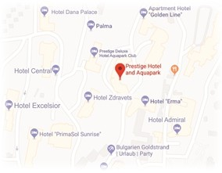
Guarded parking lot: 24/7

