Effect Algara Beach Club Hotel ****

All Inclusive Description

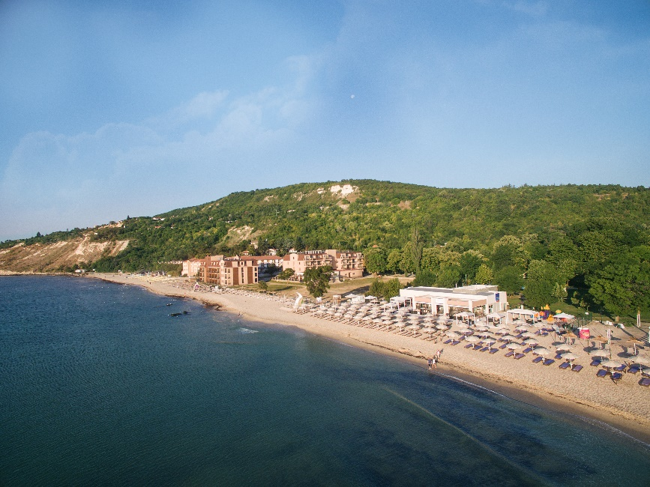

Restaurants and bars

Main restaurant „ Algara“

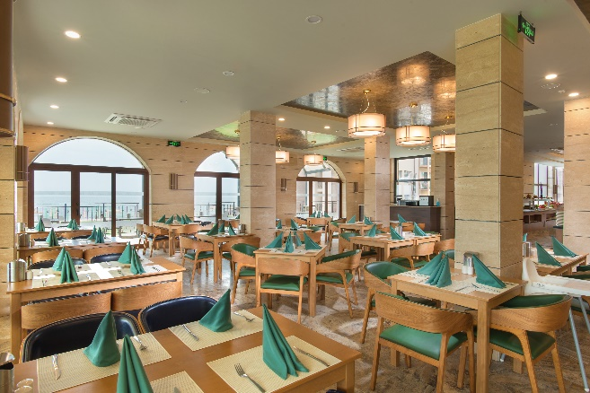

- Breakfast:buffetstylefrom 7:30 to 10:00 (free – water, juice, hot drinks)
- Lunch:buffetstylefrom 12:30 to 14:30 (free – wine, beer, water, juice, softand hot drinks)
- Dinner:buffetstylefrom 18:30 to 21:00 ( free – wine, beer, water, juice, softand hot drinks)
- Themed dinners
- Dry package or snack in the main restaurant for late arrivals and early departures.
- Imported alcohol and bottled drinks – at extra charge (for royal guests, imported alcohol is free) .

Beach bar„ Mirage“ / Mediterranean a-la-carte restaurant:

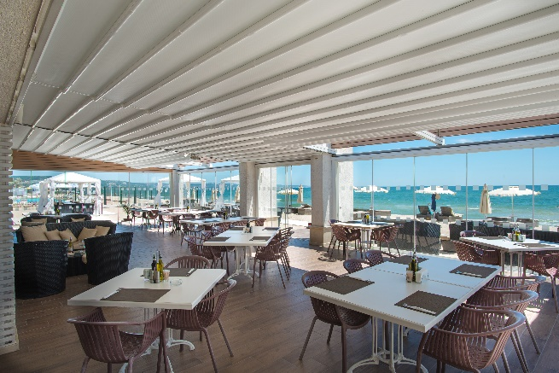

- Continental breakfast:from 10:00 to 11:00
- Snack:from 11:00to 17:00
- Dinner:from18:30 to 22:00
- 1 dinner per stay in the Mediterranean restaurant, included in the All Inclusive price. Applied for a minimum stay of 4 nights. Pre-registration required.
- Bulgarian alcohol, beer, wine, hot drinks, cocktails from the all-inclusive menu.
- Imported alcohol and bottled drinks – at extra charge(for royal guests, imported alcohol is free) .

Bulgarian a-la-carte restaurant„ Oresha“

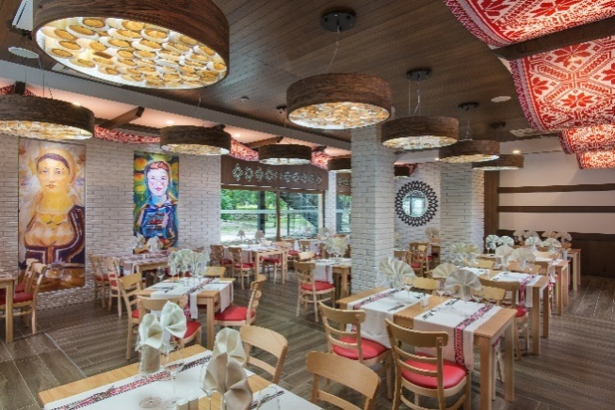

- Dinner:from18:00to 22:30
- 1 dinner per stay, included in the All Inclusive price. Applied for a minimum stay of 4 nights. Pre-registration required.
- Bulgarian alcohol, beer, wine, hot drinks, cocktails from the all-inclusive menu.
- Imported alcohol and bottled drinks – at extra charge(for royal guests, imported alcohol is free) .

Lobby bar

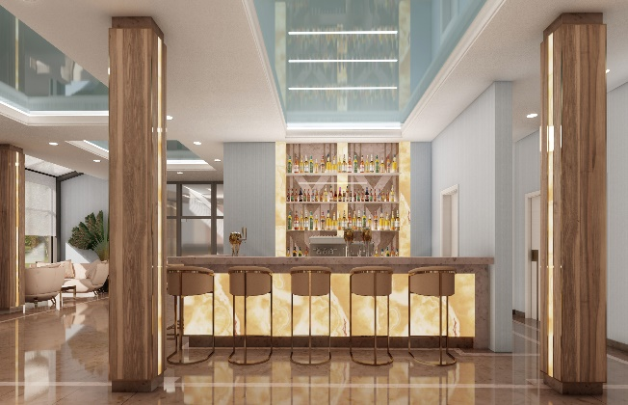

- Opening hours:from 08:00 to 24:00
- Bulgarian alcohol, beer, wine, hot drinks, cocktails from the all-inclusive menu.
- Imported alcohol and bottled drinks – at extra charge.

* All inclusive of all bars ends at 23:00.

Beach and Pool

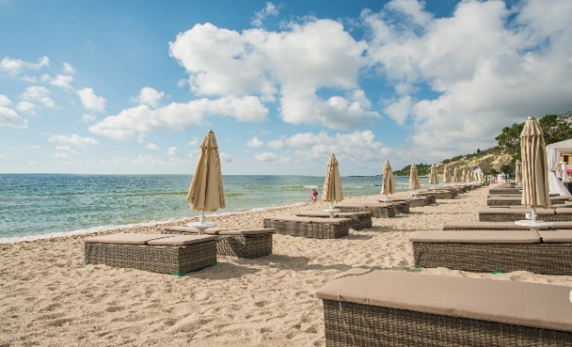

Outdoorswimming poolforadults(withmineralwater)
- Free sunbeds and parasols

Outdoorswimming poolforchildren (withmineralwater)

Children’s splash pool with attractions

Beach
- Free sunbeds and parasols
- Beach towels - against deposit

Sport and Entertainment

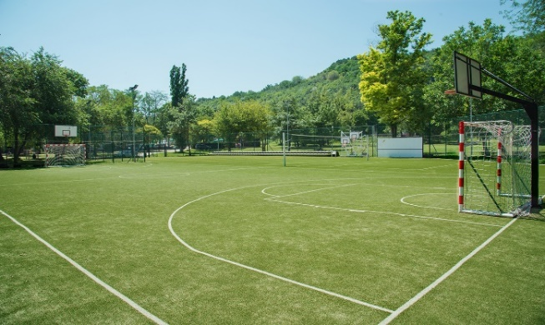

Multifunctionalplaygroundwithartificial turf(tennis, football, basketball,volleyball, archery)
- Free usefrom 08:00 to 17:00
- From 17:00 to 00:00 – 25BGNperhour

Animation
- 6 times a week – animation for children, sport, mini disco и evening show programs;
- Implemented concept for families with children “Katta Macht Urlaub”, developed by our main partner Schauinsland Reisen

Other activities
- Beach volleyball, beach football
- Table tennis
- Bicycle for rent
- Water sports on the beach – at extra charge

Other services
- Free parking (1 car per room)
- Freeinternet - in the room, indoor and outdoor common areas
- Mini market
- Massages – at extra charge
- Mini bar in the room – at extra charge; for royal guests- free water, beer, soft drinks.
- Check-in after 14:00 and Check-out before 12:00
- EarlyCheck-inandLateCheck-out – depends on the hotel’s availability; at extra charge.
- All Inclusive starts with lunch on the day of arrival and ends with breakfast on the last day

Royal Club

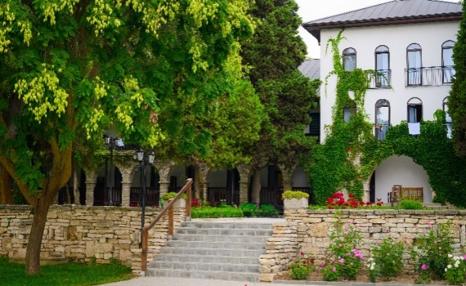

- Accommodation in royal rooms, apartments and villas
- Priority Check-in and Check -out
- Imported alcohol at the bars from a menu
- Freeminibar (water, beer, soft drinks) – daily replenished
- Coffee machine with capsules in the room - daily replenished
- Pillow menu
- Highspeed internet
- High quality cosmetics in the bathroom
- Discount for laundry service

* The Hotelier reserves the right to change the opening hours of all bars, restaurantsand the prices of the extra services.
There may be changes in the services in the low season.

