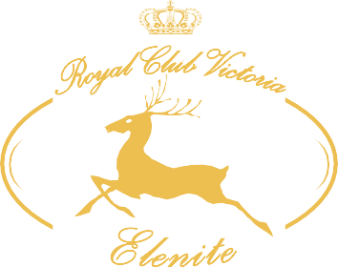
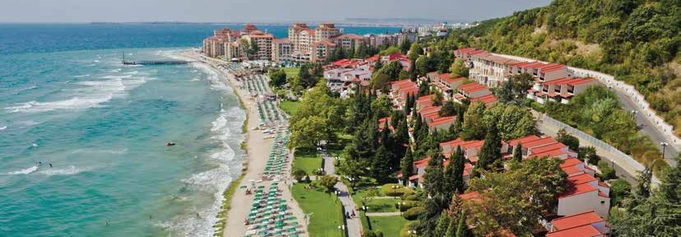
ROYAL CLUB VICTORIA, ELENITE

OUR PROMISE
ALL

INCLUSIVE

SUMMER 2021

Our primary goal is to make your vacation an extraordinary memory. For us, it is essential to know whether you need our special attention.
We will listen to you and ﬁnd a solution. We oﬀer many ways for you to share your opinion during your stay and after.
GUEST RELATIONS | guestrelations@victoriagroup.bg

IDENTIFICATION
All guests on All Inclusive board must be identiﬁed by their plastic bracelets.
RETURN| Upon leaving the hotel.
LOST | Fee 30.00 BGN.
Plastic bracelets for coresponding hotel are required from all guests to access the main restaurant during the main meals ( breakfast, lunch, and dinner).

COVID-19 MEASURES
Our guests’ safety is important to us, so our team accepted additional rules and anti-epidemic measures for prevention and control on the territory of the complex and the adjacent sites, all compliant and by the recommendations of health authorities.
ALL MEASURES | www.victoriagroup.bg/covid-19-measures/

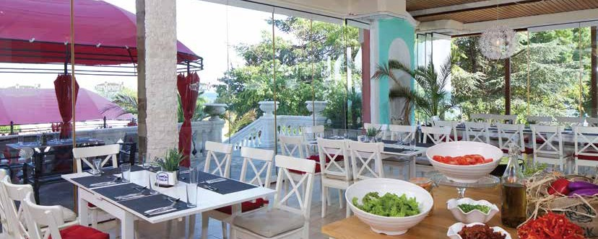

RESTAURANTS

MAIN RESTAURANT | IN THE HOTEL YOU ARE STAYING
Breakfast– 7.30 – 10.00 | Lunch – 12.30 – 14.30 | Dinner – 18.30 – 21.00 |
If necessary, hourly sittings and extension of working hours will be applied to avoid crowding Buﬀet, salads, soups, starters, main dishes, desserts, fruit, non-alcoholic beverages, beer, wine, coﬀee/tea at breakfast.

A-LA CARTE RESTAURANTS
Fixed 4 component A-la carte menu (salad, starter, main course and dessert) and All-inclusive alcoholic and non-alcoholic beverages. The A-la carte package is available and outside the
All Inclusive with a extra charge - 29.00 BGN per adult, 14.00 BGN per child

MEDITERRANEAN RESTAURANT
Working hours: 18.00 – 22.30 | 15.06 -31.08
European and Mediterranean cuisine

ITALIAN RESTAURANT
Working hours:18.00 – 22.30 | 01.06 - 15.09
Italian cuisine

HOW TO BOOK A-LA CARTE RESTAURANTS

A-la carte restaurants become a part of your All Inclusive programme with minimum 4 nights stay. Preliminary booking is required. Reservations are made in the mornings with the Guest Relations Oﬃcer in the hotel you are staying and according the occupancy of the restaurants.
The number of visits included in you package depends of the length of your stay.

FROM 4 TO 7 NIGHTS| 1 visit
FROM 8 TO 15 NIGHTS | 2 visits
OVER 15 NIGHTS | 3 visits

IMPORTANT! A-la carte restaurants seats are limited and are subject to availability. A la Carte reservations are only available with your plastic bracelet.

SNACKS & DRINKS|IN THE TERRITORY OF THE COMPLEX 

GYROS | Cental Alley
Working hours: 10.00 – 17.00 | 01.06 - 15.09 |
Gyros
HOT-DOG & SPRING ROLLS | Cental Alley Working hours: 10.00 – 17.00 | 01.06 - 15.09 | Hot dog and spring rolls / mini roll of crusts with ﬁlling /
BURGERS| Pool bar Royal Park
Working hours: 10.30 – 17.00 | 01.06 - 15.09 |
Burgers

FORNETTI
Working hours: 10.00 – 16.30 | 01.06 - 15.09 | Sweet and savory fornetti
GELATERIA| Cental Alley
Working hours: 10.00 – 16.30 | 01.06 - 20.09 | Various types of ice cream
LOBBY BAR | In the hotel you are staying
Working hours: 10.00 – 24.00
Bulgarian alcoholic and soft drinks, beer and wine, coﬀee, cappuccino, hot chocolate and tea and sweets
POOL BAR ATLANTIDA | Aqua Park
Working hours: 10.00 – 17.00 | 01.06 - 15.09 |
Ice cream, beer and soft drinks, juices, tea, coﬀee,
cappuccino, hot chocolate
POOL BAR | Hotel Royal Bay
Working hours: 10.30 – 17.00 | 01.06 - 15.09 |
Ice cream, beer and soft drinks, juices, tea, coﬀee,
cappuccino, hot chocolate
POOL BAR | Hotel Royal Park
Working hours: 10.30 – 17.00 | 01.06 - 15.09 |
Ice cream, beer and soft drinks, juices, tea, coﬀee,
cappuccino, hot chocolate

POOLS|IN THE TERRITORY OF THE COMPLEX 
SUNBED AND PARASOL | Working hours: 09.00 – 18.00
They are a part of the All Inclusive board and can be used on the each swimming pool in front of the corresponding hotel, subject to availability.
All umbrellas and sunbeds are arranged according to the requirements of the Ministry of Tourism.
IMPORTANT!
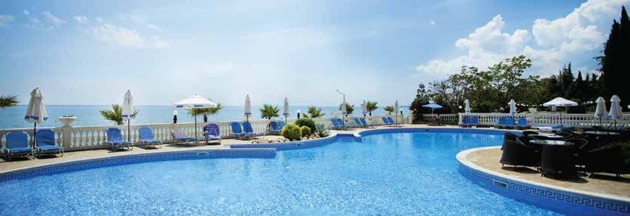
Towels placed on sunbeds in advance are considered to be forgotten, and our staﬀ will remove them.

Version: 12.01.2021 The hotel reserves the right to make changes.
Please, always double-check if you are using the latest version at www.victoriagroup.bg/hotel-packages-descriptions/?lang=en

ANIMATION & ACTIVITIES|IN THE TERRITORY OF THE COMPLEX 
ANIMATION | 01.06 - 15.06
Daily program with various entertaining activities for adults and children and evening anima-
tion includes various evening shows.
In connection with Covid-19, the animation will be held only outdoors!

AQUAPARK ATLANTIDA
Working hours: 10.00 – 17.00 | 01.06 - 15.09 Sunbeds and umbrella at Aqua Park might be used free of charge, subject to availability.

CHILDREN CLUB
Working hours:
10.00 – 12.00 & 15.00 – 17.00| 01.06 - 15.09
Welcomes children between 4 and 12 years old It will work with reduced capacity and physical distance
DAY OFF: Monday

TENNIS
Working hours: 09.00 – 21.00 | 01.06 - 15.09 | Free of charge using of the court.

FITNESS CENTER & TABLE TENNIS
Working hours: 09.00 – 19.00 | 01.06 - 15.09 |

MINI GOLF
Working hours: 09.00 – 11.00 & 17:00 – 21:00 |
01.06 - 15.09 |
Free use of the golf course. Renting a stick and a ball - deposit of 30.00 BGN. Equipment is sub- ject to availability.

ADDITIONAL SERVICES & ACTIVITIES | 

IN THE TERRITORY OF THE COMPLEX

INTERNET
Free basic internet at the lobby and
reception in each hotel of the complex

SAFE BOX
Free use of in-room safe

SPA CENTER HOTEL ROYAL CASTLE
Access for an additional fee to the indoor pool,
sauna, steam bath, ice bucket, massages, etc.

MINI MARKET
Working hours: 09.00 – 20.00
Drinks, souvenirs and beach accessories

OTHERS
PARKING
Parking price – 12.00 BGN per day, per car. Parking spaces are subject to availability and reservation is not possible

PET POLICY
The hotel allows dogs up to 5 kg. Paid at the reception - 10.00 BGN per day, per pet

Telepfone, taxi, rent-a car, curency exchange, medical service
CHANGES|
VERSION: 12.01. 2021
The hotel reserves the right to make changes, including changing the dates and times of opening and closing of services and facilities.
Please always check if this is the latest version at: www.victoriagroup.bg/hotel-packages-description

