GrifidClub Hotel Arabella is located on the marvelous sandy coast of Black Sea, in the seaside resort Golden Sands. It is a hotel with club character offering a relaxing atmosphere for the entire family. It is famouswith its high quality, excellent service and pleasant ambience.Because of the variety of the product and the unsurpassed service, you will spend a holiday to remember.

Highlights and new services
- NEW: French club with professional animators
- NEW: Pop up BBQ event (July- August)
General information
- ULTRA All inclusive basis
- 8-floor one main building
- 100m from the beach
- 15km from Varna
- 30km from Varna Airport
- 50m from the center of the resort
- 50m from the shopping center
- 500m from a public bus station
- Languages spoken : Bulgarian, English, German, French, Russian
- 24-hours Front desk&24 hours security
- Guest Relation services – taking care of all little details that matter for your stay
- Main restaurant, 3 a la carte restaurants /Asian, Bulgarian, Italian/, Snack restaurant, Coffee shop
- Lobby bar, Pool bar, Night bar offers variety of local and international alcoholic and non-alcoholic beverages
- Facilities in public areas are wheelchair accessible (except the beach location)
- Parking – limited and against charge
- Grifid Souvenir Shop
- Free Wi-Fi connection in hotel lobby area
- Taxi&Rent-a-car services
- Laundry service
- Currency exchange
- Shop
- Doctor
- Gym, Wellness & Relax center
- PC room with internet access (additional charge)
- Entertainment, sport activities and animation program for adults & children
- Grifid Aqua Parklocated in a Grifid Hotel Bolero and operates in June-September /weather depending/, free of charge and can be accessed by all hotel guests – transfer to and from Aquapark is two times per day
- Certificated by Travelife
Accommodation
- Check-in time –from 14:00h – starts with snack menu
- Check-out time – until 12:00h – ends with continental breakfast
- 2013 complete renovation of all hotel rooms
- 2014 complete renovation of all family rooms
- 294hotel rooms all with sea side view, most with sea view
- All rooms are with bathrooms with bathtub and shower in it
- Hairdryer and cosmetic mirror
- International dialing phone
- Central air conditioning system
- Satellite TV
- Free Wi-Fi connection
- In-room safe (additional charge)
- Mini bar – free of charge, daily restocked /water, soft drinks, beer/
- All rooms are with carpet floor, some junior suites also with laminated floor
- Balcony
- Tea & Coffee facilities in all junior suites & family rooms
- Pillow menu&Top mattress menu/against charge/ – upon request
- Baby cots – free of charge

The early check-in and late check-out are according the capacity of the hotel and are a subject of additional payment.
Restaurants – part of ULTRA All inclusive basis

Arabella Main Restaurant
Spacious hall with belonging open-air terrace overlooking the pool.
Opening hours:
Breakfast 07:30 – 10:00 buffet
Lunch 12:30 – 14:00 buffet
Dinner 18:00 – 21:30 buffet
- Capacity: 250 seats inside and 90 seats on the terrace
- Buffet breakfast, lunch and dinner
- Varied culinary delights offered from on spot cooking, carving, pizza and pasta stations; diet, salad and delicious pastry buffets
- Beverage buffet with mineral water, soft drinks, beer and country wine
- Highchairs for children
- Culinary thematic buffets – 2 times per week
- Gala dinner – once in 10 days
- Nonsmoking inside

Dress code for Gala dinner required (gentlemen with long trousers)

Snack Restaurant
Situated in the zone of the “quiet” pool outside the main building. Offers meals in the welcoming sun lighted terrace.
Opening hours:
Continental breakfast 10:00 – 12:00 table service
Lunch 12:00 – 15:00 buffet
Afternoon Snack 15:00 – 17:00 buffet
  - Capacity: 100 seats
  - Buffet for all meals(time depending) – Sandwiches, Hot Dog, Pizza ,Dönner, Burgers, Pancakes, Salads, Fruits
  - Beverage buffet with mineral water, soft drinks, coffee, beer and country wine

Bulgarian a la carte Restaurant “Horo”
Situated outside the main building next to the “quiet” pool. The guests are welcomed in the atmosphere and style of the typical Bulgarian house.
Opening hours:
Dinner 18:30 – 21:30 table service

  - Capacity: 56 seats
  - A la carte service and traditional Bulgarian menu for dinner
  - Beverages - mineral water, soft drinks, beer and country wine
  - Children’s menu& highchairs
  - advance reservation required
  - smoking is not allowed

Dress code for dinner required – long trousers for gentlemen

Asia a la carte Restaurant “Hanami”
Thematic a la carte restaurant with modern designer decoration and furnishing, own style and charm.
Opening hours:
Dinner 18:30 – 21:30 table service

  - Capacity: 60 seats
  - selection of Asia culinary specialties, delivered by attentive service
  - Beverages - mineral water, soft drinks, beer and country wine
  - Children’s menu& highchairs
  - advance reservation required
  - smoking is not allowed

Dress code for dinner required – long trousers for gentlemen

Italiana la carte Restaurant “Prego”
The restaurant offers culinary trip to Italy during the holiday. It boasts an elegant white salon and open-air terrace overlooking the pool and the outdoor stage of the hotel.
Opening hours:
Dinner 18:30 – 21:30 table service

  - Capacity: 60 seats inside and 28 on the terrace
  - A la carte service with variety of selected specialties from the Italian cuisine, pizza and home-made pasta
  - Beverages - mineral water, soft drinks, beer and country wine
  - Children’s menu& highchairs
  - advance reservation required
  - smoking is not allowed

Dress code for dinner required – long trousers for gentlemen

Bars – part of ULTRA All inclusive basis

Lobby Bar
“Two face” bar delivering beverages to the pool terrace and the elegant salon of the lobby bar. Indoor bar with section open towards the pool.
Opening hours:
10:00 – 23:00

- Capacity: 140 seats inside and 70 on the terrace outside
- Smoking is not allowed
- Ultra All inclusive offer features mineral water, international and local alcoholic beverages, non-alcoholic beverages and refreshing cocktails, coffee and tea, draught beer and country wine
- Bar service

Bar Salon
Spacious hall with own character and atmosphere. The perfect venue for evening entertainment programs and shows.

Opening hours:
22:00 – 02:00
  - Capacity: 180 seats
  - Ultra All inclusive offer features mineral water, internationaland local alcoholic drinks, non-alcoholic beverages and cocktails, coffee and tea, draught beer and country wine
  - bar service
  - discotheque after 23:00

Grifid Coffee Shop
Open air, green area, close to the swimming pool
Opening hours:
10:00 – 12:00
14:30 – 17:00
- Ultra All inclusive offer features cakes, cookies, crème, tartlets, ice cream, mineral water, non-alcoholic beverages, coffee and tea

Swimming pools & Wellness center
Outdoor pools:
Opening hours:
08:00 – 18:00
  - 2 outdoor pools with over 500 sq. m in total; depth - between 90 and 150 cm
  - Complimentary whirlpool integrated into the main pool
  - Children section with slide integrated into the main pool; depth 60 cm
  - Sun terraces by the pools
  - Complimentary sun lounges, parasols and towels
  - Life guard service provided

Indoor pool:

Opening hours:
09:00 – 18:00

  - Classic pool; dimensions: W7.00m/ L 22.00 m.
  - Heated
  - Complimentary sun lounges and towels
  - Life guard service provided

Beach services included

One parasol and two sun beds (with mattresses) per room on the beach available!

Children, accommodated free of charge, don’t receive the above services!

Wellness and Relax
Wellness Relax center Arabella offers the perfect combination of relaxing and revitalizing SPA temptations.
Opening hours:
09:00 – 18:00

All treatments, Sauna, Hamam, Beauty salon are additionally charged!
- Hamam with steam bath, Sauna, Hydro massage bath
- Relax zone
- Boutique – massage oils, fragrances and other body products
- Hairdresser, manicure and pedicure
- Massage rooms; Facial and body treatments and range of spa treatments
- Body and face cosmetic

Sport &Animation activities
FIT & FUN Zone
The zone is situated on the 8th floor and boasts outstanding panorama sea view

Opening hours:
08:00 – 20:00
It features:
- Fitness roomwith professional equipment by Technogym;
- Air conditioning
- Free access for all hotel guests
- Billiard, aero hockey, electronic mini football (additional charge)
WELL FIT ZONE
Open air for following activities:
- Gymnastics, Aerobics, Anti-stress gymnastic, Adventure walk, Pilates, Tae-Bo, Zumba, Nordic walk , Hot Iron, Back Fit, Fitball, Relaxing beach walk, Yoga
- Multipurpose playground for basketball, Tennis(floodlit court) ,Volleyball, Football, Foot tennis, Table tennis,
- Shuffle board
- Aqua gym, Aqua Jogging, Water polo
- Darts
- French bowls
- Bicycle tours
- Air riffle shooting

Evening shows – daily
Pop up BBQ event (July- August)
Disco
Animation program for teenagers (from 13 to 16 years old) with different sport activities

Grifid Mini club with daytime entertainment program for children:
Opening times:
10:00 – 12:30
15:00 – 17:30
- For children aged 4 to 12
- Mini disco – every day
- Children show once in 2 weeks
- Theme days and activities

Rooms
- Economy room – max. 2 persons; 16-20m² ; Park view
- Deluxe room – max. 2+1, 3+0; 26-30m²; Sea side view
- Deluxe room – max. 2+1, 3+0; 26-30m²; Sea view
- Junior suite – max. 2+2, 3+1, 30- 35m² ; Sea view; Coffee & Tea facilities free of charge
- Family room apartment – max. 2+2, 3+1, 50-55m²; Sea view; Coffee & Tea facilities free of charge

Paid Services
- Parking lot – limited
- Rent a car
- Safe in rooms
- Spa treatments in Wellness center
- Services in beauty salon
- Wine selection in all restaurants
- Baby sitter services ( for children up from 4years)
- Baby buggies & baby phone (on request)
- Tennis lessons for children and adults, Floodlit Tennis court
- Billiards, Electronic mini football
- Bicycle (when not part of the animation bicycle tour)

Mice
- Grifid Hotel Arabella provides one modern meeting room with capacity of 40 seats
- Coffee breaks, audio-visual equipment, flip charts and additional equipment and services available

Miscellaneous
- Pets arenot admitted
- Hotel reserves the right to change opening hours of the outlets if necessary.
- Under Bulgarian legislation it is not allowed to smoke in the hotel lobby, restaurant, bars and rooms
- Sun bed reservation is not accepted. Any unattended towels are removed from the pool and beach staff
- Any Food and Drinks could not be taken out of the restaurants due to Public and HACCP regulations

Contacts
Web site: www.grifidhotels.com
PHOTOS available at: http://grifidhotels.com/marketing/Grifid%20Arabella/
Covid-19 Safety and hygiene measures available at:https://grifidhotels.com/index.php?page=covid19health

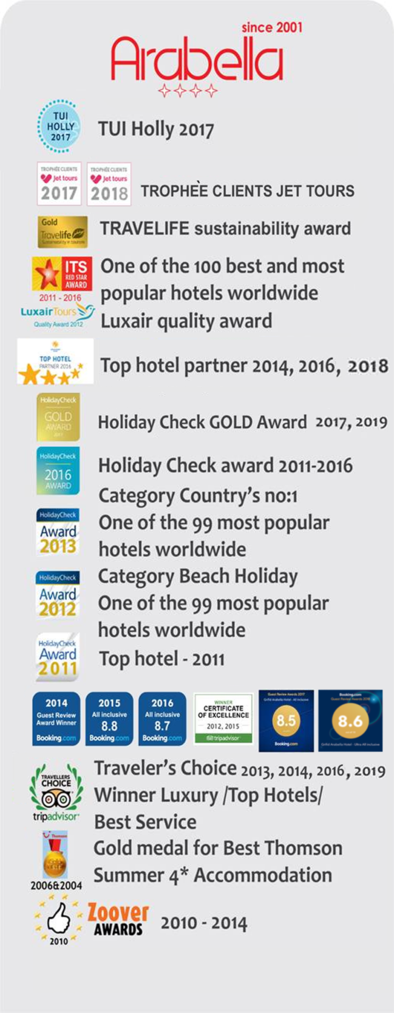
Awards

