Grifid Club Hotel Bolerois the second property of the Bulgarian hotel chain GRIFID HOTELS. Guided by the GRIFID's high standards of quality and unsurpassed service, a team of experienced professionals fulfills the company’s ongoing commitment to guest satisfaction.

Highlights and new services
- NEW: Pop up events (BBQ; beach parties : July - August)
- NEW: From season 2020 sauna and steam bath (against charge)
- NEW: Renewed Dine Around program – a great selection of A la carte Restaurants offers variety of moments by experiencing different cuisines in selected restaurants in GrifidVistamar and Metropol.
- NEW: Fusion restaurant in GRIFID Metropol is against charge!
- The Unique for Golden Sands Grifid Aqua Park
- Human Soccer play field
- 24 hours All inclusive (24 hours beverages and midnight snack from 23:30-00:30)
- Recently renovated family rooms – two deluxe rooms with interconnecting doors offer an option for accommodation of big families (min 4 – max 5 persons)

SPECIAL for the KIDS!
- The Grifid Mini Club shaped like a Pirate Ship
- Welcome party for all new arrived kids (pups show and presentation about Grifi story). A great way to get to know the hotel better and meet new friends.
- Aqua Mini disco in the Kids Aqua park (weather dependent)
- The Kids Club offers a whole day of supervised activities for ages 4 – 12 years old (in July-August with prolonged working time from 10a.m. to 20 p.m.)
- Kids yoga program
- NEW: Children buffet and dedicated kids area with chairs and tables in theTerrace restaurant
- Kids evenings parties (incl. Thematic parties in Mini Club) – against charge

General information
- 24 hours All inclusive (24 hours beverages and midnight snack)
- 3separated buildings
- 8 floors in the main building
- 50m from the beach
- 15km from Varna
- 30km from Varna Airport
- 500m from the center of the resort
- 500m from the shopping center
- 400m from a public bus station
- Languages spoken : Bulgarian, English, German, French, Russian
- 24-hours Front desk&24 hours security
- Guest Relation services – taking care of all little details that matter for your stay
- Main restaurant, 3 a la carte restaurants /Asian, Bulgarian, Mexican/, Terrace restaurant, Coffee shop , Midnight snack, Renewed Grifid Dine Around program
- Pool bar, Bar salon, Relax bar, Beach baroffers variety of local and international alcoholic and non-alcoholic beverages
- Parking –indoor garage limited and against charge
- Grifid Souvenir Shop
- Free Wi-Fi connection in hotel lobby area
- Taxi&Rent-a-car services
- Laundry service
- Currency exchange
- Doctor
- Gym, Wellness & Relax center
- Internet corner (additional charge)
- Entertainment, sport activities and animation program for adults & children
- Cooking classes
- Certificated by Travelife

Accommodation
- Check-in time –from 14:00h – starts with snack menu
- Check-out time – until 12:00h – ends with continental breakfast
- 304 hotel rooms
- 2016 renovation of 27 family rooms with pool view, carpet floor, one bedroom and separated by a sliding door room with two single beds, one bathroom with shower and two sinks, tea and coffee making facilities
- 2018 renovation of 271 double deluxe rooms with view to the pools and garden in the inside court; laminated floor, bathrooms with bathtub
- 6 suites with pool and garden view, with one living room, one bedroom and two bathrooms, one of them with shower
- Hairdryer
- Cosmetic mirror in bathrooms
- International dialing phone
- Central air conditioning system
- Satellite TV
- Free Wi-Fi connection
- In-room safe (free of charge)
- Mini bar – free of charge, daily restocked /water, soft drinks, beer/
- Balcony
- Pillow menu
- Top mattress menu – upon request
- Baby cots – free of charge
The early check-in and late check-out are according the capacity of the hotel and is a subject of additional payment.

Restaurants – part of All inclusive basis
Bolero Main Restaurant
Classical restaurant for breakfast, lunch and dinner, buffet style.
Opening hours:
Breakfast 07:30 – 10:00 buffet
Lunch 12:30 – 14:00 buffet
Dinner 18:00 – 21:30 buffet
- Capacity: 240 seats
- Buffet breakfast, lunch and dinner
- Varied culinary delights offered from on spot cooking, carving, pizza and pasta stations; diet, salad and delicious pastry buffets
- Possibility for gluten and lactose free dishes (upon request)
- Beverage buffet with mineral water, soft drinks, beer and country wine
- Highchairs for children
- Culinary thematic buffets – 2 times per week
- Gala dinner – once in 10 days
- Smoking is not allowed
Dress code for dinner required – long trousers for gentlemen.

Terrace Restaurant
Unique with its two spacious terraces and with excellent view to the garden of the hotel.

Opening hours:
Breakfast (in high season only)08:30 – 10:30 buffet
Continental breakfast 10:30 – 11:30 table service
Lunch12:00 – 14:00 buffet
Afternoon Snack 14:00 – 17:00 counter service
Dinner18:30 – 21:30 buffet

  - Capacity: 100 seats inside and 135 on both terraces
  - Buffet for all meals(time depending)
  - Afternoon Snack - Sandwiches, Hot Dog, Pizza ,Dönner, Burgers, Pancakes, Salads, Fruits – self service
  - Thematic culinary buffets – 2 times per week
  - Gala dinner – once in 10 days
  - Beverage buffet with mineral water, soft drinks, coffee, beer and country wine
  - Children buffet, chairs and tables
  - Nonsmoking inside
Bulgarian a la carte Restaurant “Old house”
Welcomes its guests in the atmosphere and spirit of typical Bulgarian house.
Opening hours:
Dinner 18:30 – 21:30 table service
  - Capacity: 60 seats
  - A la carte service and traditional Bulgarian menu for dinner
  - Beverages - mineral water, soft drinks, beer and country wine
  - Children’s menu& highchairs
  - advance reservation required
  - smoking is not allowed
Dress code for dinner required – long trousers for gentlemen

Asia a la carte Restaurant “Asia”
Culinary trip to the Far East in an elegant ambience and discreet service.
Opening hours:
Dinner 18:30 – 21:30 table service

  - Capacity: 54 seats
  - selection of exotic culinary specialties, delivered by attentive service
  - Beverages - mineral water, soft drinks, beer and country wine
  - Children’s menu& highchairs
  - advance reservation required
  - smoking is not allowed
Dress code for dinner required – long trousers for gentlemen

A la carte Restaurant “Tex-Mex”
Open air restaurant offers traditional Mexican cuisine
Opening hours:
Dinner 18:30 – 21:30 table service
  - Capacity: 60 seats
  - Beverages - mineral water, soft drinks, beer and country wine
  - Children’s menu& highchairs
  - advance reservation required
  - smoking is not allowed
Dress code for dinner required – long trousers for gentlemen
Renewed Grifid Dine Around Program – a diverse and complimentary choice of a la carte restaurants with variety of cuisine types for our guests. Bulgarian, Asian, Tex-Mex as well Rodizio, selected restaurants in Metropol Mongo’s cuisine and Fusion restaurant (against charge) ; Vistamar „Social Table“ a la carte dinner, Italian a la carte restaurant and Classical a la carte restaurant.
True culinary journey around the Globe provided by Grifid with no match on the Bulgarian Black sea coast!

Bars – part of All inclusive basis

Pool Bar
Situated next to a water cascade, connecting the lagoon and classic pools
Opening hours:
10:00 – 19:00

- Capacity: 40 seats
- Ultra All inclusive offer features mineral water, international and local alcoholic beverages, non-alcoholic beverages and refreshing cocktails, coffee and tea, draught beer and country wine
- Bar service
Bar Salon
Spacious and modern furnished amphitheater salon, situated on 3 levels, with large stage for evening performances and a dancing floor. There is a belonging sunny outdoor terrace on 2 levels

Opening hours:
19:00 – 24:00
  - Capacity: 400 seats inside and 80 on the terrace
  - Ultra All inclusive offer features mineral water, international and local alcoholic drinks, non-alcoholic beverages and cocktails, coffee and tea, draught beer and country wine
  - bar service
Relax Bar
Lovely place to spend the evening, relax and enjoy the ambience.

Opening hours:
00:30 – 07:30
• Capacity: 60 seats
• Ultra All inclusive offer features mineral water, international and local alcoholic drinks, non-alcoholic beverages and cocktails, coffee and tea, draught beer and country wine
• bar service

Midnight snack
Opening hours:
23:30 – 00:30 buffet

Grifid Coffee Shop
Open air, next to the Bar Salon of the hotel

Opening hours:
10:00 – 12:00
14:30 – 17:00
- Ultra All inclusive offer features cakes, cookies, crème, tartlets, ice cream, mineral water, non-alcoholic beverages, coffee and tea
Beach Bar
Situated on the Grifid Beach in front of Grifid Vistamar Hotel.

Opening hours:
10:00 – 17:00
- Ultra All inclusive offer features mineral water,local alcoholic beverages, non-alcoholic beverages and refreshing cocktails, coffee and tea, draught beer
- Bar service

Swimming pools
Outdoor pools:
Opening hours:
08:00 – 18:00
  - Laguna pool with integrated complimentary whirlpool;
  - Classic pool with dimensions: W 12 m.; L 25 m.
  - Sun terraces by the pools
  - Complimentary sun lounges, parasols and towels
  - Life guard service provided

Indoor pool:

Opening hours:
08:00 – 18:00

- Heated with dimensions W 13 m., L 30 m.
- Complimentary whirlpool
- Complimentary lounges and towels
- Life guard service provided

Beach services included

One parasol and two sun beds (with mattresses) per room on the beach available!

Children, accommodated free of charge, don’t receive the above services!

Wellness and Relax
Bolero Wellness and Relax center offers perfect combination of relaxing and revitalizing treatments and temptations, sophisticated atmosphere and professional staff.
Opening hours:
09:00 – 18:00

All treatments, Sauna, Hamam, Beauty salon are additionally charged!
- Hamam with steam bath, Two saunas, Hydro massage bath, hot stone massage, Mud applications
- Relax zone
- Boutique – massage oils, fragrances and other body products
- Hairdresser, manicure and pedicure
- Massage rooms; Facial and body treatments and range of spa treatments
- Body and face cosmetic

Sport &Animation activities
WELL FIT ZONE
Professional animation team takes care of the pleasant stay and active holiday at Grifid Hotel Bolero.
- Open air for following activities:Gymnastics, Aerobics, Adventure walk,Nordic walk, Hot Iron, Back Fit, Tae-Bo, Yoga
- Multipurpose playground for basketball and volleyball, Tennis(floodlit court) , Football, Foot tennis, Table tennis, Human soccer
- Aqua gym, Aqua Jogging, Water polo
- Gym
- Darts
- French bowls
- Bicycle tours
- Dancing lessons
- Air riffle shooting and archery

- The unique for Golden Sands Grifid Aqua Parkwith total area of 8000 sq. m. is available free of charge for all Grifid Bolero guests. With its two sections: for adults and for children, each one accommodating 3 slides the Grifid Aqua Park offers the fun of over 400 m. of thrilling riding experience. Changing rooms and safe deposit box available free of charge. Operating June till September, weather permitting. There are height requirements for the access of adults aqua park section – from 1.40 m. The slides:
o The PIPEline™ - a classic thriller designed with over 168 m. of alternating tunnels and high speed open flume sections
o The TOPSY-TURVY™ (Tornado Slide) - 3 open funnels oscillate the rider several times before dropping them back into the ride and onto the next funnel. A combination of over 158 m. of dark tunnels and high-speed open flume sections. A slide with no match in Europe
o The BulletBOWL™ – with a steep (over 12 m. drop), tunneled in-run (88 m. of tunnels) and compact tubing bowl, provides a truly unparalleled centrifugal experience

- Evening shows – daily
- Pop up BBQ event (July- August)
- Disco
- Animation program for teenagers (from 12 to 17 years old) with different sport activities
- Grifid Mini clubwith daytime entertainment program for children.
- Grifid Mini Club shaped like a Pirate Ship is a pure 200 sq. m. fun zone for the little guests comprising of 2 separate in-door sections, outdoor veranda and playground area with many children attractions. All that is surrounded by the lush greeneries of the natural park. The Grifid Children Aqua Park has 3 slides specially designed and built for children and are the central joy point of the area. The slides end up in to 2 children pools - beautifully decorated with beloved animation characters.
Opening times:
10:00 – 13:00
15:00 – 17:00
- For children aged 4 to 12
- Mini disco – every day
- Children show once in 2 weeks
- Theme days and activities
- Kids evenings parties (incl. Thematic parties in Mini Club) – against charge

Rooms
  - Economy room – max 2 pax, 22 m2
  - Double deluxe room – 2+0, 2+1, 2+2,25m2. Extra bed is sofa. Most rooms with pool view
  - Family rooms – 2+2, 3+1. 32 m2. Pool view. Coffee and tea facilities free of charge
  - Apartment – 2+2, 3+1. 35 m2. Pool view. Coffee and tea facilities free of charge

Paid Services
- Parkinglots outdoor and garage – limited
- Spa treatments in wellness center
- Services in beauty salon
- Wine selection in all restaurants
- Baby sitter services ( for children up from 4years)
- Baby buggies & baby phone (on request)
- Billiard
- Tennis lessons for children and adults, Floodlit Tennis court
- Bicycle (when not part of the animation bicycle tour)

Mice

Grifid Hotel Bolero provides 4 modern meeting rooms:
- Conference room “Bulgaria” - capacity 120 pax
- Conference room “Sofia” - capacity 40 pax
- Conference room “Varna” - capacity 16 pax
- Bar Salon Grifid Hotel Bolero - capacity 400 pax
Coffee breaks, audio-visual equipment, flip charts and additional equipment and services available (welcome cocktails, transfers from and to Varna airport, etc.)

Miscellaneous

- Pets arenot admitted
- Hotel reserves the right to change opening hours of the outlets if necessary.
- Under Bulgarian legislation it is not allowed to smoke in the hotel lobby, restaurant, bars and rooms
- Sun bed reservation is not accepted. Any unattended towels are removed from the pool staff
- Any Food and Drinks could not be taken out of the restaurants due to Public and HACCP regulations

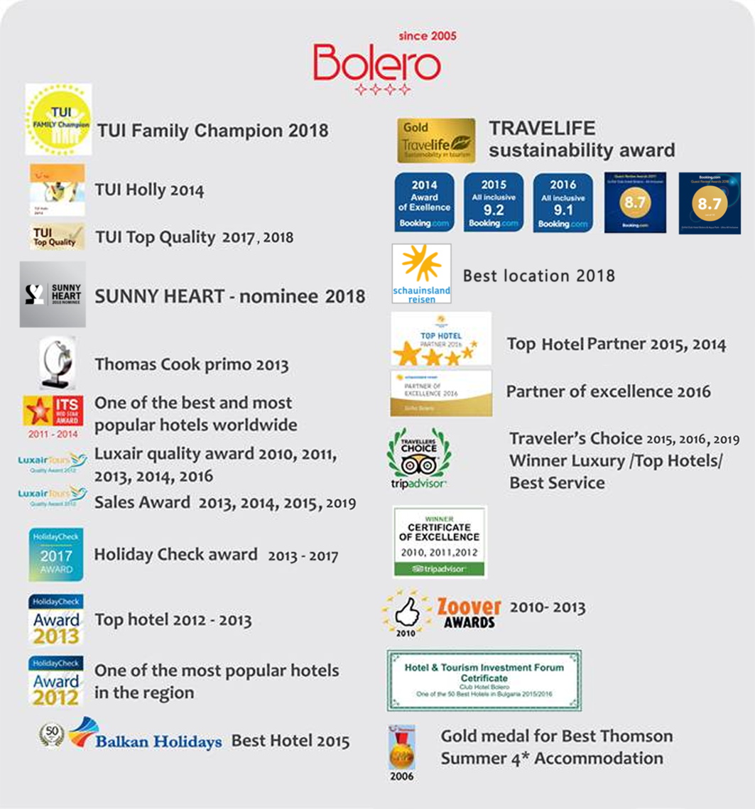
Contacts
Web site: www.grifidhotels.com
PHOTOS available at: http://grifidhotels.com/marketing/Grifid%20Bolero/
http://grifidhotels.com/marketing/Grifid%20AquaPark/
Covid-19 Safety and hygiene measures available at:https://grifidhotels.com/index.php?page=covid19health

Awards

