Grifid Foresta is a 3*** All inclusive Adults only (16+ years old) property.
Here a calm and cozy holiday is offered in a friendly environment. The smallest member of Grifid collection combines the tranquility of green surroundings with a welcoming ambience.
Highlights and new services
- Adults only (16+ years)
- Weekly activities (Cooking classes, live music several times a week, Nordic walking and adventure tour to National park of Golden Sands with collocutor)
- Free bicycle (up to 4 hours per day; reservation required)
- Pop up BBQ event (July- August)
- Parking lot is against charge
General information
- All inclusive basis
- 3-floor building
- 800m from the beach
- 15km from Varna
- 30km from Varna Airport
- 800m from the center of the resort
- 800m from the shopping center
- 20m from a public bus station
- Languages spoken : Bulgarian, English, German, French, Russian
- 24-hours Front desk & 24 hours security
- Main restaurant, Snack menu, Sweets in the afternoon
- Lobby bar, Pool bar, Beach bar offers variety of local and international alcoholic and non-alcoholic beverages
- Sandwiches for the beach – preorder needed – free of charge
- One dinner at A la carte restaurant at Grifid Hotel Arabella (Bulgarian or Italian or Asian) upon 7 nights stay (res. required)
- Facilities in public areas are wheelchair accessible (except the beach location)
- Parking – limited and against charge
- Grifid Souvenir Shop
- Free Wi-Fi connection in hotel lobby area
- Taxi & Rent-a-car services
- Laundry service
- Doctor
- Wellness & Relax center (in hotel Grifid Arabella, additional charge)
- PC room with internet access (additional charge)
- Option for providing Hotel Office
- Free use of Panorama Fitness in Grifid Arabella (at a 20 min. distance from hotel)
Accommodation
- Check-in time – from 14:00h – starts with snack menu
- Check-out time – until 12:00h – ends with continental breakfast
- 46 hotel rooms with pool view
- All rooms are with bathrooms shower
- Separated wash basin from the bathroom
- Hairdryer
- International dialing phone
- Central air conditioning system
- Satellite TV
- Free Wi-Fi connection
- In-room safe (additional charge)
- Mini bar – free of charge, daily restocked /water, soft drinks, beer/
- All rooms are with laminated floor
- Balcony
- Tea & Coffee facilities free of charge
- Pillow menu
The early check-in and late check-out are according the capacity of the hotel and are a subject of additional payment.
Restaurants – part of All inclusive basis

Main Restaurant
Opening hours:
Breakfast 07:30 – 10:00 buffet
Continental Breakfast 10:00 – 12:00 table service
Lunch 12:30 – 14:00 buffet
Dinner 18:00 – 21:30 buffet
- Buffet breakfast, lunch and dinner
- Varied culinary delights
- Beverage buffet with mineral water, soft drinks, beer and country wine, coffee and tea
- Culinary thematic buffets – 2 times per week
- Nonsmoking inside
Dress code for dinner required

Snack Restaurant
Opening hours:
Afternoon Snack 15:00 – 17:00
- Table service
- Sandwiches

Bars – part of ULTRA All inclusive basis
Lobby Bar
Opening hours:
10:00 – 24:00
Coffee, tea, cookies 17:00 – 18:00

- Smoking is not allowed
- All inclusive offer features mineral water, international and local alcoholic beverages, non-alcoholic beverages and refreshing cocktails, coffee and tea, draught beer and country wine
- Bar service

Pool Bar
Opening hours:
Drinks 10:00 – 18:00 (pool operating time)
Ice cream station 15:00 – 18:00

- All inclusive offer features mineral water, non-alcoholic beverages and draught beer
- Self-service

Beach Bar

Opening hours:
10:00-17:00 bar service

- All Inclusive offer features local alcoholic and non-alcoholic beverages, refreshing cocktails, coffee and tea, draft beer

Swimming pools & Wellness
Outdoor pool:
Opening hours:
09:00 – 18:00

- Sunny lounge terrace by the pool
- Complimentary sun lounges, parasols and towels
- Life guard service provided

Beach services included

One parasol and two sun beds (with mattresses) per room on the beach available!

Wellness and Relax
Wellness and Relax (at Grifid Hotel Arabella) – extra charge

Opening hours:
09:00 – 18:00

All treatments, Sauna, Hamam, Beauty salon are additionally charged!
- Hamam with steam bath, Sauna, Hydro massage bath
- Relax zone
- Boutique – massage oils, fragrances and other body products
- Hairdresser, manicure and pedicure
- Massage rooms; Facial and body treatments and range of spa treatments
- Body and face cosmetic

Sport & Animation activities
FIT & FUN Zone
- Table tennis, darts - free of charge
- Bicycle hire *up to 4 hours promotion for free bike riding
- Panorama Fitness in Grifid Arabella (at a 20 min. distance from hotel)

Pop up BBQ event (July- August)
Rooms
- Double room with pool view: 29 m². 2+0, 3+0.
Paid Services
- Parking lot – limited
- Rent a car
- Safe in rooms
- Spa treatments in wellness center
- Services in beauty salon
- Wine selection in all restaurants
- Bicycle *up to 4 hours promotion for free bike riding

Miscellaneous
- Pets are not admitted
- Hotel reserves the right to change opening hours of the outlets if necessary.
- Under Bulgarian legislation it is not allowed to smoke in the hotel lobby, restaurant, bars and rooms
- Sun bed reservation is not accepted. Any unattended towels are removed from the pool staff
- Any Food and Drinks could not be taken out of the restaurants due to Public and HACCP regulations

Contacts
Tel.: +359 52 351 051 (Hotel Reception)
Tel.: +359 52 394 972 (Marketing department)
Fax: +359 52 351 055
E-mail: reservations@grifidhotels.com
Web site: www.grifidhotels.com
PHOTOS available at: http://grifidhotels.com/marketing/Grifid%20Foresta/
Covid-19 Safety and hygiene measures available at : https://grifidhotels.com/index.php?page=covid19health

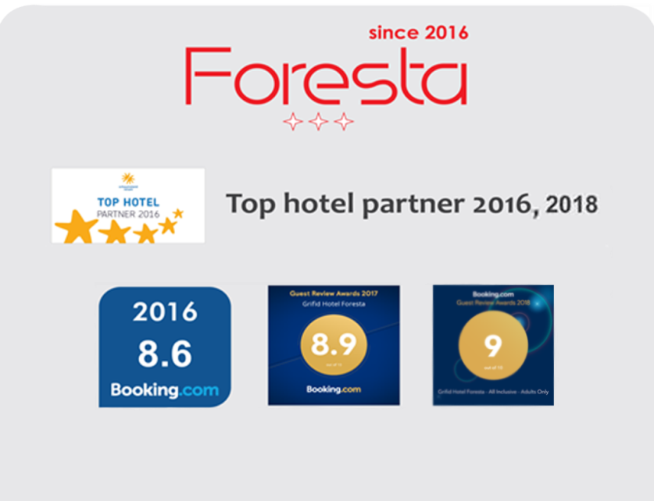
Awards

