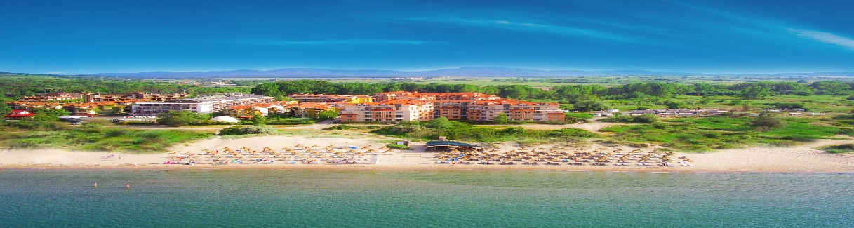
HACIENDA BEACH RESORT
Located in proximity to the “Golden Fish” Bay, 30 km south of Burgas and 6 km from the Ancient town of Sozopol.
Its tranquil location on the beautiful sandy beach makes it a favorite destination for many travelers.
Close to the hotel are situated the popular camping sites “Gradina” and “Golden Fish”, which are the most beautiful and tranquil places for summer vacation on Bulgaria’s southern Black Sea Coast.

LOCATION  - GPS Coordinates: 42.698965.27.71709  - Distance to Airport: Bourgas-40км.; Varna-165км. Sofia - 413км.  - Distance to nearby towns: Sozopol-4км.; Burgas-31км  - Distance to Bus Station: 500м. Bus to Sozopol on every 10 min.  - Distance to „Golden Fish“beach -100м.; Beach in camping site “Gradina”-2.5 км |  |  | HOTEL DETAILS  - 3 stars  - Total Surface: 3600 м2  - Number of apartments: 120  - Build in 2012  - Last renovation: 2018  - 5 buildings by 4 flours  - Elevator – one in each building.  - Main Restaurant: BB & All-inclusive  - A-la-carte Restaurant

PARKING  - Secured parking with limited parking spaces  - Price -6.14 Euro per day, per vehicle  - Advanced Reservations are not possible  INTERNET  - WiFi free of charge in the entire property |  |  | GENERAL SERVICES  - Room cleaning: once daily  - Towels change: once daily  - Bedsheets change: twice per week  - Amenities – once per stay  - Accepted Credit Cards: VISA § MasterCard  - Rent-a-car: For additional payment  - Doctor Visit: Paid/ on request.

SWIMMING POOL AND BEACH  - Outdoor pool, free, working hours 09:00-17:00  - Sunbed and umbrella by the pool, free of charge and subject to availability  - Sunbed & umbrella at the beach, paid service |  |  | RECEPTION  - Check-in: 14.00 hrs  - Check-out: 12.00 noon  - Late Check-out subject to availability and additional payment

RESTAURANTS  - The Main Restaurant “Atia” offers Buffet for Breakfast, Lunch and Dinner, according to the meal plan booked  Working Time: 07:30-10:30hrs., 12:00-14:30hrs.,  18:00-21:30ч  Baby chairs in the restaurant: Free of charge  - A-la-Carte Restaurant |  |  | BARS  - Pool Bar: Working time 11:00-23:00 hrs.  - Pool Bar All-Inclusive package 11:00-17:00 hrs  - Snack Bar: Working time 11:00-22:30 hrs.  - Snack Bar All-Inclusive package 11:00-17:00 hrs  - *In proximity to the hotel are located some iconic Beach bars, which could be visited for an extra charge

CHILDREN  - Kids Menu: Paid  - Baby Cot, free of charge, on request  - Outdoor Children Playground: free of charge |  |  | PET POLICY  - Pets up to 5 kg are welcome  - Price: 5.11 Euro per day  - Must be requested in advance.

1-BEDROOM APARTMENT  - Size: 40-62 sq.m.  - View: Sea & Park View  - Minimum occupancy: 2 pax  - Maximum occupancy: 2+3pax  - Comprised of Bedroom, Sitting room & Bathroom  - Bed types: Queen size bed and Sofa |  |  | APARTMENT FACILITIES  - Balcony  - Air-Condition  - Phone  - TV  - Cable TV  - Safety Box  - Floor type: tiles  - Mini fridge  - Electric kettle  - Hairdryer  - Shower or Bathtub  - Amenities: once per stay  - Iron on request  *Please note that the apartments does not offer paid channels and CD or DVD players
2-BEDROOM APARTMENT
- Size: 70-85 sq.m.
- View: Park view
- Minimum Occupancy: 4
- Maximum occupancy: 4+2
- Comprised of two bedrooms, sitting room and one bathroom
- Bed types: two queen size beds and sofa.

VIP APARTMENT  - Size: 60 sq.m.  - View: Sea view  - Minimum occupancy: 2  - Maximum occupancy: 2+2  - Comprised of bedroom, sitting room, bathroom and kitchen.  - Bed types: queen size bed & sofa  - Reservations only on request. |  |  | MEDIA KIT  - Hi-resolution images ca be found and downloaded on https://victoriagroup.bg/our-hotels/hacienda-beach/gallery/  - Virtual tour of the resort on the following link:  https://victoriagroup.bg/virtual-tours/  *Please note that the most updated information for the resort and its services may be found in the present document, therefore please use only the information available in the present fact sheet..
*Please note that the following services are not available at the resort: Safe on the reception, Room Service, Washing and dry cleaning.

ALL-INCLUSIVE PACКAGE

SUNBEDS & UMBRELLAS BY THE POOL  Working time is 09:00 to 17:00 hrs  Sunbeds and umbrellas are located around the swimming pool and are subject to availability. Kindly note that it is not acceptable to block intentionally the sunbeds by leaving personal belongings, while rooming around the resort. Such situations are having a negative impact on the service and prevents our dedicated staff to provide the needed comfort to all our guests. Beach towels left unattended on the sunbeds will be collected by our staff.  *Please note that the Golden Fish bay beach front is managed by a concessioner and the usage of sunbeds and umbrellas are paid services, which is to be settled on the spot. An advanced booking is not possible.  SPORT ACTIVITIES AND ANIMATION  Outdoor Children Playground  Children animation  Tennis table  OTHER SERVICES  Safety box free of charge in all apartments.  WiFi Internet connection free of charge in all the hotel. |  |  | RESTAURANTS & BARS  All guests booked on All-Inclusive package will be given bracelets for identification. The bracelets must be returned to the reception upon check-out. If the bracelet is lost an additional charge of 30lv will apply. Upon check-in the guests will be given a Hotels passport, which will serve as identification and should be presented in the restaurant for Breakfast, Lunch and Dinner.  Main Restaurant „Atia“  For Breakfast, Lunch and Dinner, the restaurant offers Buffet set up with Salad Bar, Soups, Appetizers, Main course, Fruits and desserts. There is a choice of Bulgarian non-alcoholic and alcoholic beverages, Beer and Wine. *Tea and coffee for Breakfast.  Working time:  Breakfast: 07:30 – 10:30 hrs.  Lunch: 12:00 – 14:30 hrs.  Dinner: 18:00 – 21:30 hrs  Pool Bar (Working time: 11:00 – 17:00 hrs.)  - The guests can enjoy Hot and cold beverages, Bulgarian non-alcoholic and alcoholic beverages, beer and wine.  Snack Bar (Working time: 11:00 – 17:00 hrs.)  - The Snack bar offers a choice of Ice cream, Donuts, Pizza, Bulgarian Non-Alcoholic beverages, Beer and wine.

