BULGARIA
8240 Sunny Beach
Tel.+359 554 25575
e-mail : office@hotelbellevue-bg.com
www.hotelbellevue-bg.com

Location: On the South Bulgarian Black Sea coast, 30 km from Burgas airport (BOJ) In the northern part of the famous and biggest Bulgarian resort Sunny Beach, only a few minutes away from the resort centre, first line, directly on the fine sandy beach - Blue Flag award winner. Amazing panoramic view over the Gulf of Sunny Beach. Regular mini-train and a bus to Nessebar. Old town with small cobblestone streets and beautiful fish harbour, only 5 km away, world heritage protected by UNESCO. Regular bus-service to the city of Burgas.
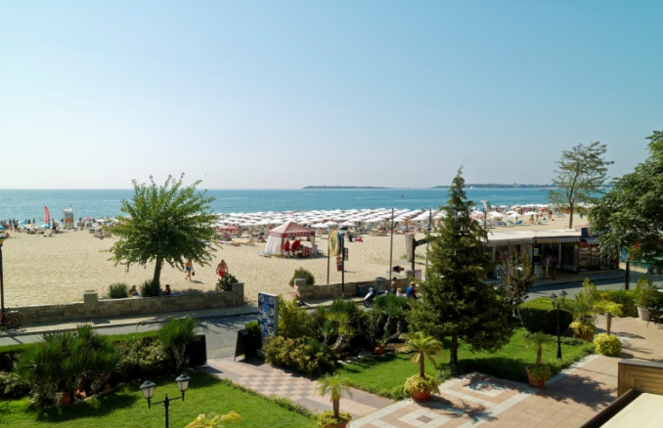
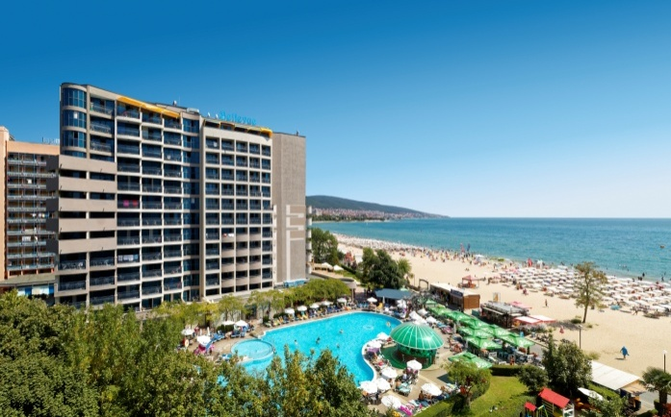

Facilities:
This modern, fully air-conditioned, 4 Star establishment has 254 double rooms, 16 family rooms with interconnecting doors on 12 floors, 4 passenger lifts, reception area and safety deposit boxes, 1 lobby bar, 1 main restaurant with panoramic sea view terrace and 1 à la carte restaurant with sea view terrace. Free Wi-Fi. In the well-kept grounds there is a swimming pool (shared with the guests of the neighboring hotel) with pool-bar, sun terrace, sun loungers and parasols included. Money exchange office. Car parking.
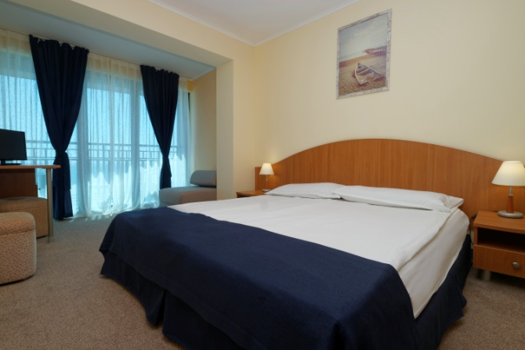
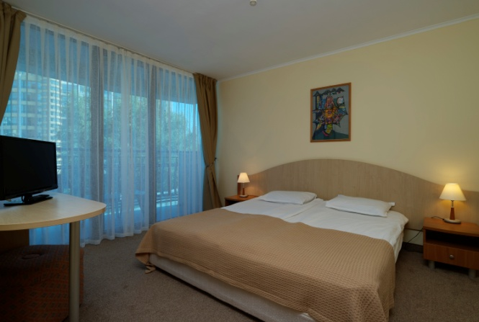

Accommodation:
254 Double Rooms with Side Sea View - 20 m²-24 m² /min.1 and max. 3 pax/
Twin bed, carpet floor, telephone, central air-condition, hairdryer, cable LCD TV, mini-bar, balcony, bathroom with shower, Wi-Fi. Extra bed /sofa bed/
16 Family Rooms - 48 m²/min. 2+2/
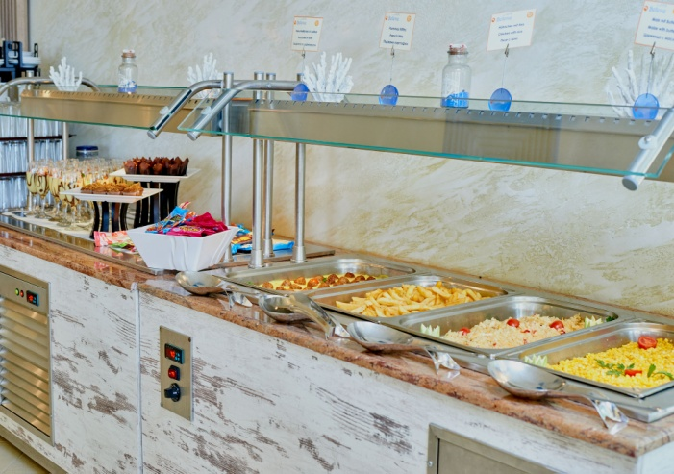
2 Double rooms with interconnecting door, carpet floor, telephone, central air-condition, hairdryer, Cable LCD TV, mini-bar, balcony, bathroom with shower, Wi-Fi
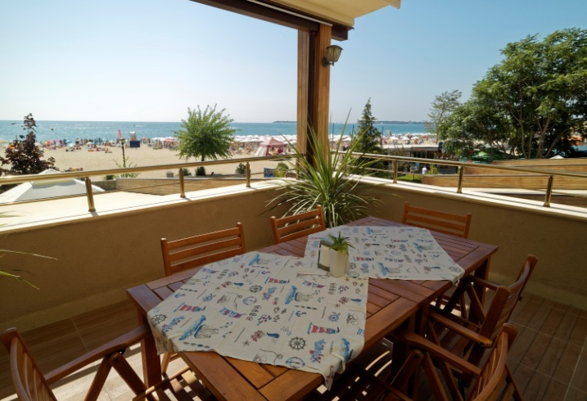
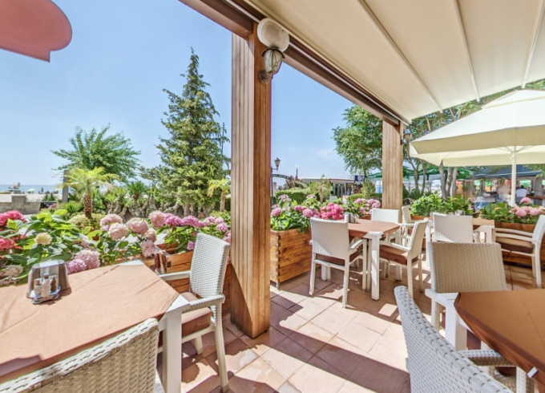
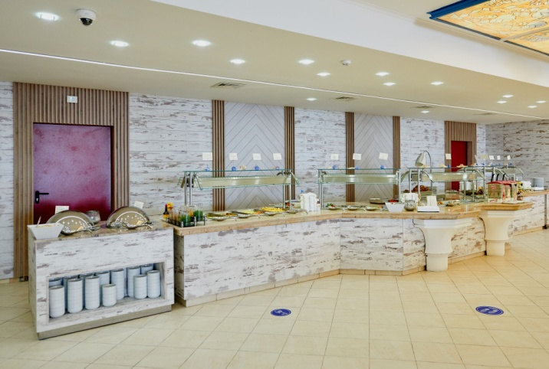
Restaurants and Bars
1 Main Restaurant with varied buffets for breakfast, lunch and dinner
1 A-la carte Restaurant offering specialities from Bulgarian and International cuisine.
1 Lobby bar
1 Pool bar
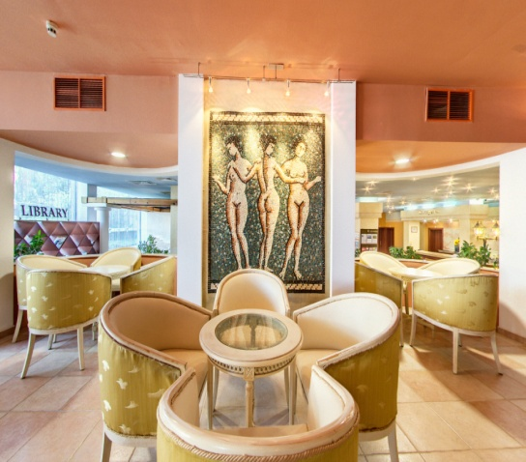
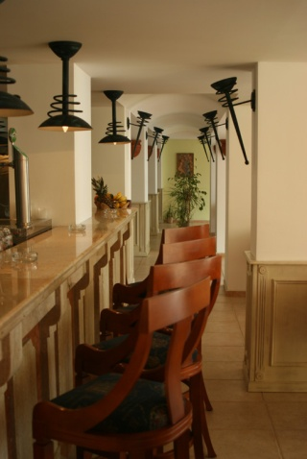
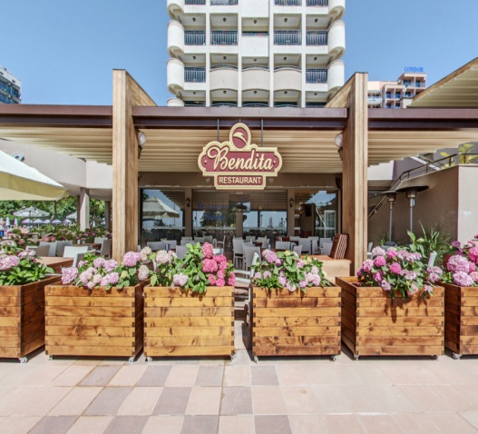

Sports and Entertainment:
Hairdresser, a wide variety of massages, fitness area and table tennis - free of charge, billard. Various water sports on the beach – sailing, surfing, jetski, paragliding, mini-golf. Also available upon request:, rent a bicycle. Sunny Beach offers an extensive variety of day and night entertainments including bars, restaurants and casinos.

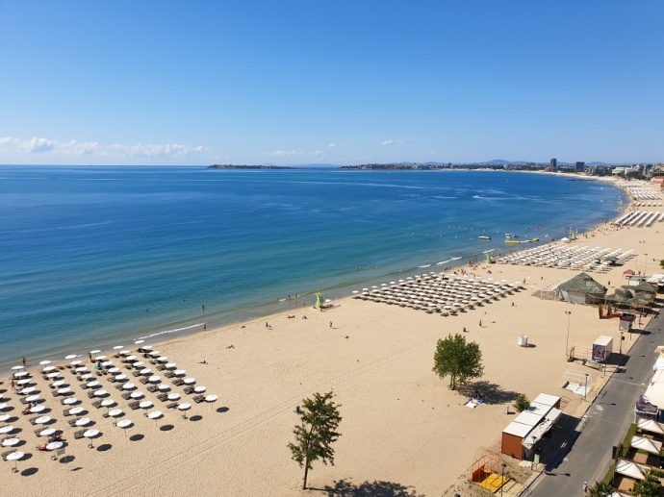
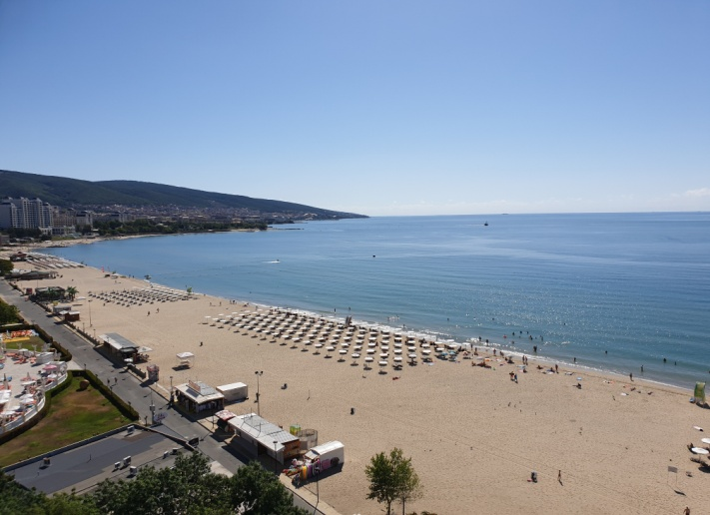
Children:
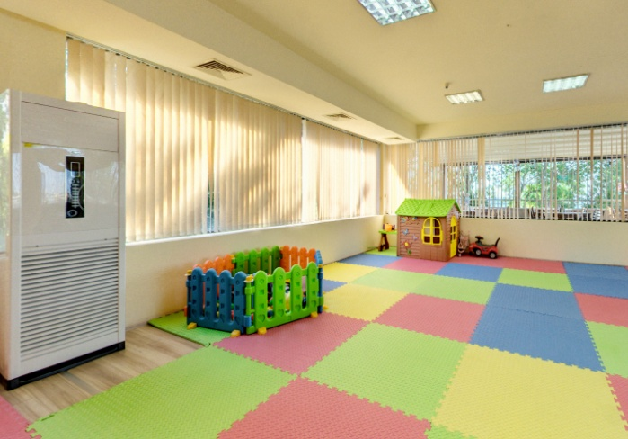
Kids Buffet. Highchairs. Kids club /4-12y/, integrated children’s pool in the outdoor pool. Children’s entertainment. Baby cot.
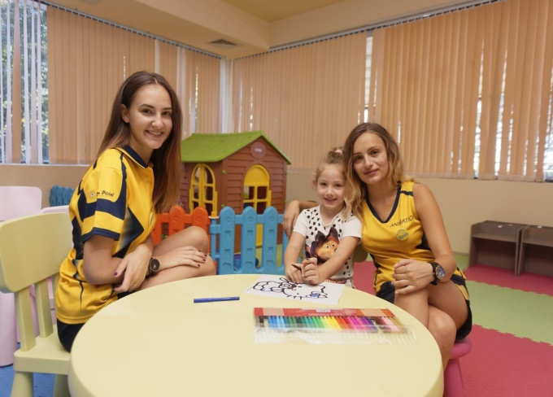

Other services: rent-a-car, laundry service, money exchange.

