VILLAS AT LIGHTHOUSE GOLF & SPA RESORT
THREE BEDROOM VILLAS

Villa Type G:
The ‘Type G’ Villas are typical two-storey countryside houses. These large, luxury two-storey villas offer the ultimate in comfort and home from home well-being.
On the ground floor, you will find a large living area and fully equipped kitchen. Other features are a guest bedroom, spacious bathroom and large terrace overlooking the beautifully landscaped gardens. On the second floor are two large bedrooms for you and your family, as well as a bathroom and generously sized terrace with magnificent views.
Floor Plan Description: On the first floor: Living room with kitchen and dining-room, one bedrooms, a bathroom with toilet. On the second floor: two bedrooms, a bathroom with toilet and terrace, corridor, staircase.
Available villas in Green District:
No | House | District | Area | Terrace | Total Area | Garden area | Price (EUR)
4 | G4 | Green | 135,23 | 25,54 | 149,12 | 395,00 | 170 000,00
5 | G5 | Green | 135,23 | 25,54 | 149,12 | 369,40 | 170 000,00
7 | G7 | Green | 135,23 | 25,54 | 149,12 | 378,50 | 170 000,00
38 | G38 | Green | 135,23 | 25,54 | 149,12 | 385,30 | 170 000,00
39 | G39 | Green | 135,23 | 25,54 | 149,12 | 389,30 | 170 000,00
41 | G41 | Green | 135,23 | 25,54 | 149,12 | 400,50 | 170 000,00

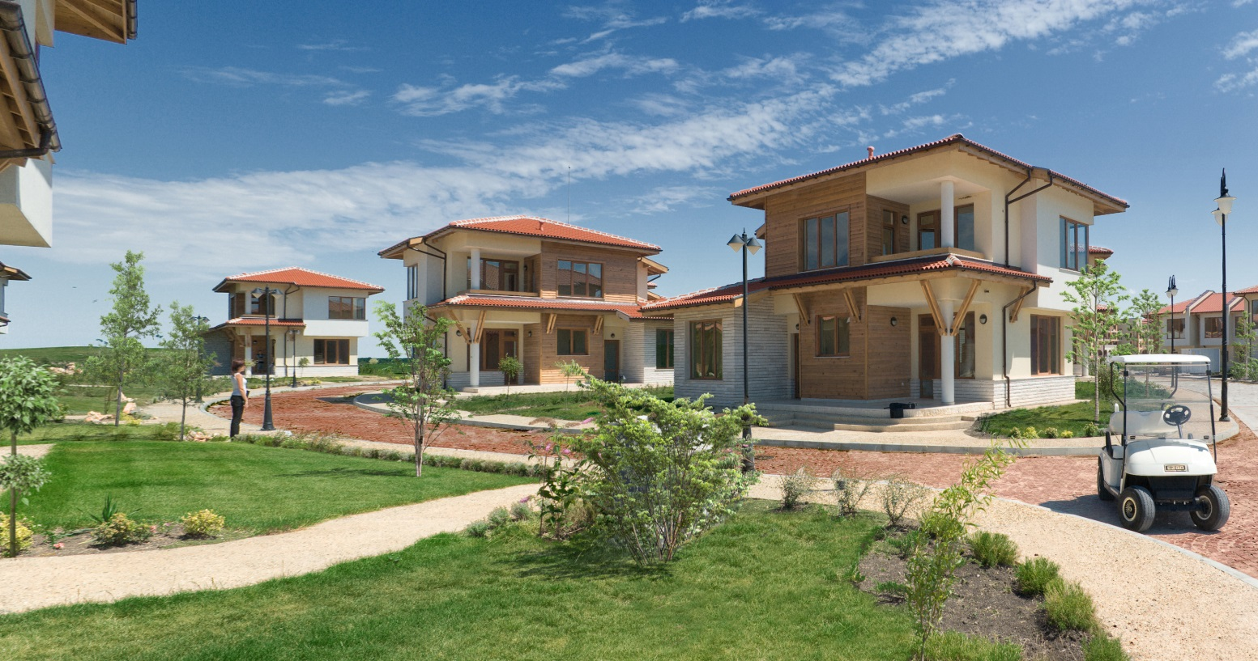
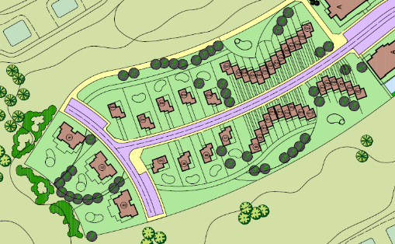

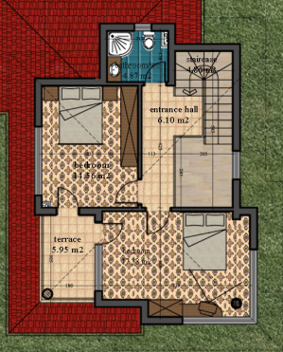
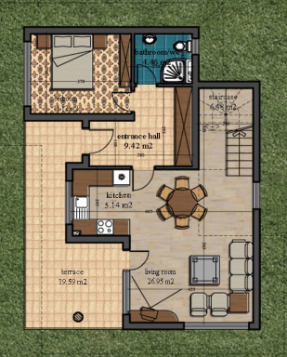
TWO BEDROOM VILLAS

Villas Type C:
If you feel that a family house is a little larger than you need, but you prefer a house to an apartment, Lighthouse Golf Resort can offer you the best solution; a house of an optimal surface, incredible view and own garden. Semi-detached houses are located in the Forest & Green districts in two varieties with two and three bedrooms, both of which ensure a panorama view.
Floor Plan Description: On the first floor: Living room with kitchen and dining-room, toilet. On the second floor: two bedrooms, a bathroom with toilet and two terraces, corridor, staircase
Available villas in Forest District:
No | House | District | Total Area | Garden area | Price (EUR)
23 | F23 | Forest | 84,75 | 80,00 | 75 000,00
24 | F24 | Forest | 84,75 | 80,00 | 75 000,00
25 | F25 | Forest | 84,75 | 80,00 | 75 000,00
30 | F30 | Forest | 86,73 | 80,00 | 75 000,00
32 | F32 | Forest | 84,75 | 80,00 | 75 000,00
37 | F37 | Forest | 84,75 | 80,00 | 75 000,00

