

ALL INCLUSIVE SEASON 2023

All Inclusive meals and snacks:  Breakfast:  • Varied buffet with show cooking stations  • Continental breakfast for late risers |  | 07:30 - 10:00h  10:00 - 11:00h
Lunch:  • Extensive buffet with variety of salads, soups, vegetarian corner, dishes with different meat types, incl. prepared at the show cooking stations, assorted desserts |  | 12:30 - 14:00h
• Snack - restaurant: lunchtime and afternoon snacks |  | 12:00 - 17:00h
Sweet-shop CakeIt!:  sweet temptations from the hotel’s own pastry production and ice-creams |  | 15:00 - 17:00h
Dinner:  • Extensive buffet with variety of salads, soups, vegetarian corner, dishes with different meat types, incl. prepared at the show cooking stations, assorted desserts  • Special evenings: themed buffets (2 x week), Gala-dinner |  | 18:00 - 21:00h
Optional dinner at the themed restaurants:  (reservations are required in advance and available at the hotel, visits are not limited per stay, operation depends on the hotel’s occupancy ) • Italian buffet restaurant (several times a week)  • Asian buffet restaurant (several times a week)  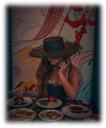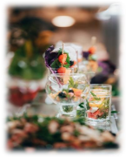 | 18:30 - 21:00h  18:30 - 21:00h  

Dress code is required for the gentlemen in the restaurants during dinner: long trousers and T- Shirts with sleeves. Guests’ accommodation starts with lunch and finishes with breakfast
Hotel Astoria****
Golden Sands, BULGARIA www.hotelastoria-bg.com
All-inclusive beverages:
Unlimited locally produced alcoholic and non- alcoholic beverages are offered at the bars and in the restaurants
• At the available bars  Non- alcoholic beverages, coffee, tea, alcoholic beverages (spirits, draft wine, draft beer, cocktails) | 10:00 - 24:00h
Beach Bar with all- inclusive beverages (middle of June – middle of Sept., depending on the weather conditions ) | 10:00 - 17:00h
• In the restaurants (available for self service):  • At breakfast: soft drinks, coffee, tea  • At lunch and dinner: soft drinks, draft wine, draft beer | During the meals

Services included in the rate:
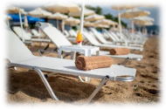
• Sunbeds and umbrellas at the beach and near the pools (upon availability)
• Wi-Fi internet access at the hotel’s area and in the hotel’s rooms
• 2 outdoor pools with 1 separate outdoor kids pool; 1 indoor pool with 1
separate children’s pool (heatable in April, May, September and October)
• Pool/Beach towels – free of charge
• Sports: fitness, workout, aqua gym, water polo, boccia (pétanque), darts,
table tennis
• Day-time animation program for adults and children aged between 4 -12
years – games, competitions, mini disco (6 times x week)
• Day-time sport animation for adults (6 times x week)
• Evening animation: show programs, live music or program from the hotel’s
animation team (6 times x week)
Services with extra charge:
• Parking (outdoor and garage, upon availability). Parking fee - 20 BGN/night. Parking service ends at check-out time on departure date.
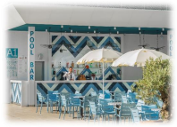
• Wide range of massages and beauty treatments, sauna, steam bath, hammam, salt room and relax area. • Beauty Salon
• In-room safe deposit box
• Laundry
• External calls from the in-room phone
• Medical care 24h
Additional information:
Check in time - after 15:00h
Check out time - till 11:00h
Opening and meal times are subject to change.
All guests are required to wear an “all inclusive” wristband for identification
purposes
Hotel Astoria****
Golden Sands, BULGARIA www.hotelastoria-bg.com

