Adults only hotel (16+)
GRIFID Metropol is a unique product, part of the GRIFID Hotels family since 2013. Our Adults only hotel (16+) offers Premium All inclusive with a la carte service. Right on the promenade having superb location in the first line of Golden Sands, it is a deluxe hotel with welcoming ambience for exquisite guests. The hotel offers accommodation with modern design and breathtaking view to the Black Sea.

Highlights and new services
- Special - Direct Transfer - Varna Airport-hotel/hotel - Varna Airport
- Quality branded bath amenities in all rooms - “RITUALS”
- Welcome gift for all guests
- A la carte service in all outlets
- Selection of quality branded Bulgarian and International wines in all restaurants
- Healthy line in all restaurant menus
- Pool bar at infinity pool
- Tasteful smoothies and fruits infused water at the pool bar
- Sky Bar with breathtaking panoramic view
- Lounge Beach Bar on GRIFID Metropol Beach
- One parasol and two sun beds per room on the beach - upon availability
- Beach cabanas - reservation required and with surcharge
- Romantic Dinner at the beach in front of the hotel - reservation required and with surcharge
- Bio swimming pool with a natural pebble bottom, artificial beach and natural surrounding
- Professional evening entertaining program
- Thematic A la cart dinner - limitation of free access by the duration of stay (except Main a la carte restaurant):
- Stay up to 3 nights including – a la carte restaurants are not included
- Stay of 4 and 5 nights including – one dinner in Prego a la carte Restaurant is included
- Stay of 6 nights and more – one dinner in Fusion a la carte included, unlimited access to Prego Restaurant for dinner and to Dine Around
- Advance reservation is required for all a la carte dinners
- Premium DINE AROUND - valid for stays of at least 6 nights (including once per stay one a la carte dinner in Fusion restaurant in Metropol and one in SKY restaurant “Pagur” in hotel Vistamar (adults only section); reservation is required
- Theme parties (BBQ evenings and beach parties; July - August)
- Free access to Fitness studio in Encanto Beach Medi SPA center from 06:00 - 21:00h

General information

- PREMIUM All Inclusive basis, Adults only hotel (16+)
- one main 11-storey building
- Located on first line in Golden Sands resort
- 15 km from Varna
- 30 km from Varna Airport
- 500 m from the center of the resort
- 50 m from the shopping center
- 500 m from a public bus station
- Languages spoken: Bulgarian, English, German, French, Russian
- 24-hours reception & 24 hours security
- GRIFID Concierge service - taking care of all little details that matter for your stay
- Main restaurant (for breakfast and dinner), “Prego” a-la-carte restaurant (for continental breakfast, lunch, afternoon snack and theme dinner: Mediterranean cuisine, Bulgarian, Rodizio & Italian), Premium Dine Around Program
- Lobby/Piano bar, Pool bar, Sky bar offer variety of local and international alcoholic and non-alcoholic beverages, Lounge bar at the beach - selection of local alcoholic and non-alcoholic beverages
- Facilities in public areas are wheelchair accessible (except for the beach location)
- Parking - limited and against charge
- GRIFID Souvenir Shop
- Free Wi-Fi connection in hotel lobby area and in the rooms
- Taxi & Rent-a-car services
- Laundry and ironing service - at a charge
- Currency exchange
- Doctor
- Gym, Wellness & Relax center
- Certificated by Travelife

Accommodation
- Check-in time - from 14:00h - starts with afternoon snack menu
- Check-out time - until 12:00h - ends with late continental breakfast
- 136 hotel rooms with sea side view or direct sea view, Junior suites with sea/side sea view, apartments with sea view
- All bathrooms are with bathtub with shower in it (in Junior suites and apartments there is a separate shower)
- Hairdryer & Cosmetic mirror
- International dialing phone
- Central air conditioning system
- Satellite TV
- Free Wi-Fi connection
- In-room safe - free of charge
- Mini bar - free of charge, daily restocked (water, soft drinks, beer)
- Coffee machine with capsules in all rooms
- Balcony
- Rooms with wall-to-wall carpet or laminated floor
- Quality branded bath amenities - “RITUALS”
- Pillow menu
- Top mattress menu - upon request
Early check-in and late check-out depend on the availability of the hotel and are subject to additional payment.

Restaurants
Part of Premium All Inclusive basis
MAIN RESTAURANT
Spacious hall with belonging open-air terrace overlooking the bio swimming pool.
Breakfast 07:30 - 10:00
Dinner 18:00 - 21:30

- A la carte service
- Breakfast served in combination of cold buffet for cold cuts, cereals etc. with a la carte menu and table service for hot dishes such as omelets, pancakes, eggs, etc.
- Included drinks for breakfast - freshly pressed orange juice, smoothies, water, coffee, tea
- Dinner is a combination of buffet for salads, starters and desserts and a la carte menu
- Included drinks for dinner - water, juice, soft drinks, draft beer, selection of quality branded International and Bulgarian wine
- Gala dinner - once in 10 days
- Smoking indoor is not allowed
- Dress code for dinner required (gentlemen with long trousers)

“PREGO” A LA CARTE RESTAURANT
Continental breakfast 10:00 - 12:00 a la carte service
Lunch 12:00 - 14:00 a la carte service
Afternoon snack 14:00 - 17:00 a la carte service
Dinner 18:30 - 21:30 a la carte service

- Lunch with daily menu and buffet for salads and fruits
- Afternoon snack: pizza, pasta, salads, desserts, ice cream
- Theme evenings: Mediterranean cuisine, Bulgarian, Rodizio & Italian - reservation in advance required
- Included drinks - water, juice, soft drinks, draft beer, selection of quality branded International and Bulgarian wine
- No smoking indoors
- Тhematic a la carte dinner is Included with minimum stay required
FUSION A LA CARTE RESTAURANT
18:30 - 22:00 a la carte service
- 9 courses degustation menu including Fusion and molecular cuisine!
- Once per stay free of charge with minimum stay required
- Reservation in advance required
- Dress code for dinner required (gentlemen with long trousers)

RENEWED PREMIUM DINE AROUND PROGRAM
Valid for stays of at least 6 nights - a diverse and complimentary choice of a la carte restaurants with variety of cuisine types for our guests, Prego in Metropol with theme evenings (Italian, Bulgarian, Rodizio and Mediterranean), Asian in Bolero and in Vistamar - European Restaurant and fixed menu at “Sofra” - social table with a la carte service.
Two more exclusive offers: one dinner during the stay in Fusion restaurant in hotel Metropol and Sky restaurant “Pagur” in hotel Vistamar.
True culinary journey around the world provided by GRIFID with no match on the Bulgarian Black Sea Coast! For all restaurants in the “Dine Around” program advance reservations are required.

Bars
Bars - part of Premium All Inclusive basis
LOBBY - PIANO BAR
Drinks 15:00 - 24:00
Cookies, coffee, tea 15:00 - 17:00
- PREMIUM All Inclusive offer features local and imported alcoholic and non-alcoholic beverages, refreshing cocktails, coffee and tea, draft beer and local wine and selection of quality branded International and Bulgarian wine
- Live music evenings and entertainment (professional musicians and dancers)
- A la carte service
- Afternoon pastries

POOL BAR
Drinks 10:00 - 17:00
- PREMIUM All Inclusive offer features local and imported alcoholic drinks, non-alcoholic beverages, refreshing cocktails, tasteful smoothies and fruits infused water, coffee and tea, draft beer
- Bar service
SKY BAR
With breathtaking panoramic view complements the experience of our guests with innovative cocktails
Drinks 20:00 - 24:00
BEACH BAR
10:00 - 17:00
In high season: 09:00 - 18:00
- Mineral water, local alcoholic and non-alcoholic beverages, refreshing cocktails, coffee and tea, draft beer and local wine
- Bar service
- Special snacks selection at the beach bar between 11:30-17:00 o’clock
- Fresh fruits are served to the sun chairs in the afternoon

Swimming pools and Wellness center

OUTDOOR POOL WITH INFINITY EFFECT
09:00 - 18:00

- Sun terrace by the pool
- Complimentary sun lounges, parasols, pool towels
- Life guard service provided
OUTDOOR BIO POOL WITH PEBBLE BOTTOM
09:00 - 18:00

- Artificial beach with sun terrace by the pool
- Natural surrounding
- Complimentary sun lounges, parasols, pool towels
- Life guard service provided
Beach services included
One parasol and two sun beds per room on the beach in front of the hotel upon availability (only for full paying customers)!

Wellness and Relax
Services - Massage room, Sauna, Beauty salon, Relax zone
09:00 - 18:00
- All treatments: massages, sauna and Beauty salon are additionally charged!
- Sauna
- Relax zone
- Hairdresser, manicure and pedicure
- Massage rooms; facial and body treatments and range of spa treatments

SPORT & Activities

- Small fitness room with air conditioning in hotel Metropol
- Fitness Studio at Encanto MediSPA (06:00-20:00)
- Boccia
- Yoga
- Bicycles (extra charge)
- Well-fit zone - with Step Aerobics, Gymnastics
- Water Gymnastics
- Multifunctional playground at GRIFID Club Hotel Bolero - for football, basketball, volleyball, tennis court and tennis rackets - free of charge; reservation required
- GRIFID Human Soccer (in GRIFID Club Hotel Bolero) - the popular across Europe modern game for all ages is available for our guests at the special play field for 10 people

ROOMS

Double room with sea side view or frontal sea view - 2+0. Appr. 23 m2
Junior suite with sea and side sea view - 2+0, 3+0. Appr. 38 m2.
Apartment with sea view - 2+0, 3+0. Appr. 55 m2.

EXTRA Paid Services

- Parking lot - limited
- Rent a car
- Spa treatments in wellness center
- Services in Beauty salon
- Special Wine List – at extra charge
- Bicycle (when not part of the animation bicycle tour)

Miscellaneous

Pets are not allowed.
Hotel reserves the right to change opening hours of the outlets, if necessary.
Under Bulgarian legislation it is not allowed to smoke in the hotel lobby, restaurant, bars and rooms (indoors).
Sun bed reservation is not accepted. Any unattended towels are removed from the pool and beach staff.
Food and beverages cannot be taken out of the restaurants due to Public and HACCP regulations.

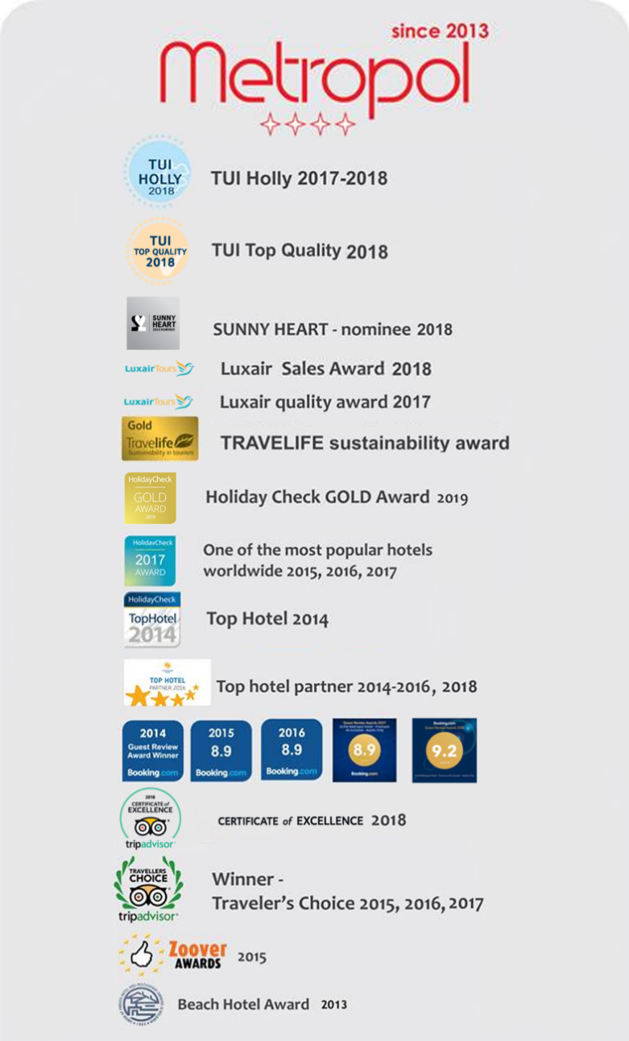
Contacts

Tel.: +359 52 385 999 (Hotel Reception)
WEBSITE
www.grifidhotels.com
PHOTOS AVAILABLE AT
https://grifidmetropol.pixieset.com/grifidhotelmetropol/
AWARDS

