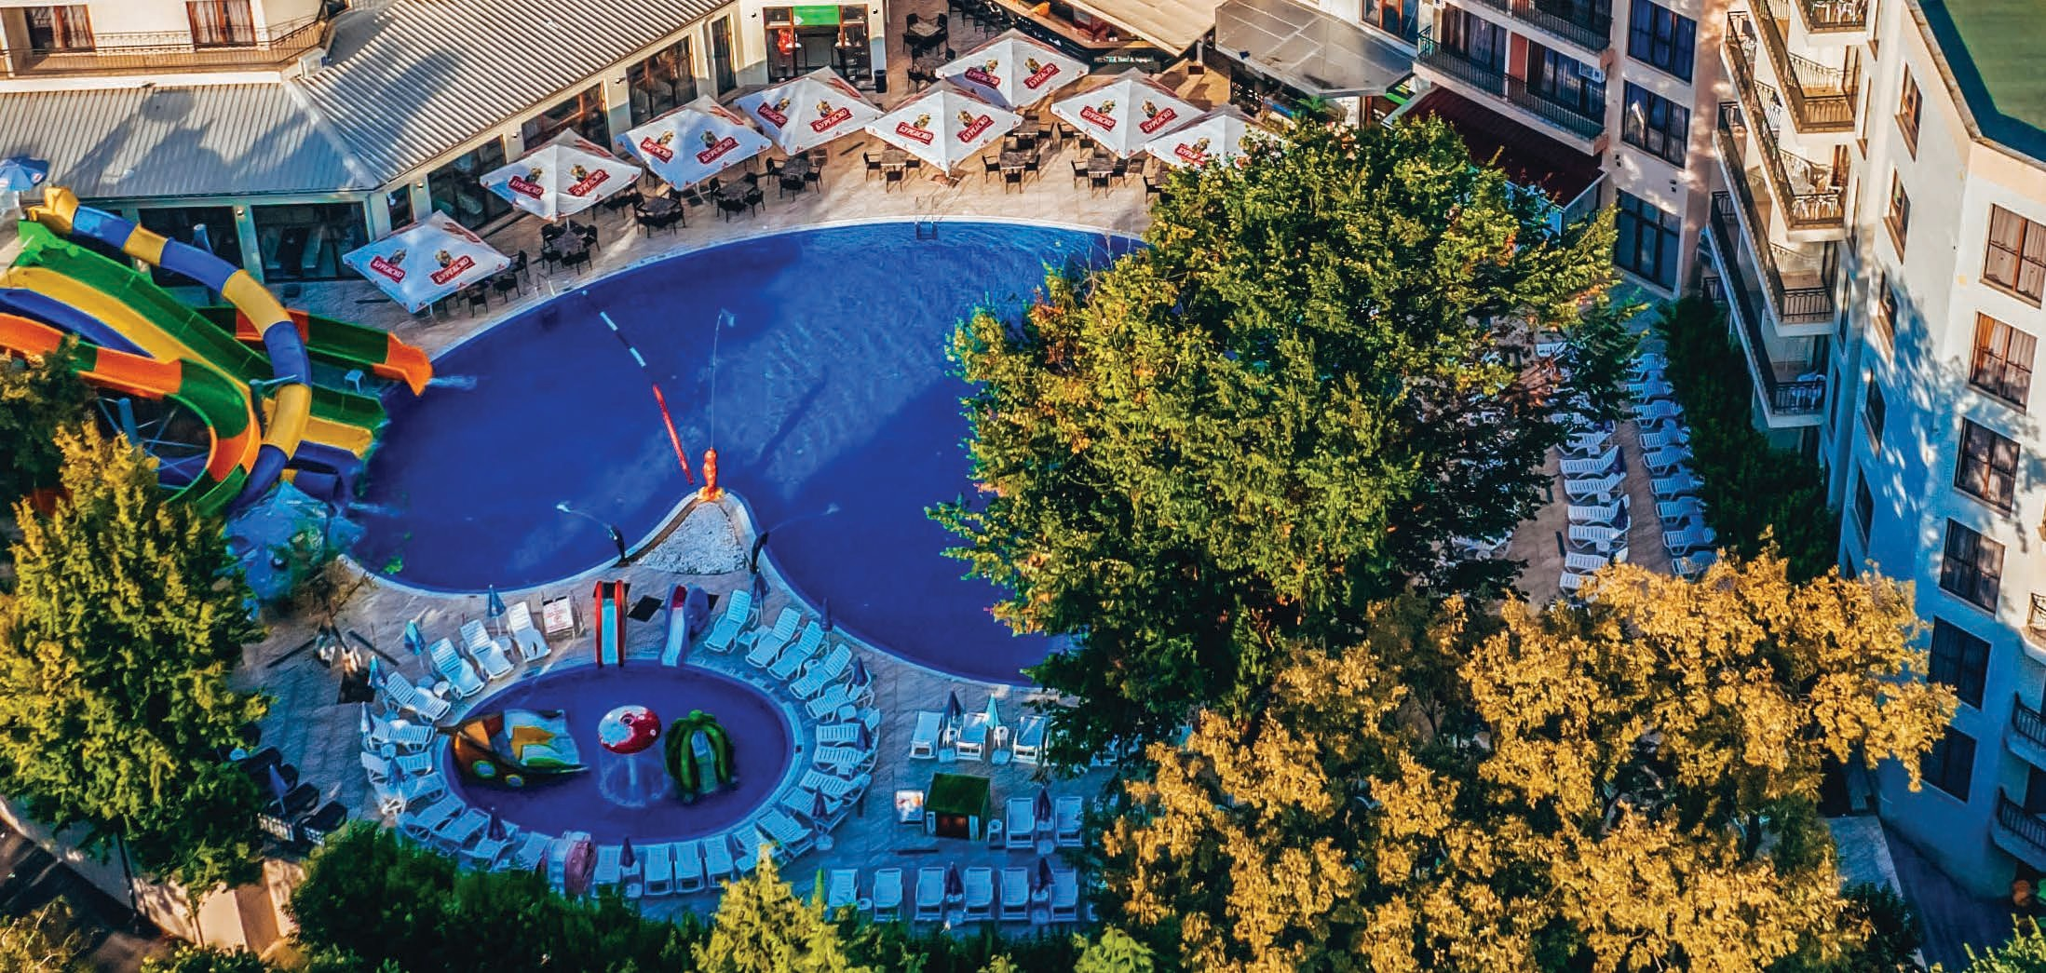Prestige Hotel & Aquapark

ALL INCLUSIVE

Varna , Golden Sands, 9007/www.prestigeaquahotel.com
@prestigeaquahotel

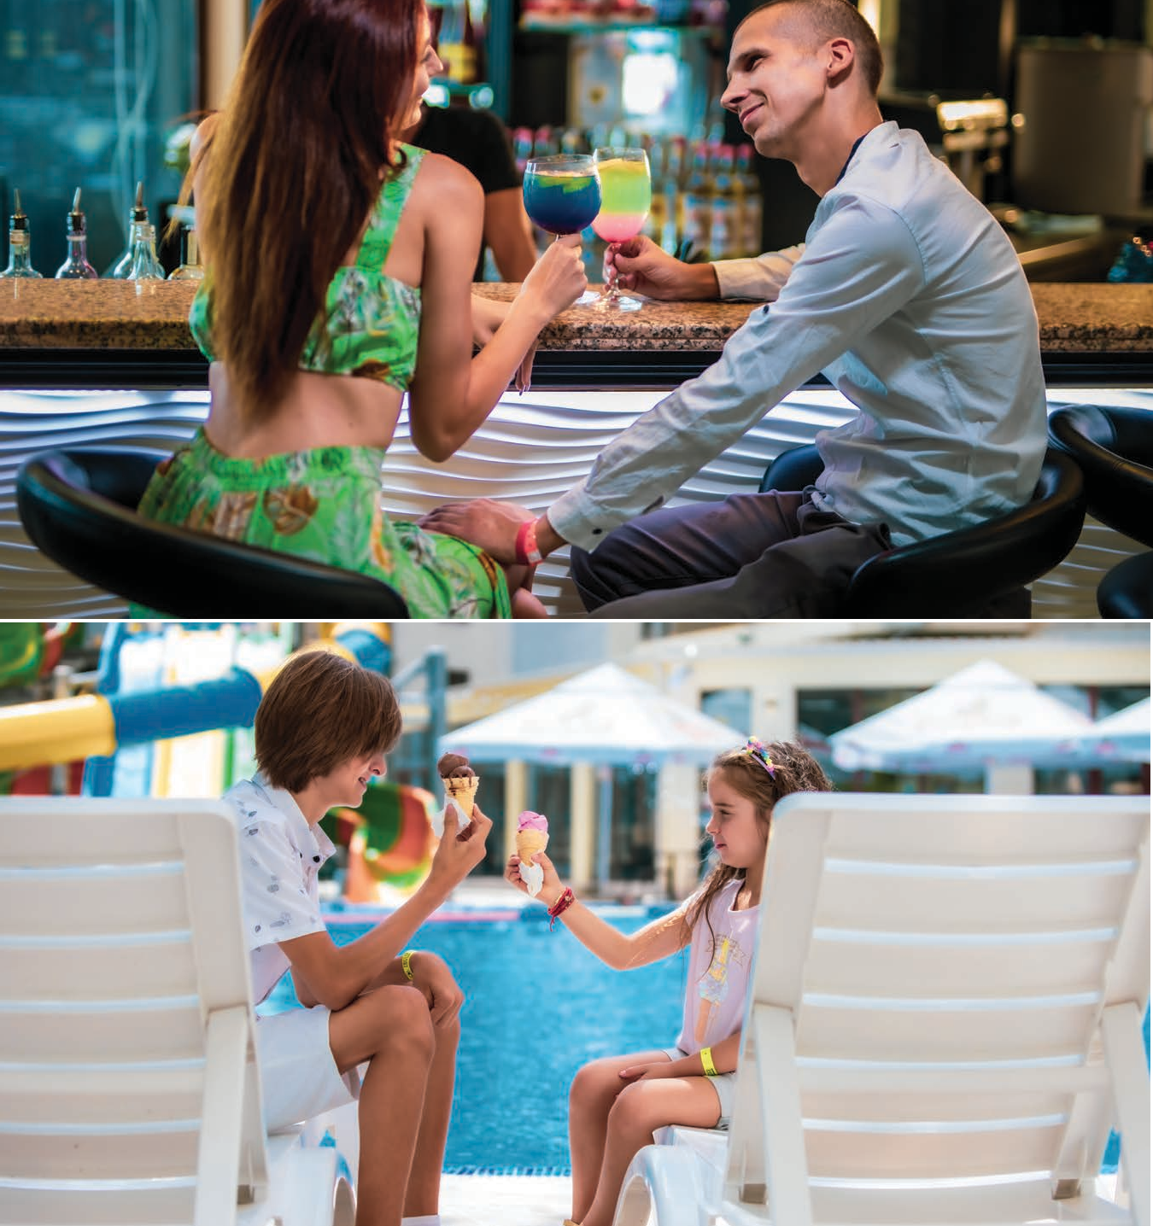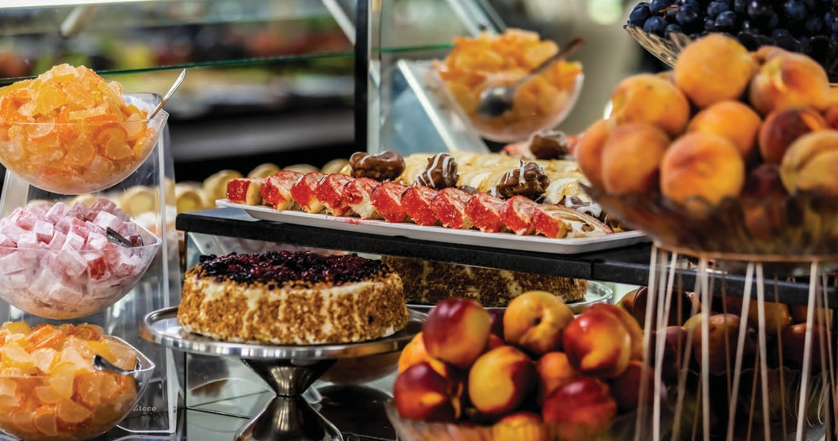Prestige Hotel & Aquapark

ALL INCLUSIVE 2024

Our Concept
TWO IS BETTER THAT ONE | Stay at one hotel, but enjoy two!
All guests of Prestige Hotel & Aquapark and Prestige Deluxe Hotel Aquapark Club can take advantage of the all range of amenities and services located at both hotels.
*The hotels are located next to each other

Food & Drinks| Unlimited

MAIN RESTAURANT
Breakfast: 07:30 - 10:00 h | Lunch: 12:30 - 14:30 h | Dinner: 18:00 - 21:00 h
BUFFET SELECTION | Salads, soups, appetizers, main dishes, desserts, fruits, ice cream
DRINKS BREAKFAST | Hot drinks, juices, mineral water, coffee, tea
DRINKS LUNCH & DINNER | Soft drinks, juices, mineral water, beer, wine
*Main meals in the restaurant are organized by hours (sittings) according to the room floor.

SNACK
10:30 - 12:00 h | Sandwiches, donuts, sweets, snacks, fruits, selection of turkish delight
15:00 - 17:00 h | Pizza, French fries, vegetables, fruits, sweets, selection of turkish delight

SNACK SWEETSHOP
10:30 - 12:00 h & 15:00 - 17:00 h | Ice cream, cookies, fruit, donuts

LOBBY BAR
10:00 - 23:00 h | Hot drinks, soft drinks, beer, wine, local alcoholic beverages, cocktails
23:00 - 00:00 h | All consumption with an extra charge 

POOL BAR
10:00 - 23:00 h | Hot drinks, soft drinks, beer, wine, local alcoholic beverages, cocktails

STAYING HYDRATED THROUGHOUT THE DAY!
Water dispensers on every floor of the hotel!

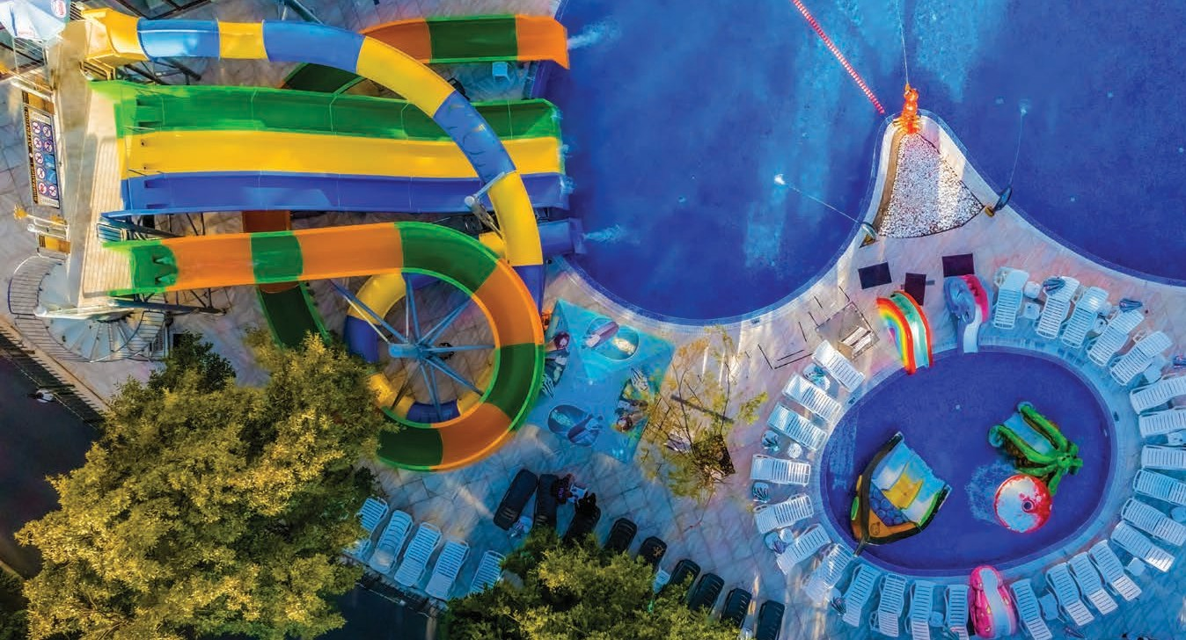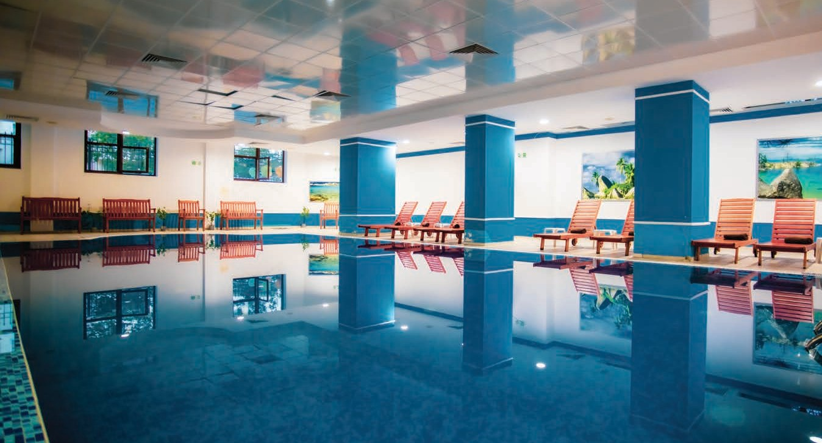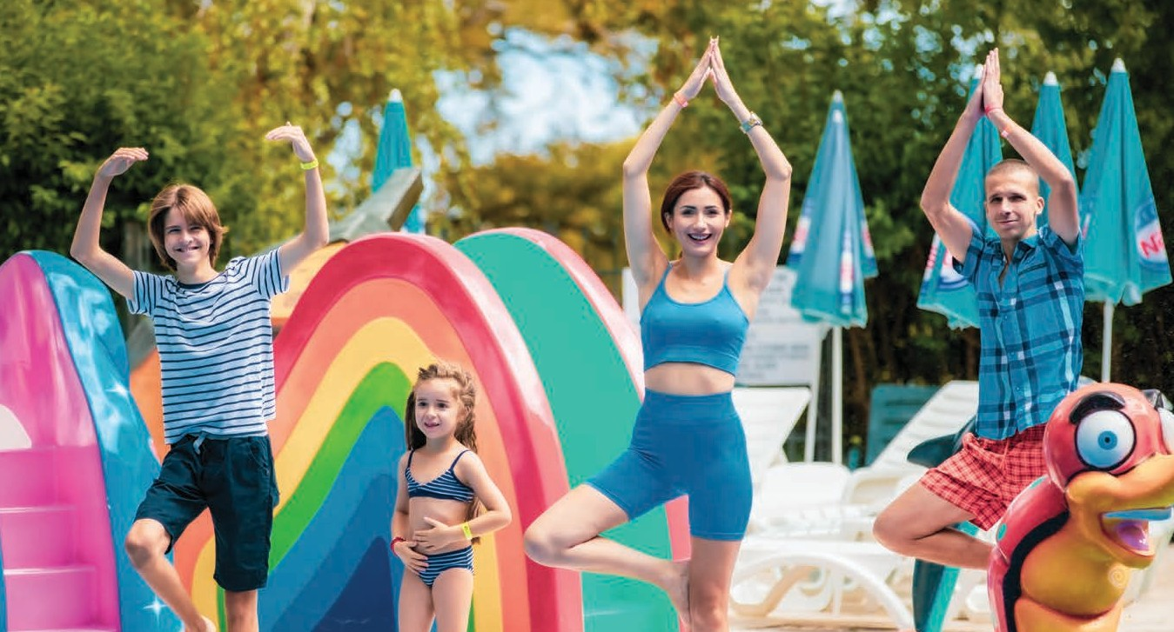Prestige Hotel & Aquapark

ALL INCLUSIVE

Water Fun

AQUA PARK & OUTDOOR POOLS
09:00 - 18:00 h
Main pool with 5 water slides
Separate children pool with kids friendly slides /pirate ship, 4 fountains, 4 slides/
Sunbeds and parasols | Subject to availability
Pool Towels

Relax & Sport

WELLNESS
09:00 - 18:00 h
Free access to heated indoor pool (27-28C), jacuzzi
ON THE TERRITORY OF PRESTIGE DELUXE HOTEL AQUAPARK CLUB
Free access to sauna, steam bath and salt room Use of hammam and massages

FITNESS
09:00 - 18:00 h
Free access to indoor fitness with cardio and strength zone Outdoor fitness available 24h

SPORT ANIMATION
6 days a week | 10:00 - 12:00 h & 16:00 - 18:00 h
Gymnastic, zumba, stretching, aerobics, boccia, darts, water gymnastic, water ball, volley- ball, football, table tennis, shulbak, shuffleboard etc.
According to the set hours of the animation program;

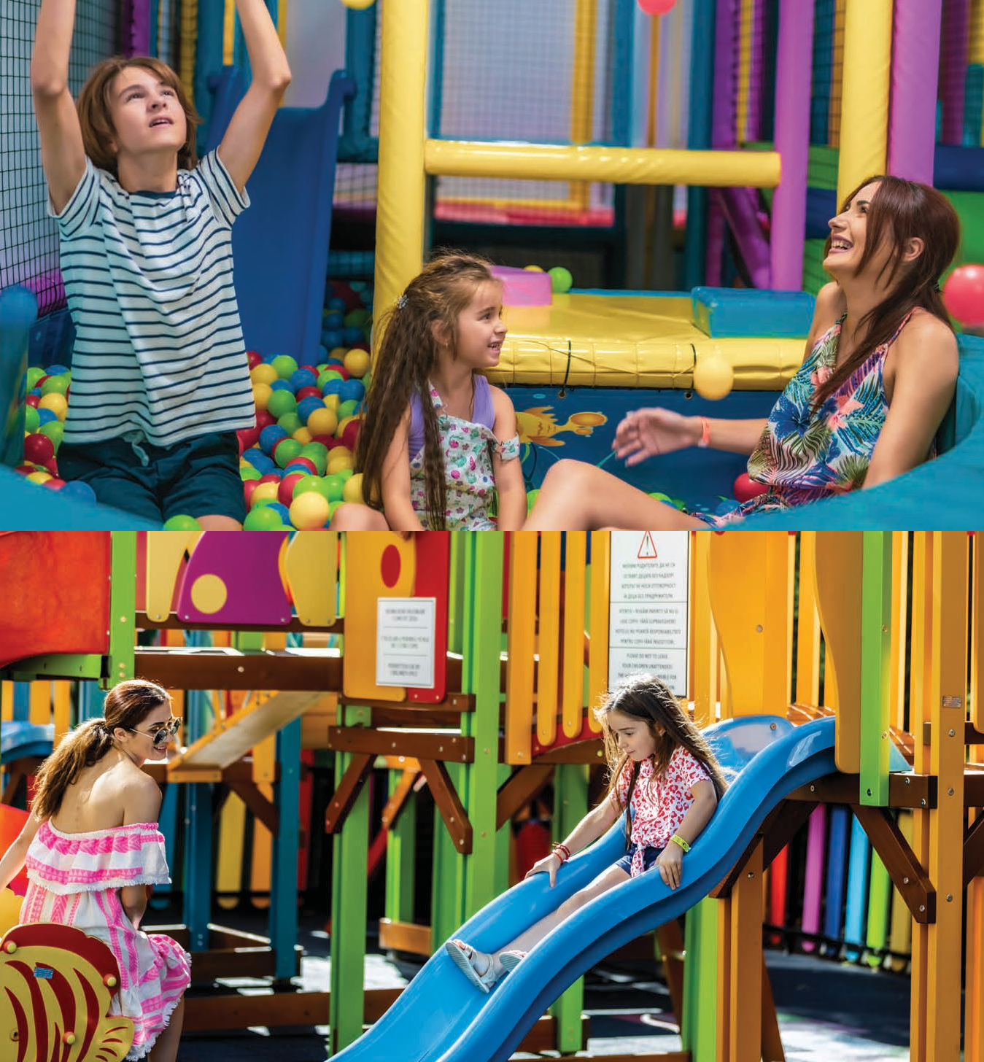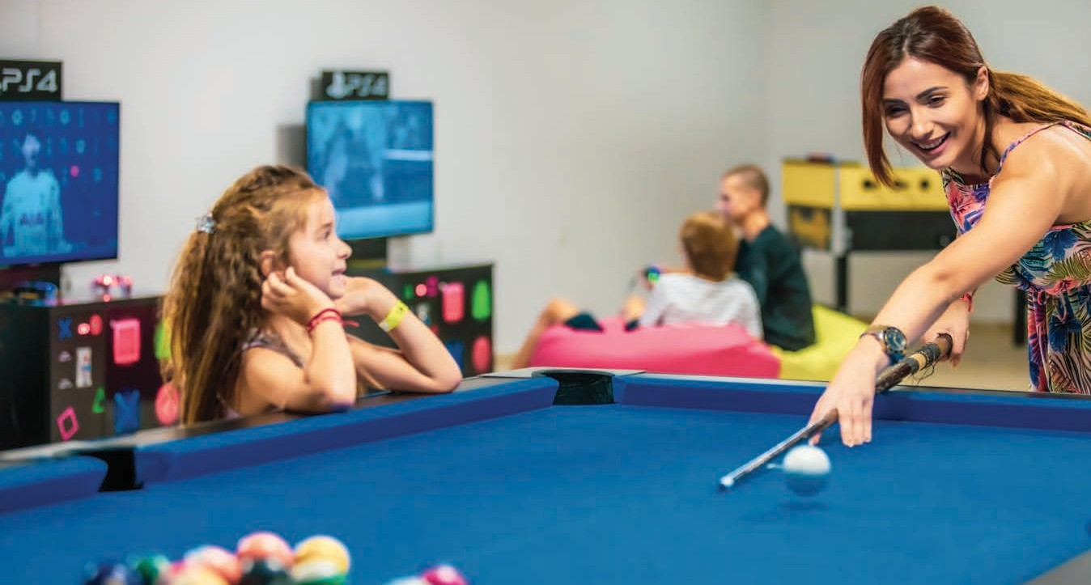Prestige Hotel & Aquapark

ALL INCLUSIVE

Children & Fun

CHILDREN CLUB
Daily
CHILDREN AGE | 2 to 12 years old
LANGUAGES | BG,RU, ENG, RO

CHILDREN ANIMATION
6 Days a week | Daytime: 10:00 - 12:00 h & 15:00 - 17:00 h | Evening: 20:00- 20:30 h Children bingo, games with ball, water games, musical games, pirate games, mini disco etc.

ADULTS ANIMATION
6 days a week | Daytime: 10:00 - 12:00 h & 16:00 - 18:00 h | Evening: 20:00- 22:30 h

CHILDREN OUTDOOR PLAYGROUND
24/7| Unguarded

GAMING ROOM
09:00 - 22:00 h
Table tennis, billiard, table football Free PlayStation Games

PRESTIGE REAL LIFE MISTERY QUIZ GAME
Start a family adventure and discover the secrets of our hotel and area

Version: 1.5 from 10.05.2023
The hotel reserves the right to make changes. Please always check if this is the latest version.
MEDIA KIT | https://bit.ly/prestigeaqua-media
Download Hotel Factsheet | https://bit.ly/prestigeaqua-fact Download High-Resolution Photos| https://bit.ly/prestigeaqua-photos Download Hotel Video | https://bit.ly/prestigeaqua-video

