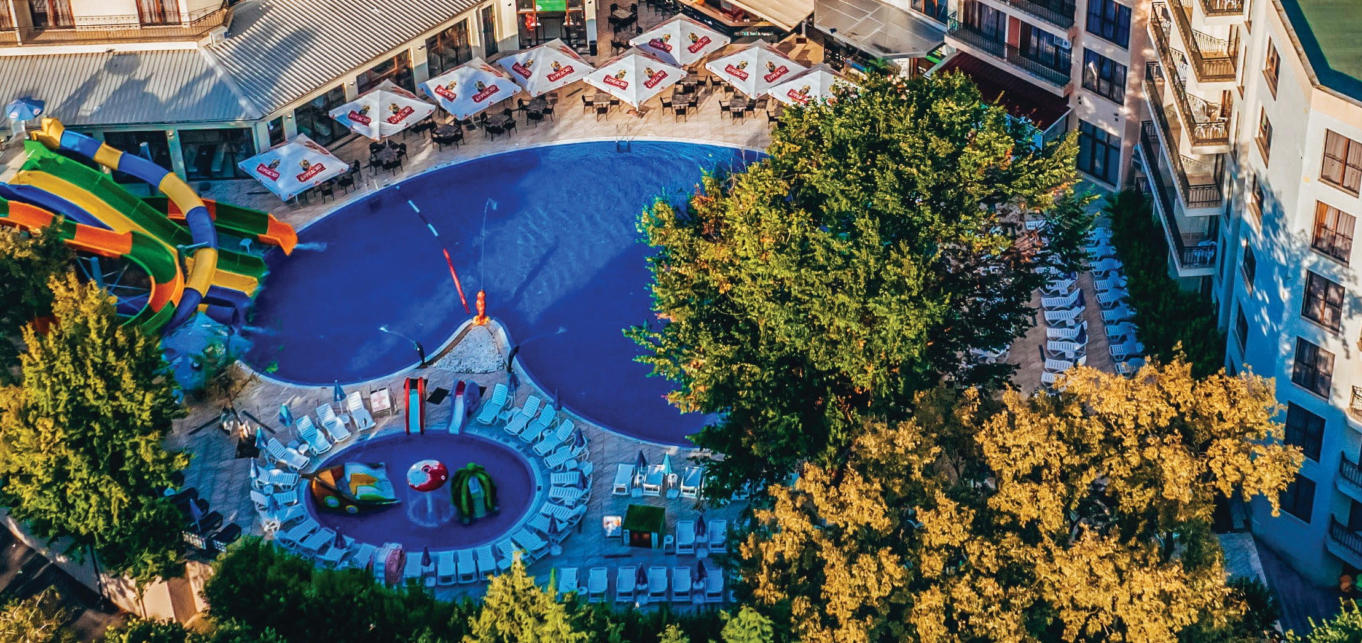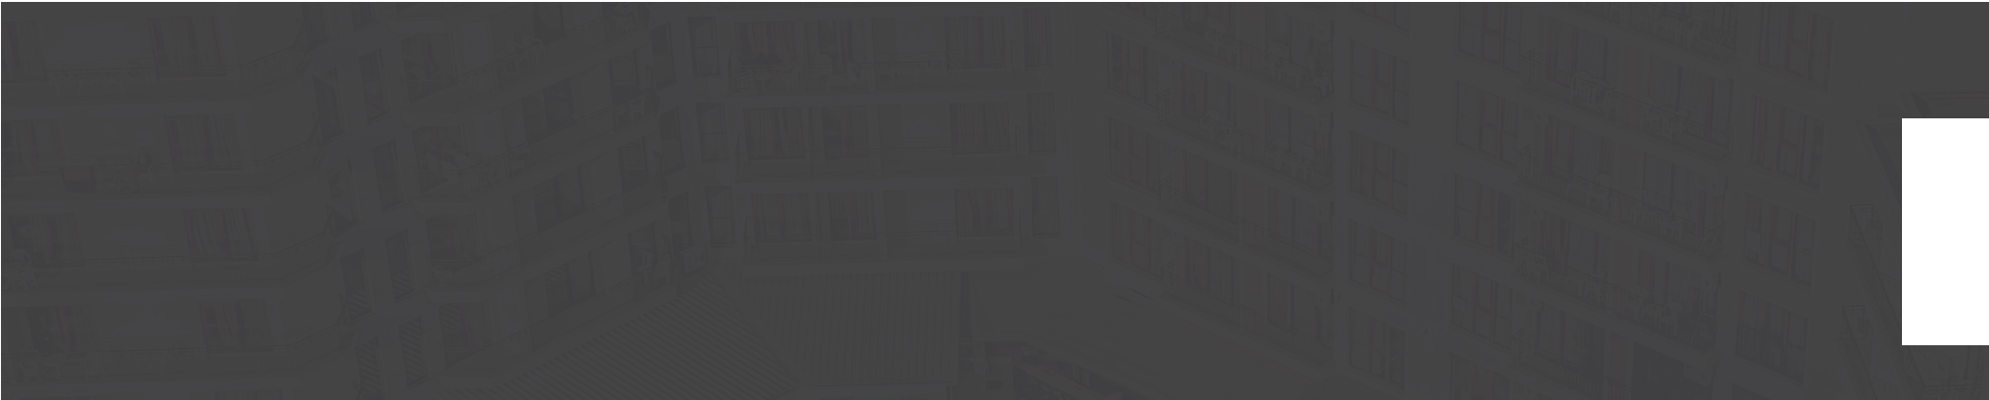Prestige Hotel & Aquapark

FACTSHEET

Varna , Golden Sands, 9007 | www.prestigeaquahotel.com
@prestigeaquahotel

Prestige Hotel & Aquapark

FACTSHEET

Room Facilities
√ No smoking rooms: smoking allowed on balconies
√ Change of bed linen: 3 times per week
√ Change of towels: Daily
√ Cleaning of the room: Daily
√ Safe box
√ Mini-fridge
√ Kettle / Water boiler
√ Coffee/tea: Single time
√ Wi-Fi
√ Phone

RoomTypes
DOUBLE STANDARD ROOM WITH BALCONY

√ TV
√ Satellite channels: FR,EN,DE,BG,RU,RO,PL,ES,IT
√ Air-conditioning: central
√ Fan
√ Hairdryer
√ Shower and/or bathtub
√ Iron: by request at reception
√ Toiletries
√ Floor type: laminate, carpet or tiles
√ Balcony
√ Water dispensers on every hotel floor

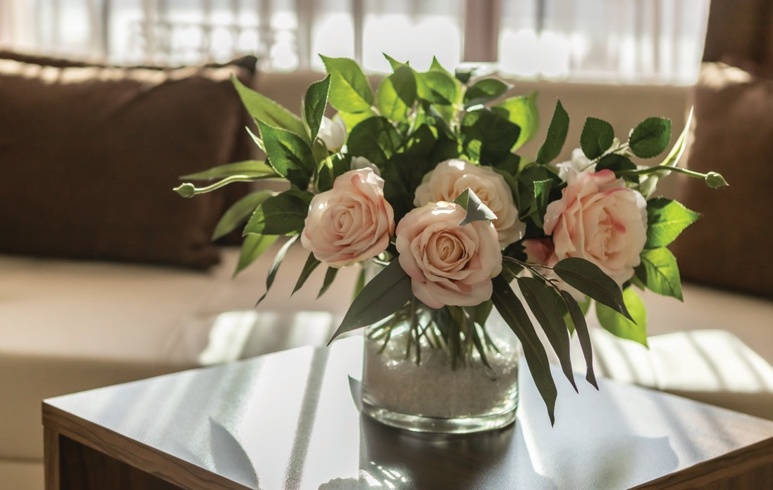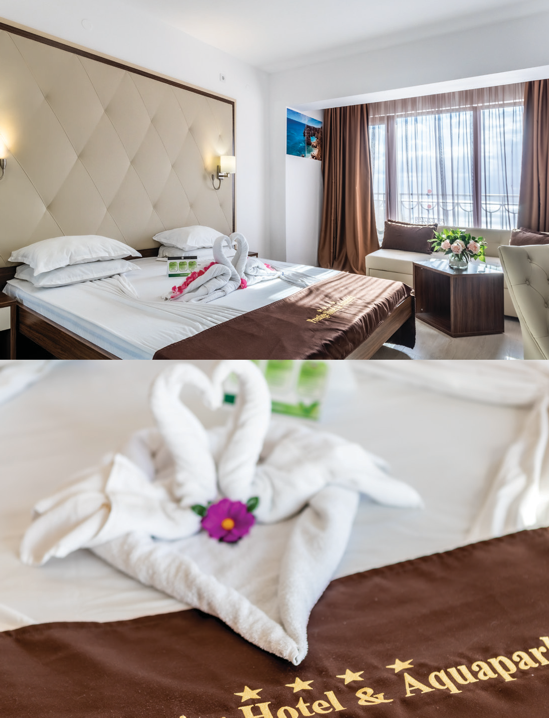√ Number: 82 √ Size: 18-20 m2
√ Type of beds: Double or twin, sofa bed √ Premises: Bedroom and Bathroom

ONE BEDROOM DELUXE SUITE
√ Number: 37 √ Size: 45 m2
√ Min.capacity: 2
√ Max.capacity: 4 +1
√ Type of beds: Double bed, sofa bed,
extra bed (foldable)
PREMIUM ROOM
√ Number: 111
√ Premises: Bedroom, Living room with dining area,Kitchenette, 2xBathroom
√ Size: 21 m2
√ Type of beds: Double bed, sofa bed
√ Min.capacity: 2
√ Premises: Bedroom, Relax area and Bathroom
√ Max.capacity: 2 +2 | 3 +1
√ Type of beds: Double or twin, sofa bed

DOUBLE STANDARD ROOM
√ Number: 48 √ Size: 18-20m2
√ Min.capacity: 2
√ Premises: Bedroom and Bathroom

√ Min.capacity: 2
√ Max.capacity: 2 +2

√ Max.capacity: 2 +2

Prestige Hotel & Aquapark

FACTSHEET

General Info

√
4 STAR HOTEL

Type
√

8
Number of ﬂoors

Location
√

1
Building

√
4

Number of lifts
√

2005
Year of building

√
YES

Disabled Facilities
√

2022
Last Renovation

√
278

Number of rooms

√ GPS Coordinates
43.28723915400633, 28.042381527004007
√ Distance to beach: 150 m
√ Distance to center: 250 m,
√ Distance to restaurant: 100 m
√ Distance to the nearest city: 17 km, Varna
√ Distance to shops: 50 m
√ Distance to shopping mall: 20 km
√ Distance to supermarket: 50 m
√ Distance to train station:
18 km, Varna Central Tran Station
√ Distance to airport: 25 km, VAR
√ Distance to bus stop: 400 m
√ Distance to ATM: 50 m
√ Distance to Medical center: 800 m
√ Distance to Hospital: 15 km
√ Distance to Pharmacy: 50 m

√ Early Check-in: Yes, upon availability
√ Late Check-out: Yes, upon availability | Extra Charge 
ACCEPTED PAYMENT TYPES:
CREDIT CARD


BANK TRANSFER

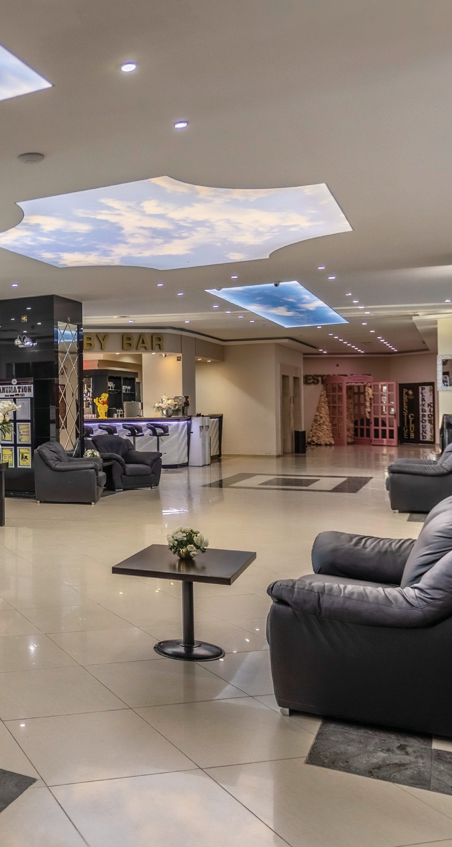
Reception
√
24 h Working hours
√
15:00 h
Check -in
√
12:00 h
Check -out
√
YES
Luggage Storage
X
Not Allowed Pet Policy
PAYPAL APPLE PAY REVOLUT
CASH

Prestige Hotel & Aquapark

FACTSHEET

Pool & Aquapark
√ Outdoor pool
√ Children outdoor pool: Separate
√ Sunbeds and umbrella by the pool: Subject to availability
√ Beach Towels: Free
√ Public beach: 200m, Sand

Wellness
√ Indoor pool: heated, 27 - 28 C

√ Water slides: 5 in main pool
√ Water slides kids: pirate ship, 4 fountains, 4 slides

ON THE TERRITORY OF PRESTIGE DELUXE HOTEL AQUAPARK CLUB
√ Sauna √ Steam bath √ Salt room √ Jacuzzi
√ Hammam: √ Massages| Extra charge

Sport
√ Fitness √ Outdoor fitness √ Yoga classes √ Billiard √ Table tennis √ Table football

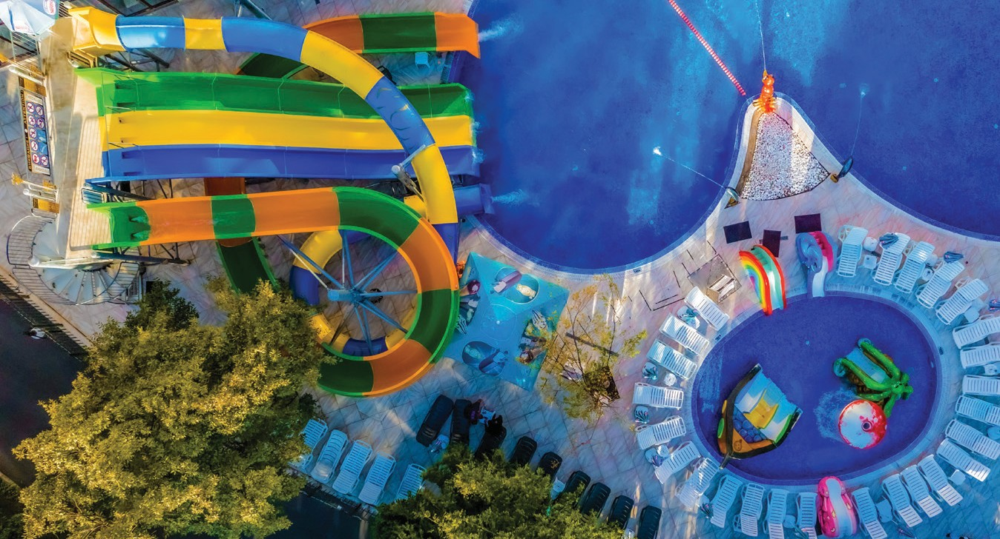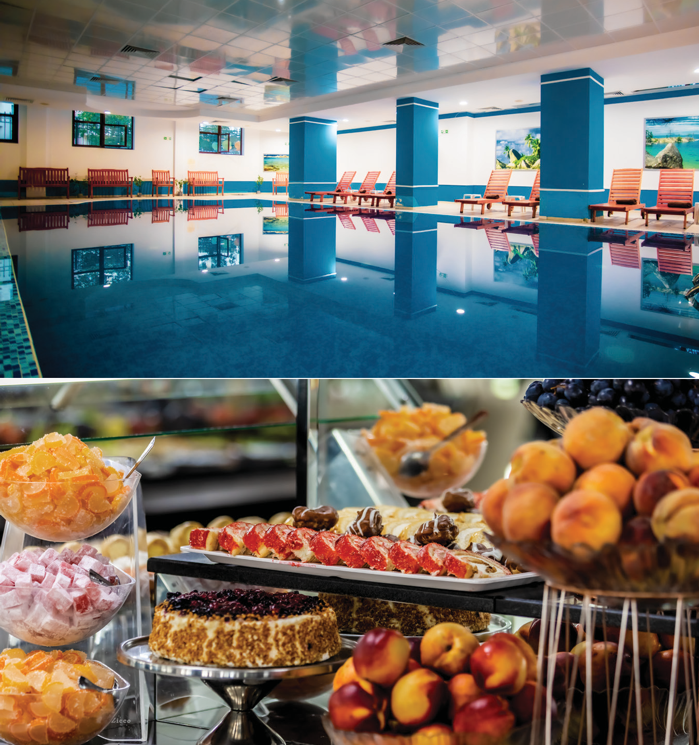Restaurants
√ 1 main restaurant
√ All-Inclusive Concept
√ Local & International cuisine
√ Capacity: Indoor 400, Outdoor: 130
√ Pastry shop

Bars
√ 2 bars: Lobby & Pool Bar
√ All-Inclusive Concept

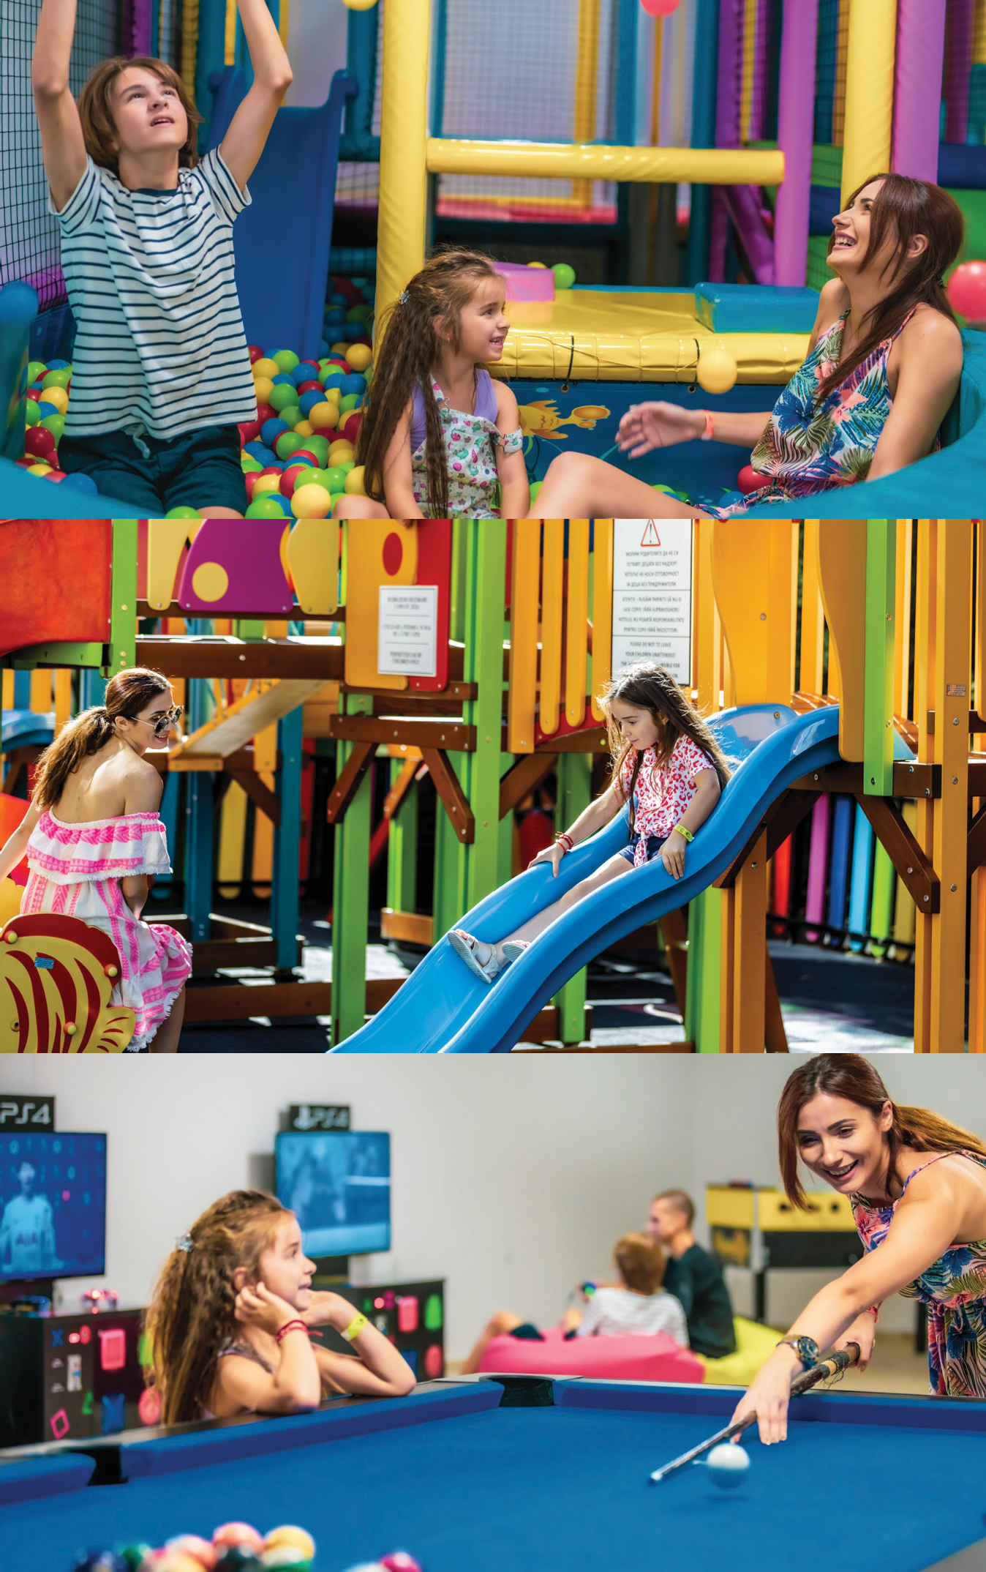Prestige Hotel & Aquapark

FACTSHEET

Children & Animation
CHILDREN CLUB with Montessori Toys
Daily
CHILDREN AGE | 2 to 12 years old
LANGUAGES | BG, RU, ENG, RO
√ Outdoor Playground
√ High-chairs in restaurant
√ Baby cot: Upon request
√ Gaming room: billiard, table footbal, table tennis, PlayStation Games

CHILDREN ANIMATION
6 Days a week | Daytime: 10:00 - 12:00 h & 15:00 - 17:00 h | Evening: 20:00- 20:30 h Children bingo, games with ball, water games, musical games, pirate games, mini disco etc.

ADULTS ANIMATION
6 days a week | Daytime: 10:00 - 12:00 h & 16:00 - 18:00 h | Evening: 20:00- 22:30 h
Other Services

√ Parking: 20.00 BGN per day, per car | 400 parking spaces, subject to availability | Reservation not possible
√ Internet: On the territory of the entire hotel
√ Bicycles rent: with deposit
√ Laundry: Extra charge
Version: 1.7 from 07.06.2023
The hotel reserves the right to make changes. Please always check if this is the latest version.
MEDIA KIT | https://bit.ly/prestigeaqua-media
Download All Inclusive Description| https://bit.ly/prestige-allinclusive Download High-Resolution Photos| https://bit.ly/prestigeaqua-photos Download Hotel Video | https://bit.ly/prestigeaqua-video

