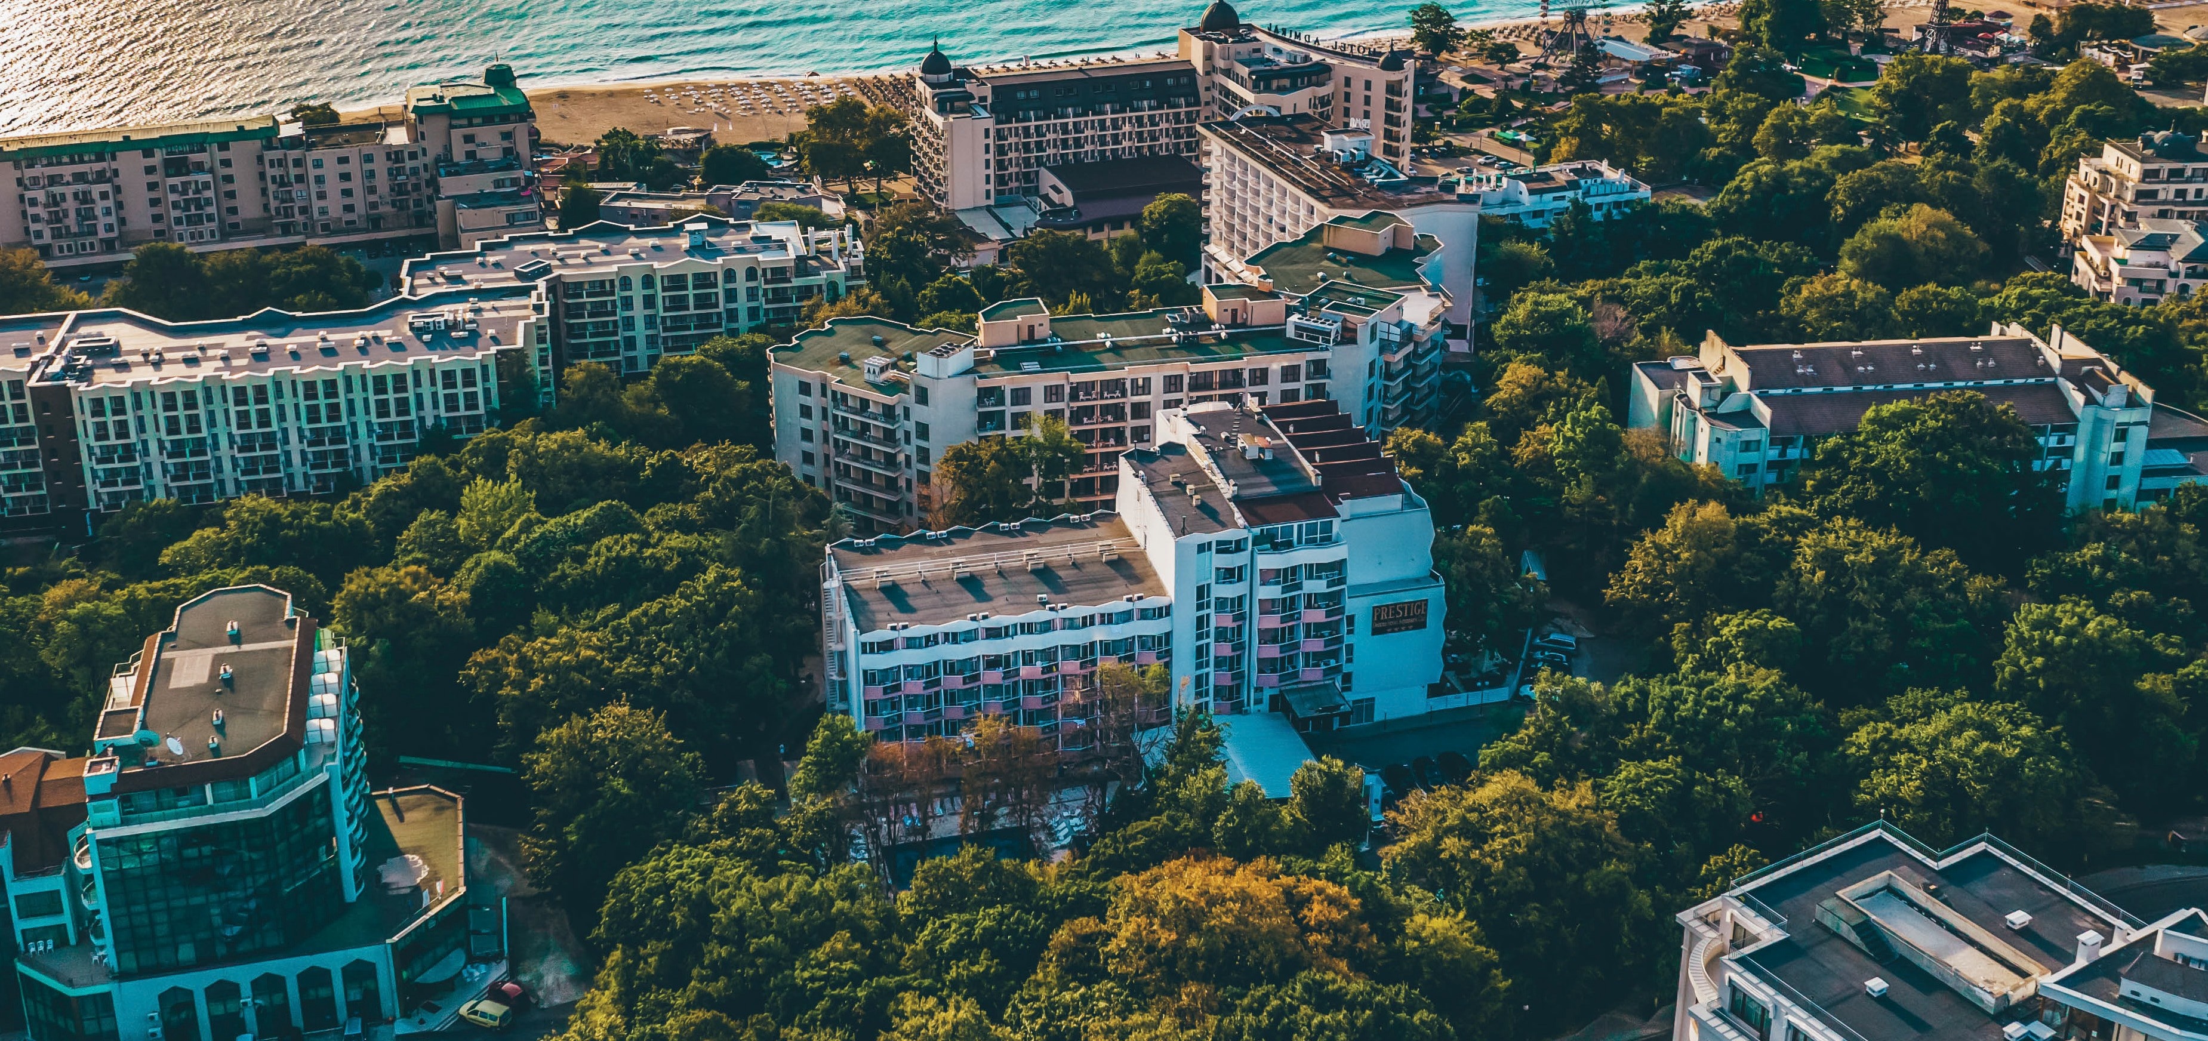Prestige Deluxe Hotel Aquapark Club

FACTSHEET

Varna , Golden Sands, 9007 | reservations@prestigeaquahotel.com | +359 895 805 805 | www.prestigedeluxeaquapark.com @prestigedeluxehotelaquapark

Prestige Deluxe Hotel Aquapark Club

FACTSHEET

Room Facilities
√ No smoking rooms: smoking allowed on balconies
√ Change of bed linen: 3 times per week
√ Change of towels: Daily
√ Cleaning of the room: Daily
√ Safe box
√ Mini-fridge
√ Kettle / Water boiler
√ Coffee / tea: Single time
√ Wi-Fi
√ Phone

RoomTypes
DOUBLE DELUXE ROOM

√ TV
√ Satellite channels: FR,EN,DE,BG,RU,RO,PL,ES,IT
√ Air-conditioning: individual
√ Fan
√ Hairdryer
√ Shower and/or bathtub
√ Iron: by request at reception
√ Toiletries
√ Floor type: laminate or carpet
√ Balcony
√ Water dispensers & coffee on every hotel floor

√ Number: 137 √ Size: 31 m2
√ Min.capacity: 2
√ Max.capacity: 2 +2 | 3+0

√ Type of beds: Double bed, sofa bed

DOUBLE FAMILY ROOM
√ Premises: Bedroom and Bathroom

√ Number: 8 √ Size: 40 m2
√ Min.capacity: 2
√ Max.capacity: 2 +3 | 3+2

√ Type of beds: Double bed, sofa bed, armchair bed

TWO BEDROOM DELUXE SUITE
√ Premises: Bedroom and Bathroom

√ Number: 6 √ Size: 55 m2 √ Min.capacity: 2
√ Max.capacity: 4 +1

√ Type of beds: Double bed, sofa bed, twin beds

PREMIUM ROOM
√ Premises: 2x Bedroom, bathroom, half bathroom

√ Number: 8 √ Size: 40 m2
√ Min.capacity: 2
√ Max.capacity: : 2 +3 | 3+2

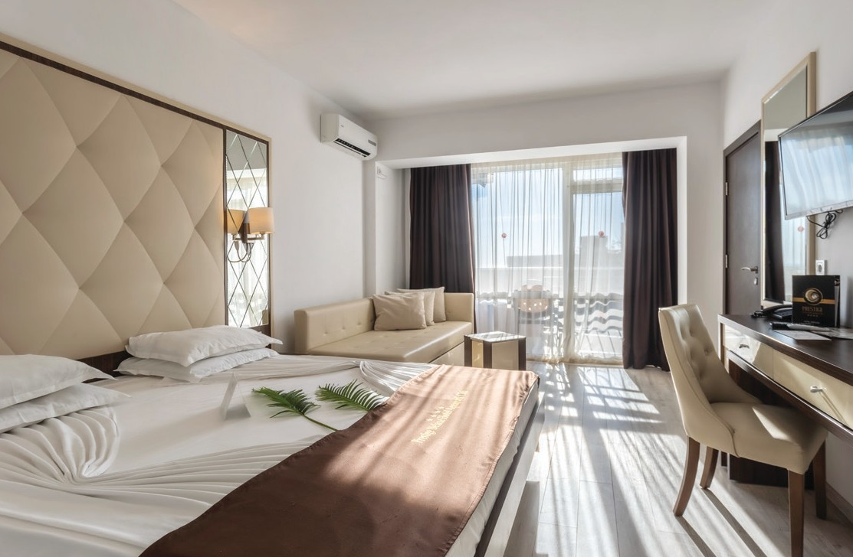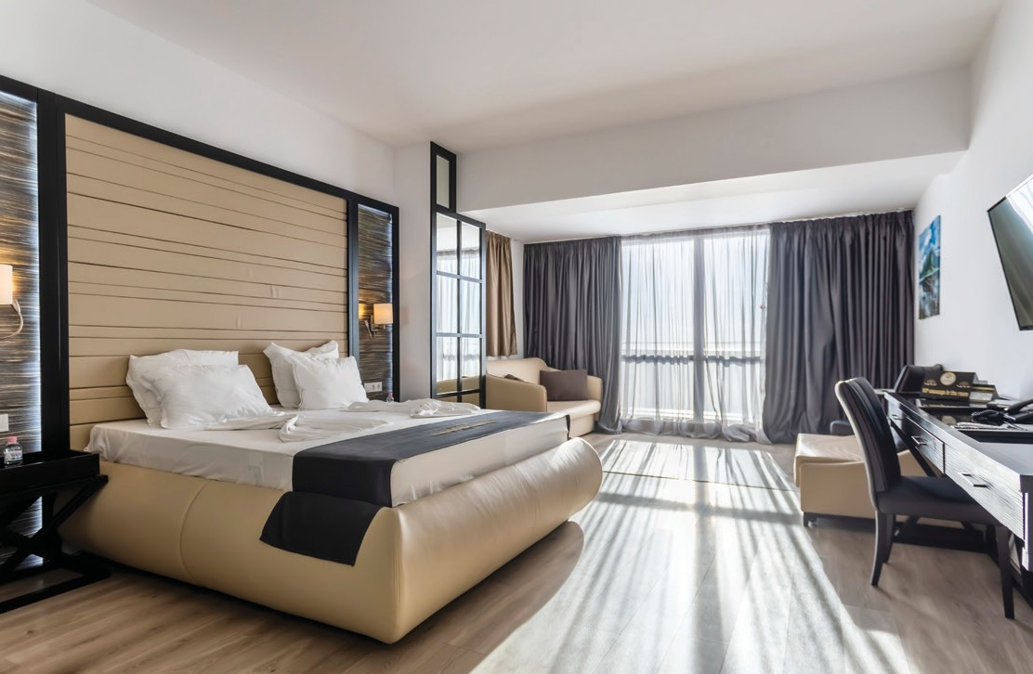√ Type of beds: Double bed, sofa bed √ Premises: Bedroom and Bathroom

Prestige Deluxe Hotel Aquapark Club

FACTSHEET

General Info

√
4 STAR HOTEL

Type
√

7
Number of ﬂoors

Location
√

1
Building

√
3

Number of lifts
√

2002
Year of building

√
YES

Disabled Facilities
√

2020
Last Renovation

√
161

Number of rooms

√ GPS Coordinates
43.28765304906302, 28.041895116673427
√ Distance to beach: 350 m
√ Distance to center: 350 m,
√ Distance to restaurant: 100 m
√ Distance to the nearest city: 16 km, Varna
√ Distance to shops: 100 m
√ Distance to shopping mall: 20 km
√ Distance to supermarket: 100 m

Reception
√ Distance to train station:
17 km, Varna Central Tran Station
√ Distance to airport: 25 km, VAR
√ Distance to bus stop: 300 m
√ Distance to ATM: 150 m
√ Distance to Medical center: 2 km
√ Distance to Hospital: 15 km
√ Distance to Pharmacy: 100 m

√
24 h Working hours
√

15:00 h
Check -in
√

12:00 h
Check -out
√
YES

Luggage Storage
X

Not Allowed Pet Policy

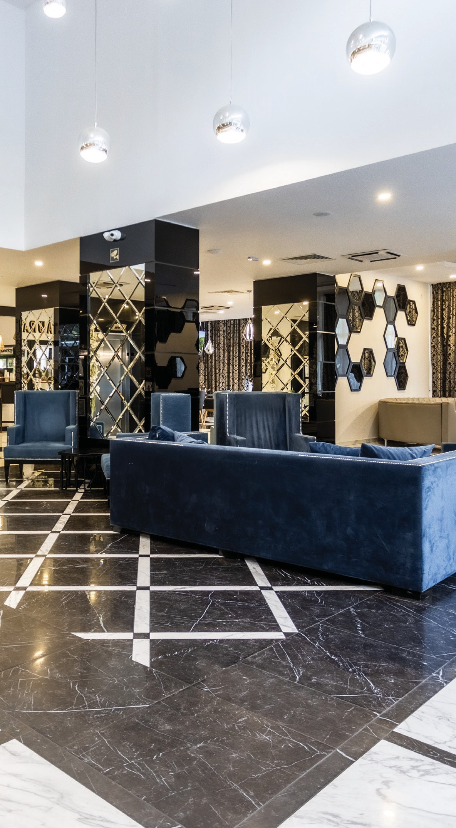
√ Early Check-in: Yes, upon availability
√ Late Check-out: Yes, upon availability | Extra Charge
ACCEPTED PAYMENT TYPES:
CREDIT CARD CASH BANK TRANSFER

PAYPAL APPLE PAY REVOLUT

Prestige Deluxe Hotel Aquapark Club

FACTSNEET

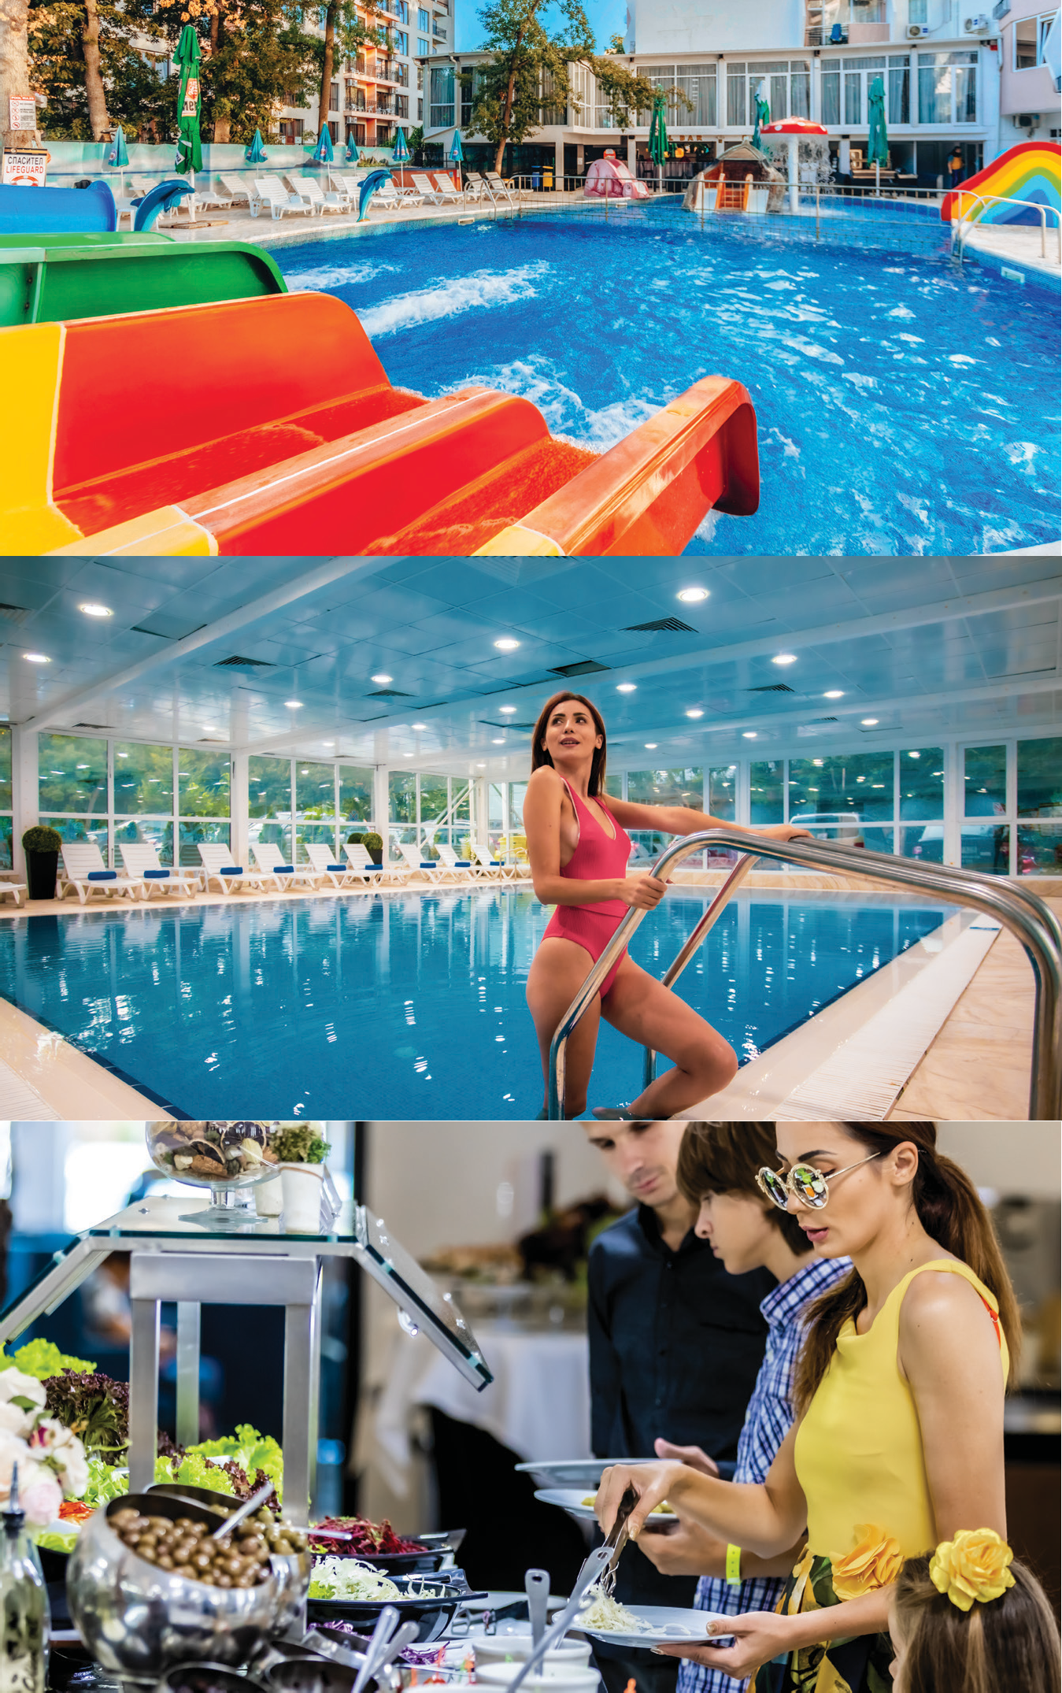Pool & Aquaпark
√ Two outdoor pools
√ Children outdoor pool section
√ Sunbeds and umbrella by the pool: Subject to availability
√ Beach Towels: Free
√ Public beach: 350m, Sand

Wellness
√ Indoor Pool: Heated, 27 – 28 C
√ Sauna
√ Outdoor jacuzzi
√ Steam bath
√ Salt room
√ Massages: Extra charge
√ Hammam: Extra charge

Restaurants
√ 1 main restaurant
√ All Inclusive Concept
√ Capacity: 240 inside, 120 terrace
√ Local & International cuisine
√ Pastry shop

√ Water slides: 6
√ Water slides kids: pirate ship, 1 fountain, 2 slides

Sport
√ Yoga classes
√ Billiard
√ Table tennis
√ Darts
√ Table football
√ Fitness | at Prestige Hotel & Aquapark
√ Outdoor fitness

Bars
√ 2 bars: Lobby & Pool Bar
√ All Inclusive Concept

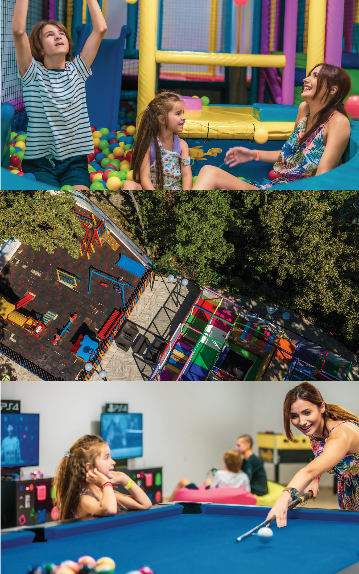Prestige Deluxe Hotel Aquapark Club

FACTSHEET

Children & Animation
CHILDREN CLUB | WITH MONTESSORI TOYS
Daily
CHILDREN AGE | 2 to 12 years old
LANGUAGES | BG, RU, ENG, RO
√ Outdoor Playground
√ High-chairs in restaurant
√ Baby cot: Upon request
√ Gaming room: at Prestige Hotel & Aqua Park with PlayStation

CHILDREN ANIMATION
6 Days a week | Daytime: 10:00 - 12:00 h & 15:00 - 17:00 h | Evening: 20:00- 20:30 h Children bingo, games with ball, water games, musical games, pirate games, mini disco etc.

ADULTS ANIMATION
6 days a week | Daytime: 10:00 - 12:00 h & 16:00 - 18:00 h | Evening: 20:00- 22:30 h

Other Services
√ Parking: 20.00 BGN per day, per car | 400 parking spaces, subject to availability | Reservation not possible
√ Internet: On the territor f the entire hotel
y o
√ Bicycles rent: with deposit
√ Laundry: Extra charge
Version: 1.7 from 07.06.2023
The hotel reserves the right to make changes. Please always check if this is the latest version.
MEDIA KIT | https://bit.ly/prestigedeluxe-media
Dowlnoad All Inclusive Description| https://bit.ly/prestigedeluxe-allinclusive Dowlnoad High-Resolution Photos| https://bit.ly/prestigedeluxe-photos Dowlnoad Hotel Video | https://bit.ly/prestigedeluxe-video

