
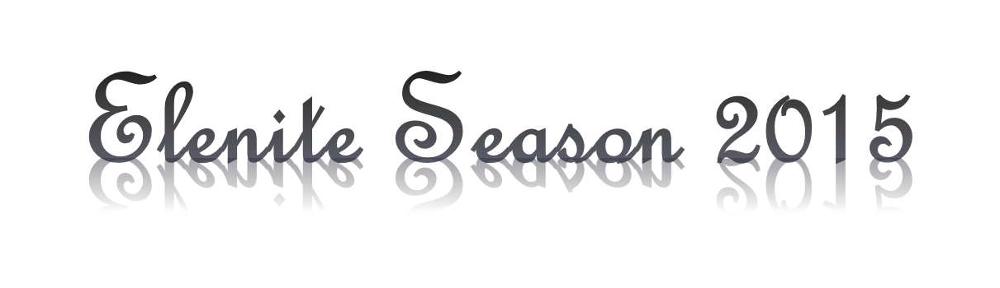

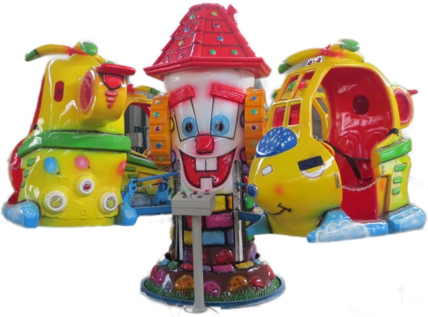
Dear Partners, we are delighted to present our innovations at Holiday Village Elenite for Summer Season 2015. This summer our guests will be able to enjoy:
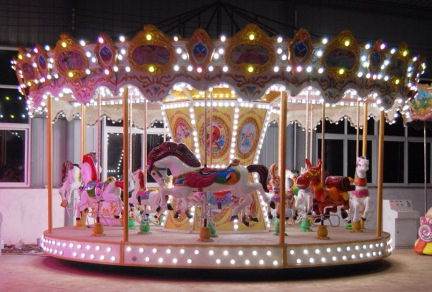
Mini Fun Fair
Amusement train for children.
Park train for adults and children.
Swing chair rides for children.
Amusement carousel for children.
Carousel rides for children.
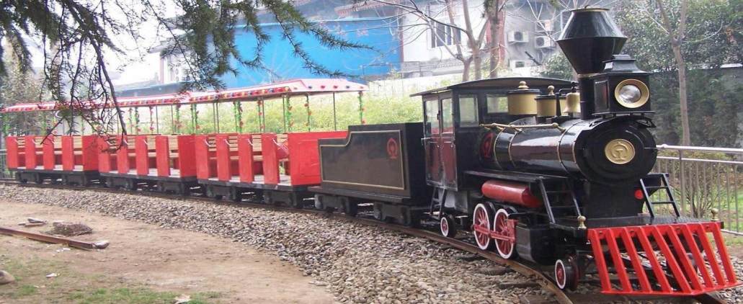
Rotating kids mini airplane rides
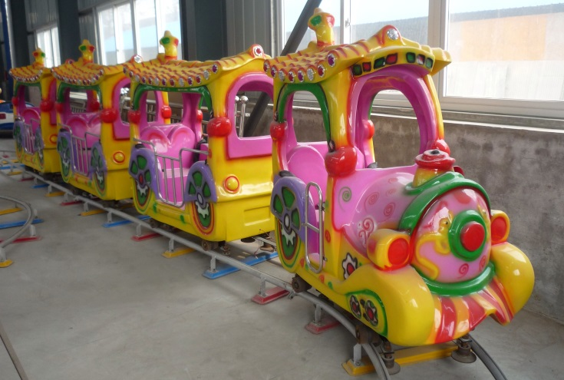
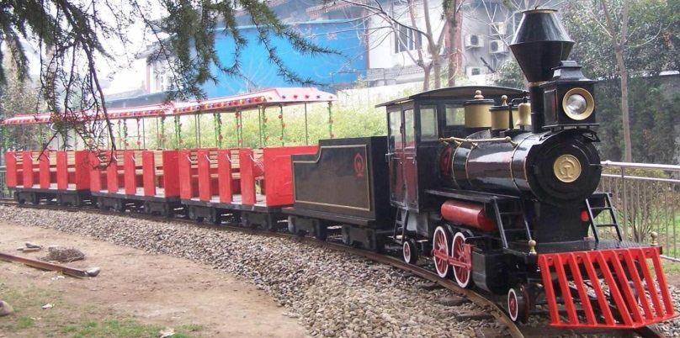

Free sun beds and parasols in Aquapark Atlantida
Free snacks and drinks in Aquapark Atlantida
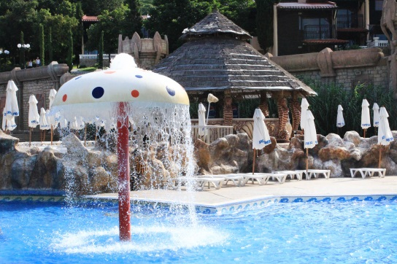
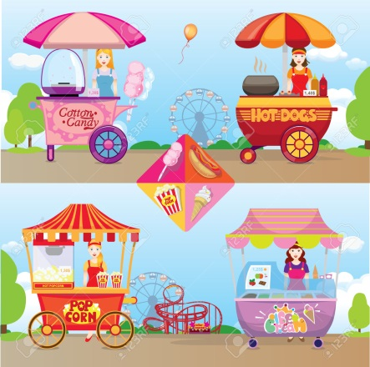
More snacks at the beach

